

**DESARROLLO SOLUCIÓN ENTREGA #1**

**Docente: Luz Enith Guerrero Mendieta**

**Presentado por:**

**Cristian David Gómez Becerra**

**Stiven Vélez Bedoya**

**Grafo Inicial**

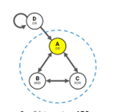

|  |  |  |  |  |  |
| --- | --- | --- | --- | --- | --- |
| Entrada de datos | Medida de distancia | Esquema de partición | Resultados con CM | Resultados sin CM | Observaciones |
| Grafo: | EMD | biparticion | MIP:  Cut [B, C] ━━/ /━━➤ [A]  Phi:  Φ = 2.3125  Time:  0.246312 s | MIP:  Cut [B, C] ━━/ /━━➤ [A]  Phi:  Φ = 2.3125  Time:  0.505238 s |  |
| EMD | tripartición | MIP:  Cut [B, C] ━━/ /━━➤ [A]  Phi:  Φ = 2.3125  Time:  0.217384 s | MIP:  Cut [B, C] ━━/ /━━➤ [A]  Phi:  Φ = 2.3125  Time:  0.476244 s |  |
| KLD | bipartición | MIP:  Cut [B, C] ━━/ /━━➤ [A]  Phi:  Φ = 2.3125  Time:  0.223403 s | MIP:  Cut [B, C] ━━/ /━━➤ [A]  Phi:  Φ = 2.3125  Time:  0.495682 s |  |
| KLD | tripartición | MIP:  Cut [B, C] ━━/ /━━➤ [A]  Phi:  Φ = 2.3125  Time:  0.223404 s | MIP:  Cut [B, C] ━━/ /━━➤ [A]  Phi:  Φ = 2.3125  Time:  0.448496 s |  |

* **EMD-Bipartición-con CM**

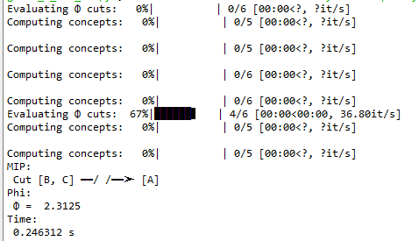

* **EMD-Bipartición-sin CM**

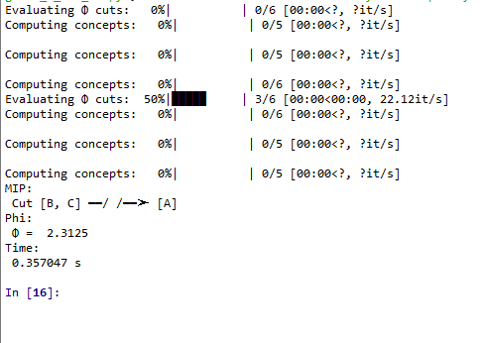

* **EMD-Tripartición-con CM**

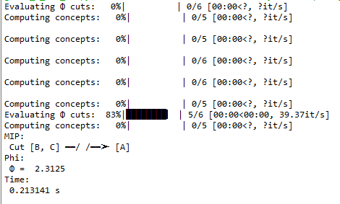

* **EMD-Tripartición-sin CM**

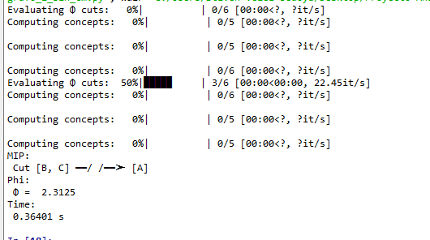

* **KLD-Bipartición-con CM**

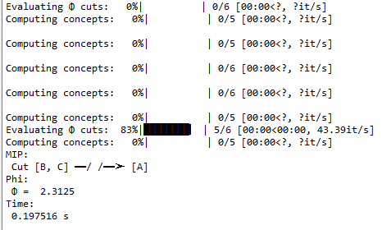

* **KLD-Bipartición-sin CM**

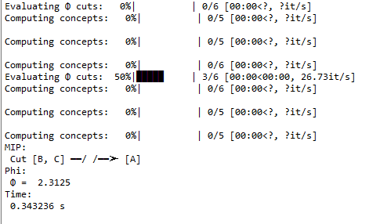

* **KLD-Tripartición-con CM**

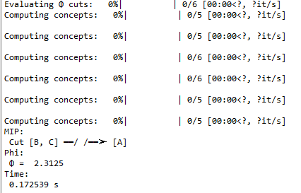

* **KLD-Tripartición-sin CM**

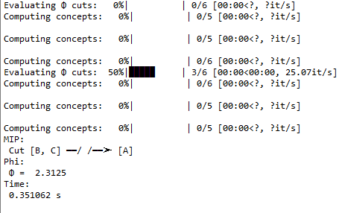

**Grafo 2**

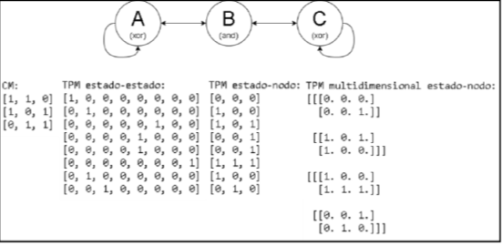

* **Estado-estado**

|  |  |  |  |  |  |
| --- | --- | --- | --- | --- | --- |
| Entrada de datos | Medida de distancia | Esquema de partición | Resultados con CM | Resultados sin CM | Observaciones |
| Grafo: | EMD | biparticion | MIP:  Cut [A, B] ━━/ /━━➤ [C]  Phi:  Φ = 0.520834  Time:  0.341088 s | MIP:  Cut [A, B] ━━/ /━━➤ [C]  Phi:  Φ = 0.520834  Time:  0.256316 s |  |
| EMD | tripartición | MIP:  Cut [A, B] ━━/ /━━➤ [C]  Phi:  Φ = 0.520834  Time:  0.271785 s | MIP:  Cut [A, B] ━━/ /━━➤ [C]  Phi:  Φ = 0.520834  Time:  0.296044 s |  |
| KLD | bipartición | MIP:  Cut [A, B] ━━/ /━━➤ [C]  Phi:  Φ = 0.520834  Time:  0.262299 s | MIP:  Cut [A, B] ━━/ /━━➤ [C]  Phi:  Φ = 0.520834  Time:  0.278293 s |  |
| KLD | tripartición | MIP:  Cut [A, B] ━━/ /━━➤ [C]  Phi:  Φ = 0.520834  Time:  0.277937 s | MIP:  Cut [A, B] ━━/ /━━➤ [C]  Phi:  Φ = 0.520834  Time:  0.289227 s |  |

* **EMD-Bipartición-con CM**

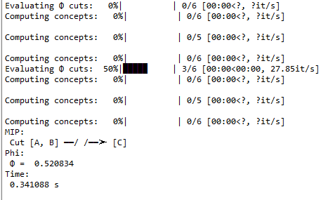

* **EMD-Bipartición-sin CM**

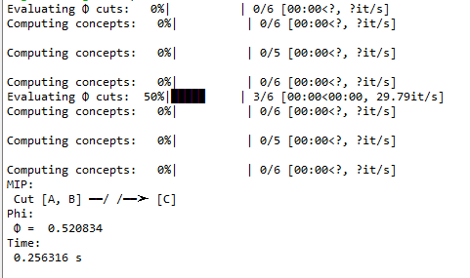

* **EMD-Tripartición-con CM**

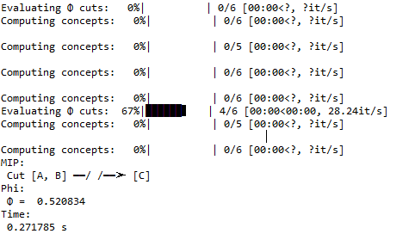

* **EMD-Tripartición-sin CM**

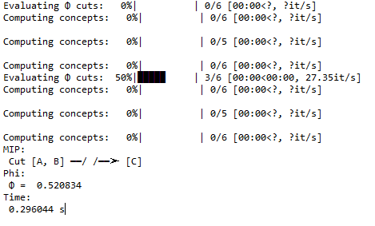

* **KLD-Bipartición-con CM**

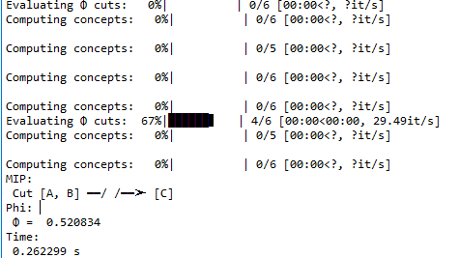

* **KLD-Bipartición-sin CM**

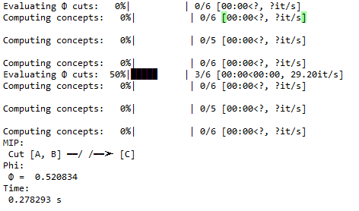

* **KLD-Tripartición-con CM**

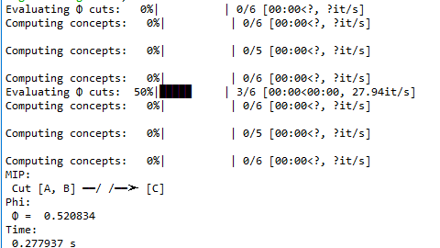

* **KLD-Tripartición-sin CM**

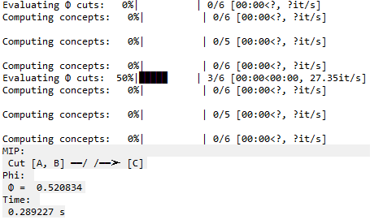

* **Estado-nodo**

|  |  |  |  |  |  |
| --- | --- | --- | --- | --- | --- |
| Entrada de datos | Medida de distancia | Esquema de partición | Resultados con CM | Resultados sin CM | Observaciones |
| Grafo: | EMD | biparticion | MIP:  Cut [A, B] ━━/ /━━➤ [C]  Phi:  Φ = 0.520834  Time:  0.215677 s | MIP:  Cut [A, B] ━━/ /━━➤ [C]  Phi:  Φ = 0.520834  Time:  0.300695 s |  |
| EMD | tripartición | MIP:  Cut [A, B] ━━/ /━━➤ [C]  Phi:  Φ = 0.520834  Time:  0.216105 s | MIP:  Cut [A, B] ━━/ /━━➤ [C]  Phi:  Φ = 0.520834  Time:  0.316358 s |  |
| KLD | bipartición | MIP:  Cut [A, B] ━━/ /━━➤ [C]  Phi:  Φ = 0.520834  Time:  0.21994 s | MIP:  Cut [A, B] ━━/ /━━➤ [C]  Phi:  Φ = 0.520834  Time:  0.300732 s |  |
| KLD | tripartición | MIP:  Cut [A, B] ━━/ /━━➤ [C]  Phi:  Φ = 0.520834  Time:  0.285125 s | MIP:  Cut [A, B] ━━/ /━━➤ [C]  Phi:  Φ = 0.520834  Time:  0.416471 s |  |

* **EMD-Bipartición-con CM**

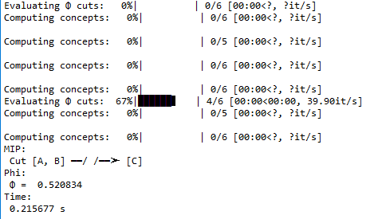

* **EMD-Bipartición-sin CM**

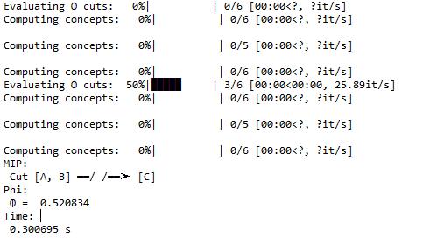

* **EMD-Tripartición-con CM**

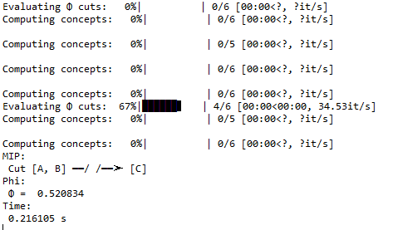

* **EMD-Tripartición-sin CM**

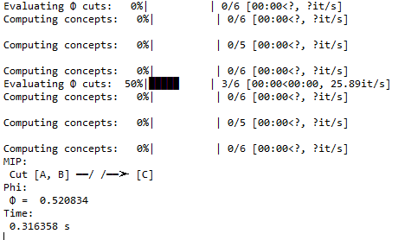

* **KLD-bipartición-con CM**

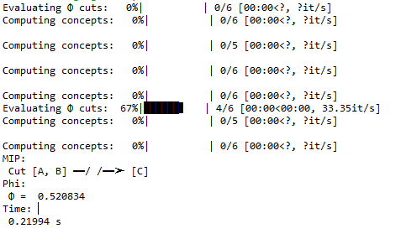

* **KLD-Bipartición-sin CM**

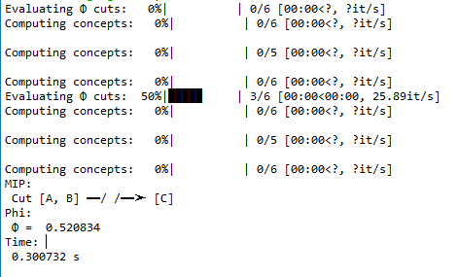

* **KLD-Tripartición-con CM**

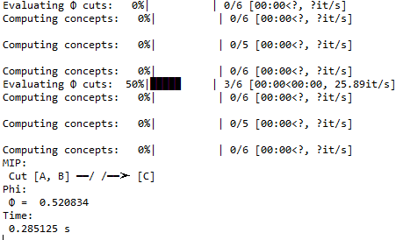

* **KLD-Tripartición-sin CM**

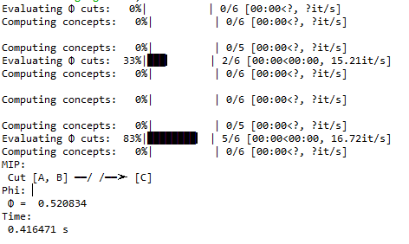

* **TPM-Multidimensional estado-nodo**

|  |  |  |  |  |  |
| --- | --- | --- | --- | --- | --- |
| Entrada de datos | Medida de distancia | Esquema de partición | Resultados con CM | Resultados sin CM | Observaciones |
| Grafo: | EMD | biparticion | MIP:  Cut [A, B] ━━/ /━━➤ [C]  Phi:  Φ = 0.520834  Time:  0.255029 s | MIP:  Cut [A, B] ━━/ /━━➤ [C]  Phi:  Φ = 0.520834  Time:  0.269397 s |  |
| EMD | tripartición | MIP:  Cut [A, B] ━━/ /━━➤ [C]  Phi:  Φ = 0.520834  Time:  0.231735 s | MIP:  Cut [A, B] ━━/ /━━➤ [C]  Phi:  Φ = 0.520834  Time:  0.21608 s |  |
| KLD | bipartición | MIP:  Cut [A, B] ━━/ /━━➤ [C]  Phi:  Φ = 0.520834  Time:  0.231457 s | MIP:  Cut [A, B] ━━/ /━━➤ [C]  Phi:  Φ = 0.520834  Time:  0.216126 s |  |
| KLD | tripartición | MIP:  Cut [A, B] ━━/ /━━➤ [C]  Phi:  Φ = 0.520834  Time:  0.231697 s | MIP:  Cut [A, B] ━━/ /━━➤ [C]  Phi:  Φ = 0.520834  Time:  0.216092 s |  |

* **EMD-Bipartición-con CM**

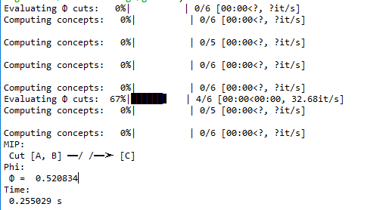

* **EMD-Bipartición-sin CM**

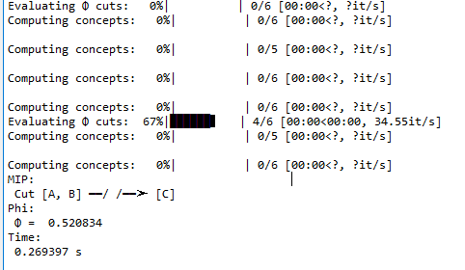

* **EMD-Tripartición-con CM**

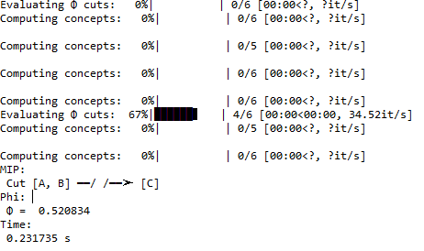

* **EMD-Tripartición-sin CM**

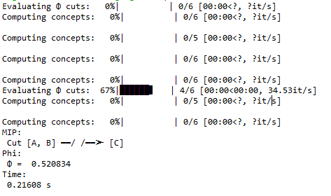

* **KLD-Bipartición-con CM**

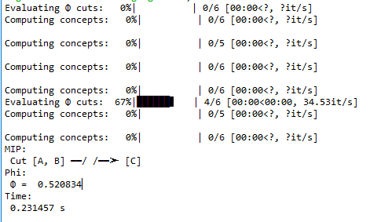

* **KLD-Bipartición-sin CM**

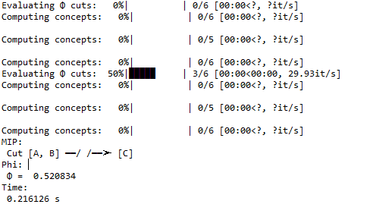

* **KLD-Tripartición-con CM**

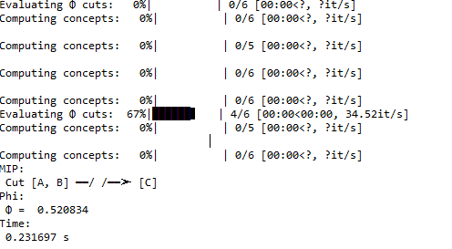

* **KLD-Tripartición-sin CM**

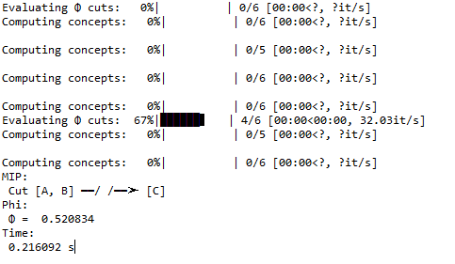

**Grafo 2**

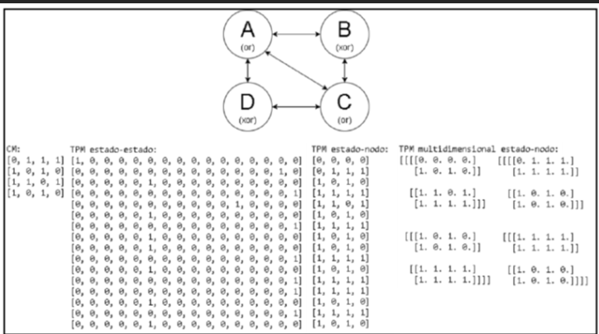

* **Estado-estado**

|  |  |  |  |  |  |
| --- | --- | --- | --- | --- | --- |
| Entrada de datos | Medida de distancia | Esquema de partición | Resultados con CM | Resultados sin CM | Observaciones |
| Grafo: | EMD | biparticion | MIP:  Cut [A, B, C] ━━/ /━━➤ [D]  Phi:  Φ = 1.28125  Time:  1.71135 s | MIP:  Cut [A, B, C] ━━/ /━━➤ [D]  Phi:  Φ = 1.28125  Time:  1.685544 |  |
| EMD | tripartición | MIP:  Cut [A, B, C] ━━/ /━━➤ [D]  Phi:  Φ = 1.28125  Time:  1.701052 s | MIP:  Cut [A, B, C] ━━/ /━━➤ [D]  Phi:  Φ = 1.28125  Time:  1.617769 s |
| KLD | bipartición | MIP:  Cut [A, B, C] ━━/ /━━➤ [D]  Phi:  Φ = 1.28125  Time:  1.665161 s | MIP:  Cut [A, B, C] ━━/ /━━➤ [D]  Phi:  Φ = 1.28125  Time:  1.648836 s |  |
| KLD | tripartición | MIP:  Cut [A, B, C] ━━/ /━━➤ [D]  Phi:  Φ = 1.28125  Time:  1.686463 s | MIP:  Cut [A, B, C] ━━/ /━━➤ [D]  Phi:  Φ = 1.28125  Time:  1.562435 s |

* **EMD-Bipartición-con CM**

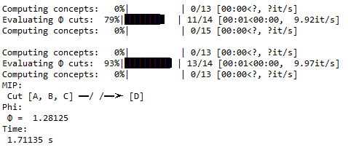

* **EMD-Bipartición-sin CM**

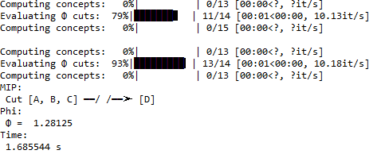

* **EMD-Tripartición-con CM**

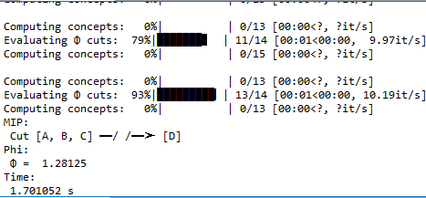

* **EMD-Tripartición-sin CM**

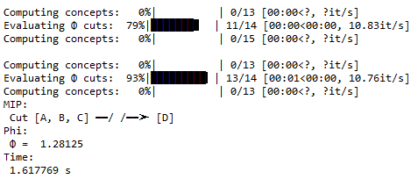

* **KLD-Bipartición-con CM**

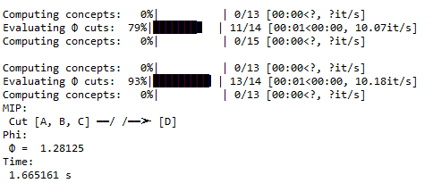

* **KLD-Bipartición-sin CM**

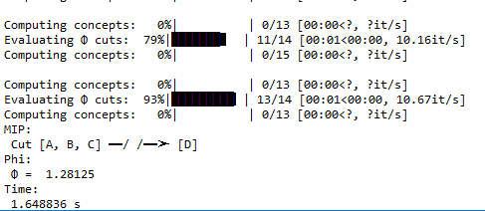

* **KLD-Tripartición-con CM**

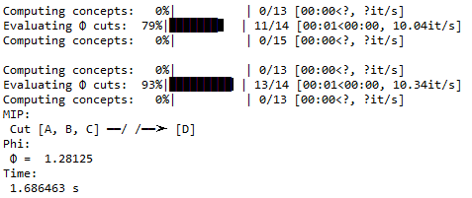

* **KLD-Tripartición-sin CM**

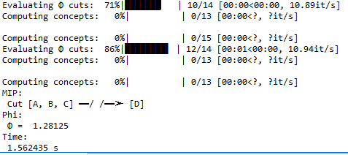

* **Estado-nodo**

|  |  |  |  |  |  |
| --- | --- | --- | --- | --- | --- |
| Entrada de datos | Medida de distancia | Esquema de partición | Resultados con CM | Resultados sin CM | Observaciones |
| Grafo: | EMD | biparticion | MIP:  Cut [A, B, C] ━━/ /━━➤ [D]  Phi:  Φ = 1.28125  Time:  2.08013 s | MIP:  Cut [A, B, C] ━━/ /━━➤ [D]  Phi:  Φ = 1.28125  Time:  1.750886 s |  |
| EMD | tripartición | MIP:  Cut [A, B, C] ━━/ /━━➤ [D]  Phi:  Φ = 1.28125  Time:  1.778046 s | MIP:  Cut [A, B, C] ━━/ /━━➤ [D]  Phi:  Φ = 1.28125  Time:  1.688907 s |
| KLD | bipartición | MIP:  Cut [A, B, C] ━━/ /━━➤ [D]  Phi:  Φ = 1.28125  Time:  1.680897 s | MIP:  Cut [A, B, C] ━━/ /━━➤ [D]  Phi:  Φ = 1.28125  Time:  1.66701 s |  |
| KLD | tripartición | MIP:  Cut [A, B, C] ━━/ /━━➤ [D]  Phi:  Φ = 1.28125  Time:  1.720237 s | MIP:  Cut [A, B, C] ━━/ /━━➤ [D]  Phi:  Φ = 1.28125  Time:  1.644308 s |

* **EMD-Bipartición-con CM**

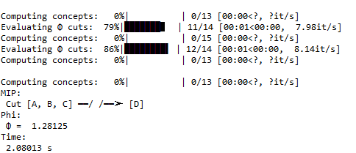

* **EMD-Bipartición-sin CM**

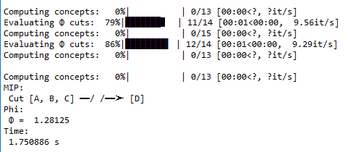

* **EMD-Tripartición-con CM**

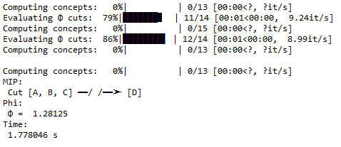

* **EMD-Tripartición-sin CM**

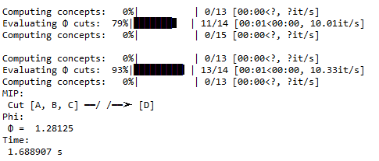

* **KLD-Bipartición-con CM**

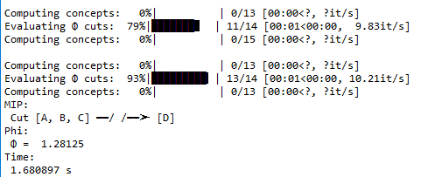

* **KLD-Bipartición-sin CM**

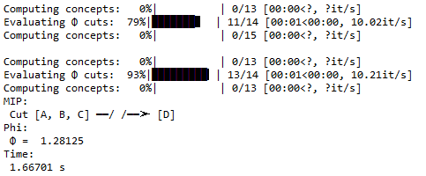

* **KLD-Tripartición-con CM**

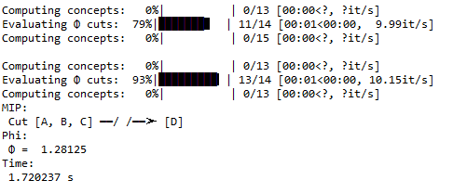

* **KLD-Tripartición-sin CM**

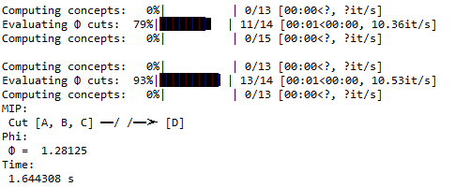

* **Estado-nodo-multidimensional**

|  |  |  |  |  |  |
| --- | --- | --- | --- | --- | --- |
| Entrada de datos | Medida de distancia | Esquema de partición | Resultados con CM | Resultados sin CM | Observaciones |
| Grafo: | EMD | biparticion | MIP:  Cut [A, B, C] ━━/ /━━➤ [D]  Phi:  Φ = 1.28125  Time:  1.933 s | MIP:  Cut [A, B, C] ━━/ /━━➤ [D]  Phi:  Φ = 1.28125  Time:  1.670471 s |  |
| EMD | tripartición | MIP:  Cut [A, B, C] ━━/ /━━➤ [D]  Phi:  Φ = 1.28125  Time:  1.665161 s | MIP:  Cut [A, B, C] ━━/ /━━➤ [D]  Phi:  Φ = 1.28125  Time:  1.733072 s |
| KLD | bipartición | MIP:  Cut [A, B, C] ━━/ /━━➤ [D]  Phi:  Φ = 1.28125  Time:  1.81586 s | MIP:  Cut [A, B, C] ━━/ /━━➤ [D]  Phi:  Φ = 1.28125  Time:  1.777333 s |  |
| KLD | tripartición | MIP:  Cut [A, B, C] ━━/ /━━➤ [D]  Phi:  Φ = 1.28125  Time:  1.779506 s | MIP:  Cut [A, B, C] ━━/ /━━➤ [D]  Phi:  Φ = 1.28125  Time:  1.844154 s |

* **EMD-Bipartición-con CM**

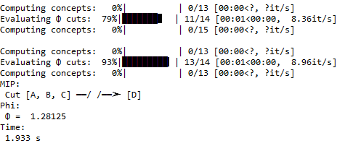

* **EMD-Bipartición-sin CM**

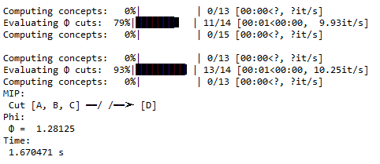

* **EMD-Tripartición-con CM**

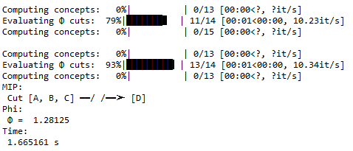

* **EMD-Tripartición-sin CM**

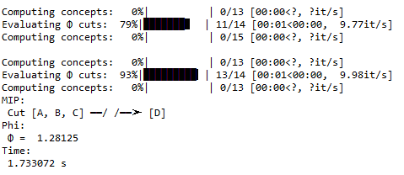

* **KLD-Bipartición-con CM**

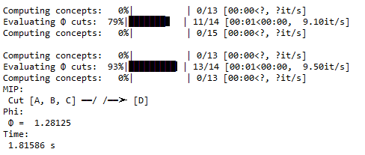

* **KLD-Bipartición-sin CM**

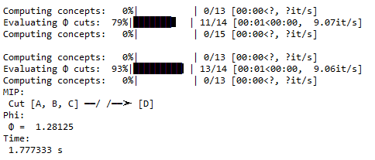

* **KLD-Tripartición-con CM**

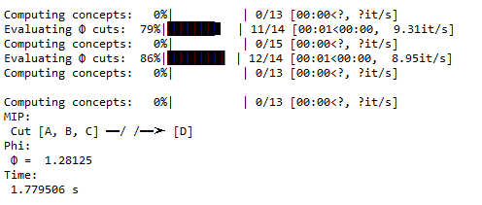

* **KLD-Tripartición-sin CM**

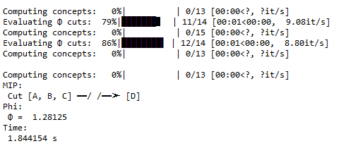

**Grafo 3**

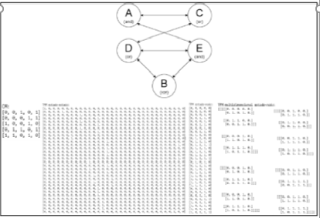

* **Estado-estado**

|  |  |  |  |  |
| --- | --- | --- | --- | --- |
| Entrada de datos | Medida de distancia | Esquema de partición | Resultados con CM | Resultados sin CM |
| Grafo: | EMD | biparticion | MIP:  Cut [A, B, C, D] ━━/ /━━➤ [E]  Phi:  Φ = 0.209503  Time:  6.12972 s | MIP:  Cut [A, B, C, D] ━━/ /━━➤ [E]  Phi:  Φ = 0.209503  Time:  6.331663 s |
| EMD | tripartición | MIP:  Cut [A, B, C, D] ━━/ /━━➤ [E]  Phi:  Φ = 0.209503  Time:  6.283878 s | MIP:  Cut [A, B, C, D] ━━/ /━━➤ [E]  Phi:  Φ = 0.209503  Time:  6.463549 s |
| KLD | bipartición | MIP:  Cut [A, B, C, D] ━━/ /━━➤ [E]  Phi:  Φ = 0.209503  Time:  6.455328 s | MIP:  Cut [A, B, C, D] ━━/ /━━➤ [E]  Phi:  Φ = 0.209503  Time:  6.738606 s |
| KLD | tripartición | MIP:  Cut [A, B, C, D] ━━/ /━━➤ [E]  Phi:  Φ = 0.209503  Time:  6.454886 s | MIP:  Cut [A, B, C, D] ━━/ /━━➤ [E]  Phi:  Φ = 0.209503  Time:  6.286688 s |

* **EMD-Bipartición-con CM**

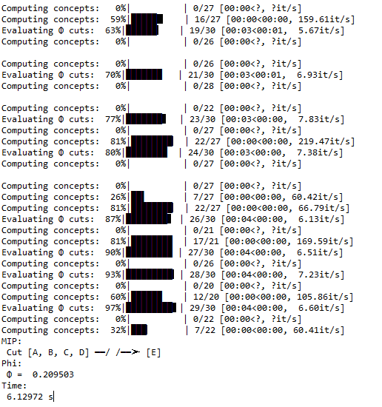

* **EMD-Bipartición-sin CM**

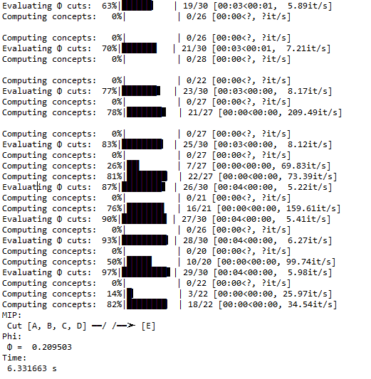

* **EMD-Tripartición-con CM**

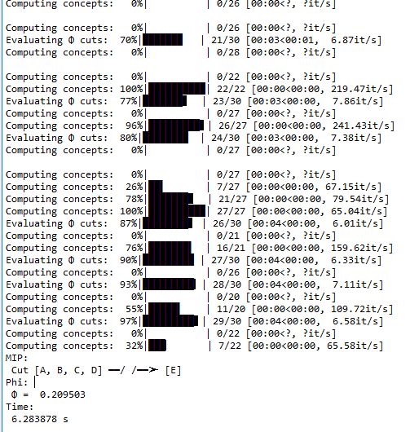

* **EMD-Tripartición-sin CM**

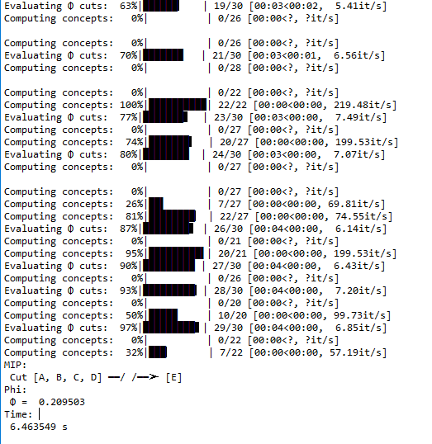

* **KLD-Bipartición-con CM**

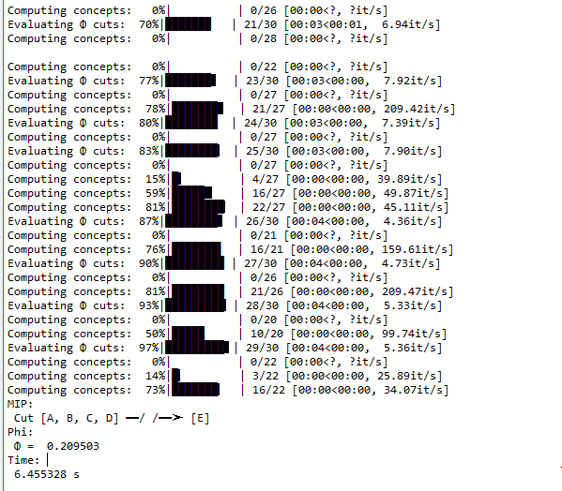

* **KLD-Bipartición-sin CM**

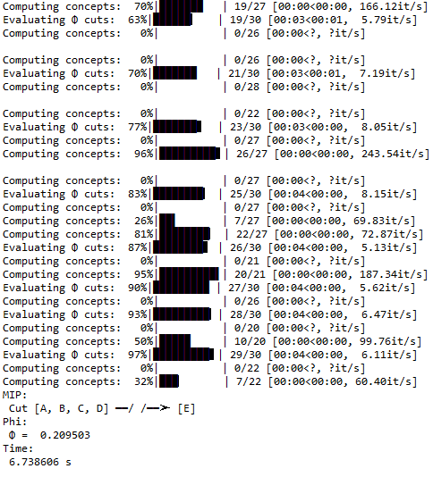

* **KLD-Tripartición-con CM**

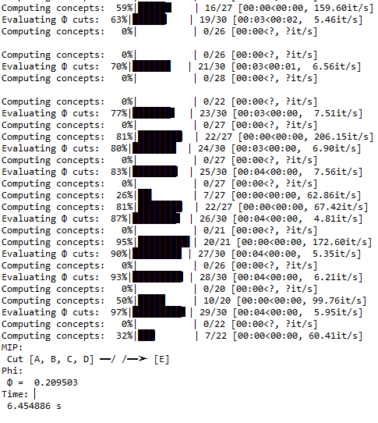

* **KLD-Tripartición-sin CM**

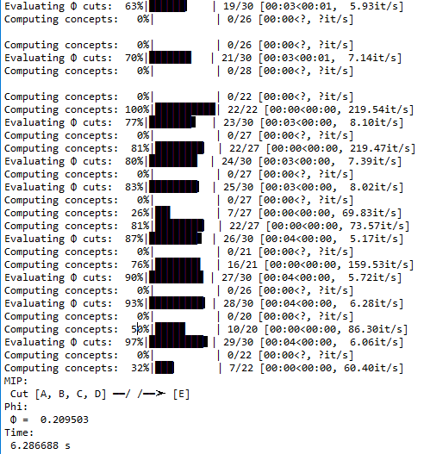

* **Estado-nodo**

|  |  |  |  |  |
| --- | --- | --- | --- | --- |
| Entrada de datos | Medida de distancia | Esquema de partición | Resultados con CM | Resultados sin CM |
| Grafo: | EMD | biparticion | MIP:  Cut [A, C] ━━/ /━━➤ [B, D, E]  Phi:  Φ = 0.249999  Time:  9.922279 s | MIP:  Cut [A, C] ━━/ /━━➤ [B, D, E]  Phi:  Φ = 0.249999  Time:  39.720679 s |
| EMD | tripartición | MIP:  Cut [A, C] ━━/ /━━➤ [B, D, E]  Phi:  Φ = 0.249999  Time:  12.107863 s | MIP:  Cut [A, C] ━━/ /━━➤ [B, D, E]  Phi:  Φ = 0.249999  Time:  39.274809 s |
| KLD | bipartición | MIP:  Cut [A, C] ━━/ /━━➤ [B, D, E]  Phi:  Φ = 0.249999  Time:  10.109698 s | MIP:  Cut [A, C] ━━/ /━━➤ [B, D, E]  Phi:  Φ = 0.249999  Time:  44.130286 s |
| KLD | tripartición | MIP:  Cut [A, C] ━━/ /━━➤ [B, D, E]  Phi:  Φ = 0.249999  Time:  10.796676 s | MIP:  Cut [A, C] ━━/ /━━➤ [B, D, E]  Phi:  Φ = 0.249999  Time:  39.269661 s |

* **EMD-Bipartición-con CM**

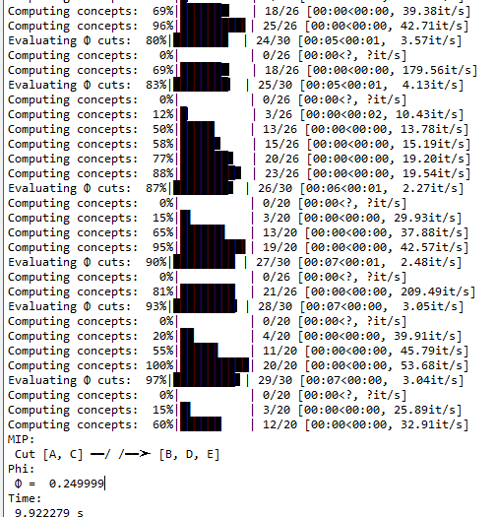

* **EMD-Bipartición-sin CM**

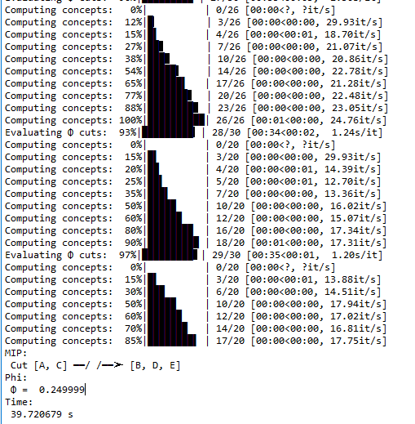

* **EMD-Tripartición-con CM**

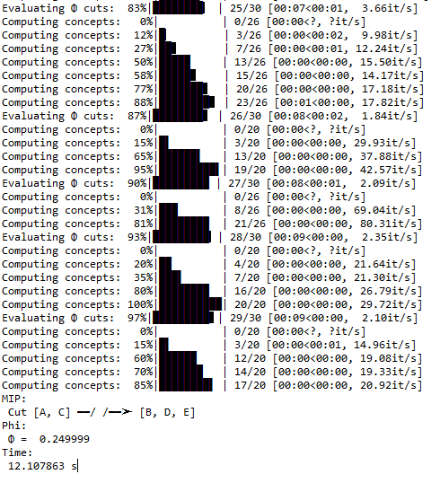

* **EMD-Tripartición-sin CM**

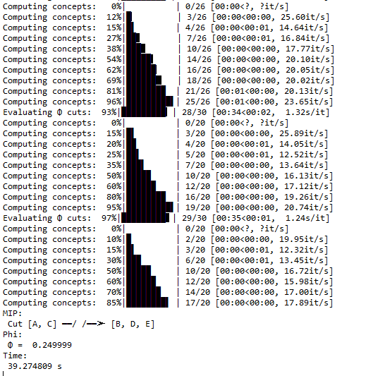

* **KLD-Bipartición-con CM**

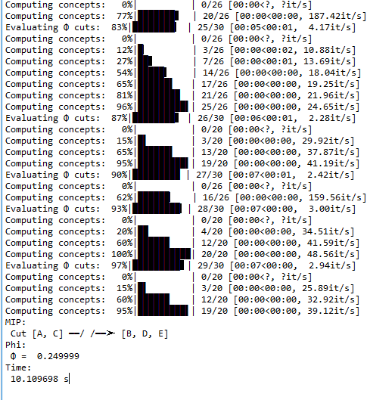

* **KLD-Bipartición-sin CM**

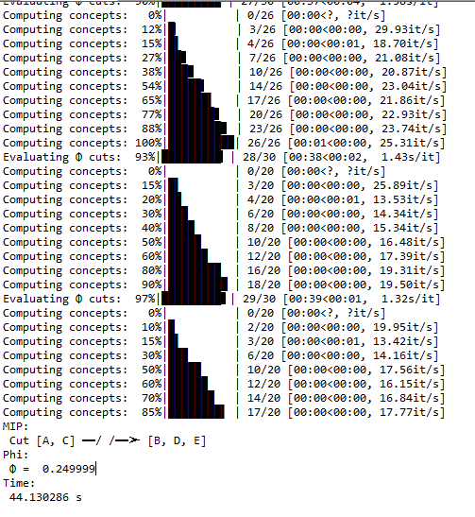

* **KLD-Tripartición-con CM**

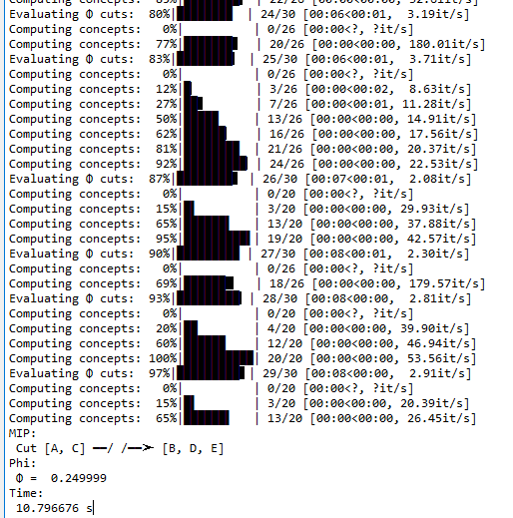

* **KLD-Tripartición-sin CM**

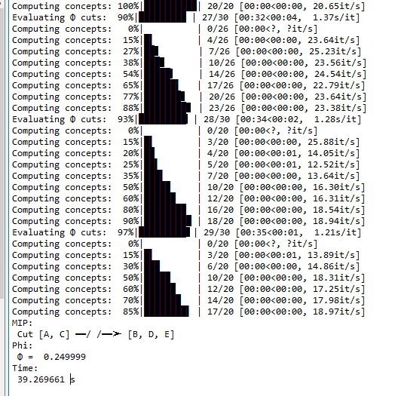

* **Multidimensional estado-nodo**

|  |  |  |  |  |
| --- | --- | --- | --- | --- |
| Entrada de datos | Medida de distancia | Esquema de partición | Resultados con CM | Resultados sin CM |
| Grafo: | EMD | biparticion | MIP:  Cut [A, B, C, D] ━━/ /━━➤ [E]  Phi:  Φ = 0.216339  Time:  6.197377 s | MIP:  Cut [A, B, C, D] ━━/ /━━➤ [E]  Phi:  Φ = 0.545098  Time:  37.868354 s |
| EMD | tripartición | MIP:  Cut [A, B, C, D] ━━/ /━━➤ [E]  Phi:  Φ = 0.216339  Time:  6.332247 s | MIP:  Cut [A, B, C, D] ━━/ /━━➤ [E]  Phi:  Φ = 0.545098  Time:  38.488696 s |
| KLD | bipartición | MIP:  Cut [A, B, C, D] ━━/ /━━➤ [E]  Phi:  Φ = 0.216339  Time:  6.330175 s | MIP:  Cut [A, B, C, D] ━━/ /━━➤ [E]  Phi:  Φ = 0.545098  Time:  41.678278 s |
| KLD | tripartición | MIP:  Cut [A, B, C, D] ━━/ /━━➤ [E]  Phi:  Φ = 0.216339  Time:  6.279065 s | MIP:  Cut [A, B, C, D] ━━/ /━━➤ [E]  Phi:  Φ = 0.545098  Time:  39.336349 s |

* **EMD-Bipartición-con CM**

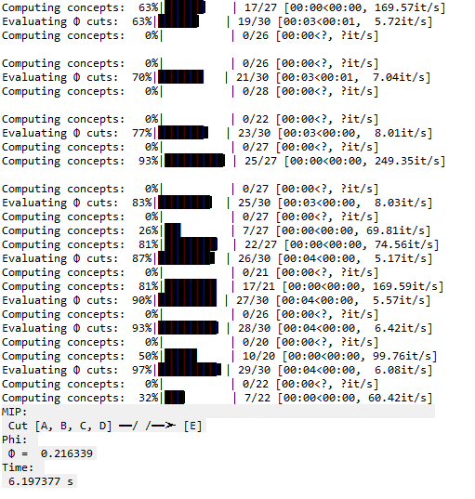

* **EMD-Bipartición-sin CM**

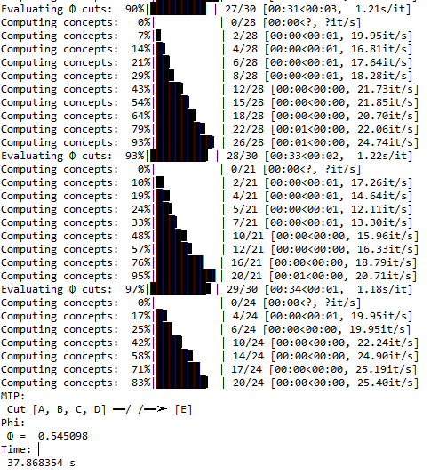

* **EMD-Tripartición-con CM**

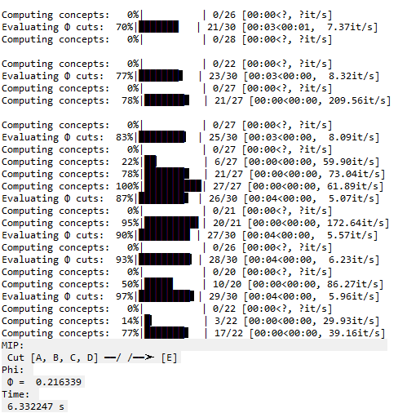

* **EMD-Tripartición-sin CM**

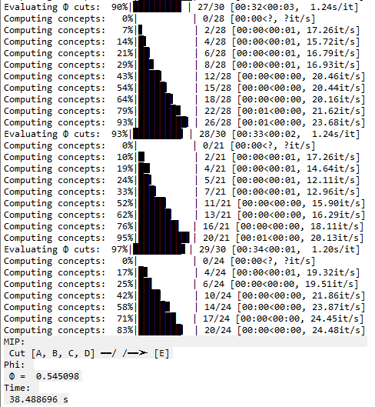

* **KLD-Bipartición-con CM**

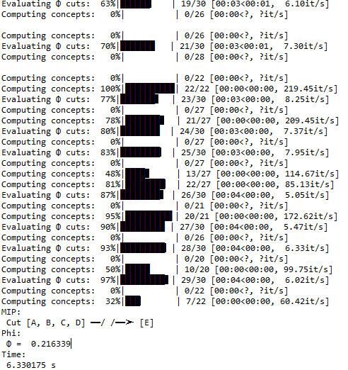

* **KLD-Bipartición-sin CM**

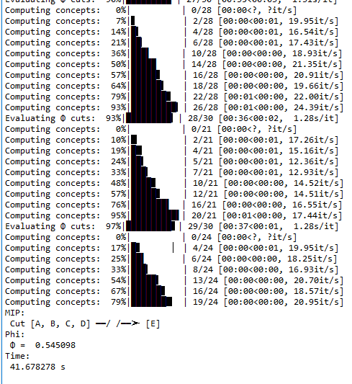

* **KLD-Tripartición-con CM**

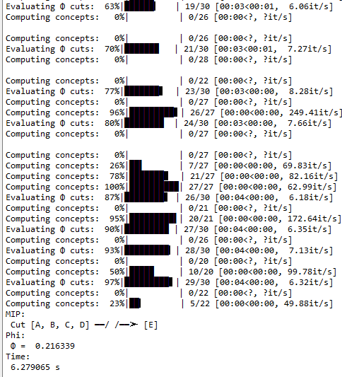

* **KLD-tripartición-sin CM**

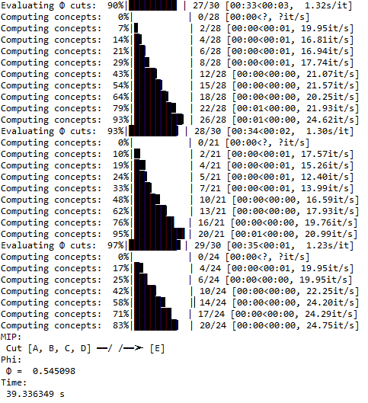

**Grafo 4**

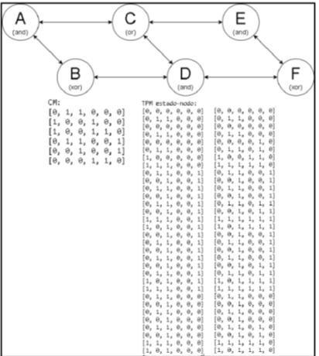

* **Estado-nodo**

|  |  |  |  |  |  |
| --- | --- | --- | --- | --- | --- |
| * Entrada de datos | Medida de distancia | Esquema de partición | Resultados con CM | Resultados sin CM | Observaciones |
| Grafo: | EMD | biparticion | MIP:  Cut [A, B, C, E, F] ━━/ /━━➤ [D]  Phi:  Φ = 0.250981  Time:  5.380019 s | MIP:  Cut [A, B, C, E, F] ━━/ /━━➤ [D]  Phi:  Φ = 0.250981  Time:  5.257774 s |  |
| EMD | tripartición | MIP:  Cut [A, B, C, E, F] ━━/ /━━➤ [D]  Phi:  Φ = 0.250981  Time:  4.995994 s | MIP:  Cut [A, B, C, E, F] ━━/ /━━➤ [D]  Phi:  Φ = 0.250981  Time:  5.316542 s |
| KLD | bipartición | MIP:  Cut [A, B, C, E, F] ━━/ /━━➤ [D]  Phi:  Φ = 0.250981  Time:  5.143403 s | MIP:  Cut [A, B, C, E, F] ━━/ /━━➤ [D]  Phi:  Φ = 0.250981  Time:  5.167946 s |  |
| KLD | tripartición | MIP:  Cut [A, B, C, E, F] ━━/ /━━➤ [D]  Phi:  Φ = 0.250981  Time:  5.128369 s | MIP:  Cut [A, B, C, E, F] ━━/ /━━➤ [D]  Phi:  Φ = 0.250981  Time:  5.14777 s |

* **EMD-Bipartición-con CM**

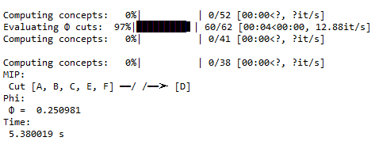

* **EMD-Bipartición-sin CM**

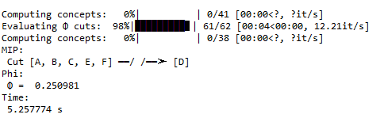

* **EMD-Tripartición-con CM**

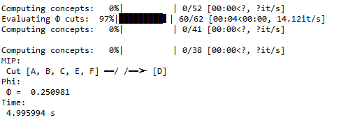

* **EMD-Tripartición-sin CM**

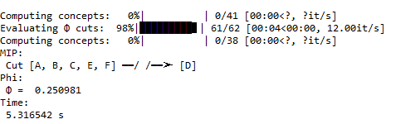

* **KLD-Bipartición-con CM**

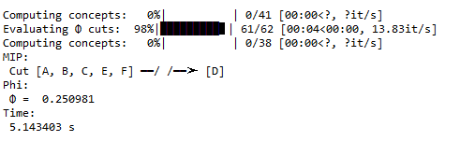

* **KLD-Bipartición-sin CM**

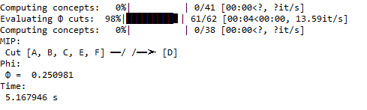

* **KLD-Tripartición-con CM**

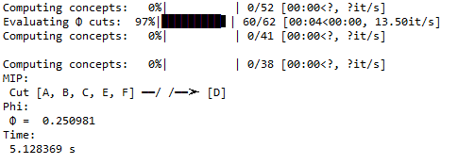

* **KLD-Tripartición-sin CM**

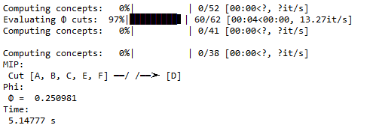

**Grafo 5**

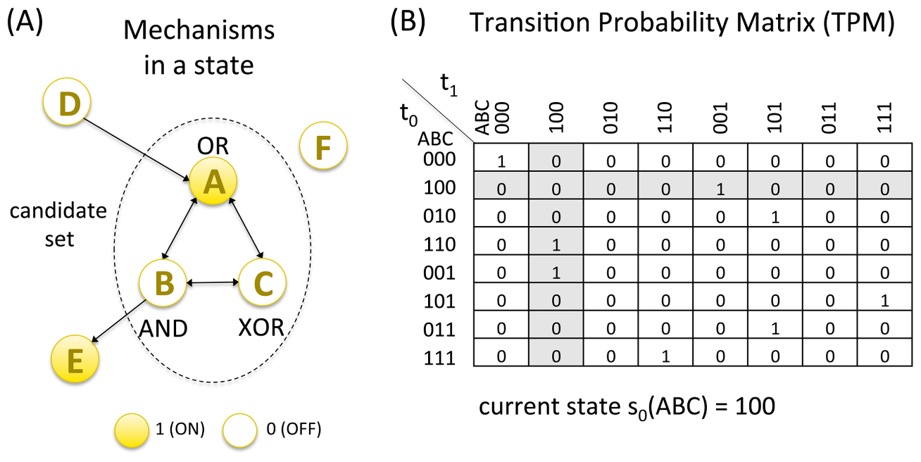

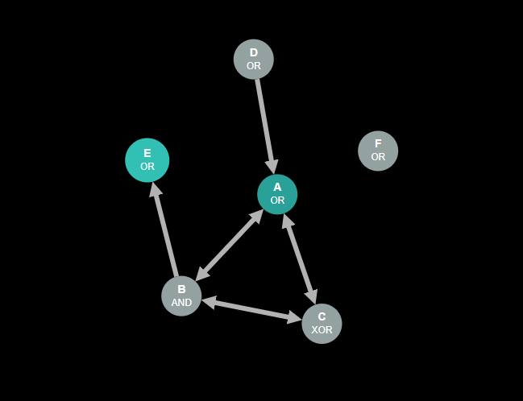

* **Estado-nodo**

|  |  |  |  |  |
| --- | --- | --- | --- | --- |
| Entrada de datos | Medida de distancia | Esquema de partición | Resultados con CM | Resultados sin CM |
| Grafo: | EMD | biparticion | MIP:  Cut [A, B] ━━/ /━━➤ [C]  Phi:  Φ = 1.916665  Time:  0.247361 s | MIP:  Cut [A, B] ━━/ /━━➤ [C]  Phi:  Φ = 1.916665  Time:  0.458124 s |
| EMD | tripartición | MIP:  Cut [A, B] ━━/ /━━➤ [C]  Phi:  Φ = 1.916665  Time:  0.300724 s | MIP:  Cut [A, B] ━━/ /━━➤ [C]  Phi:  Φ = 1.916665  Time:  0.460342 s |
| KLD | bipartición | MIP:  Cut [A, B] ━━/ /━━➤ [C]  Phi:  Φ = 1.916665  Time:  0.255092 s | MIP:  Cut [A, B] ━━/ /━━➤ [C]  Phi:  Φ = 1.916665  Time:  0.46486 s |
| KLD | tripartición | MIP:  Cut [A, B] ━━/ /━━➤ [C]  Phi:  Φ = 1.916665  Time:  0.291669 s | MIP:  Cut [A, B] ━━/ /━━➤ [C]  Phi:  Φ = 1.916665  Time:  0.438747 s |

* **EMD-bipartición-con CM**

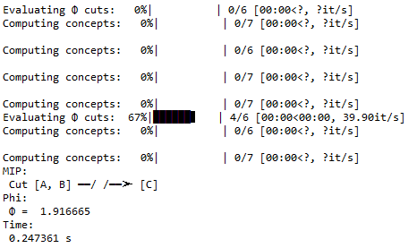

* **EMD-bipartición-sin CM**

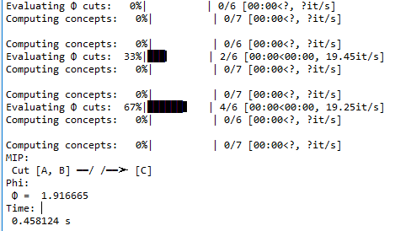

* **EMD-Tripartición-con CM**

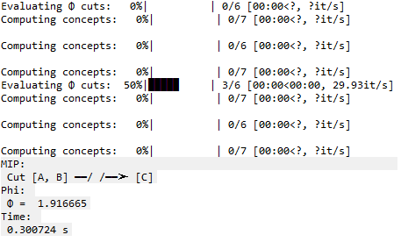

* **EMD-Tripartición-sin CM**

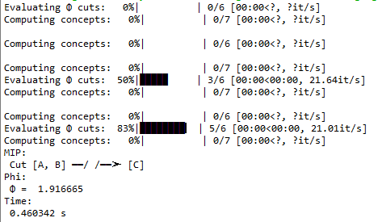

* **KLD-Bipartición-con CM**

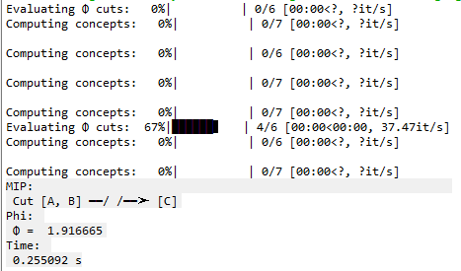

* **KLD-Bipartición-sin CM**

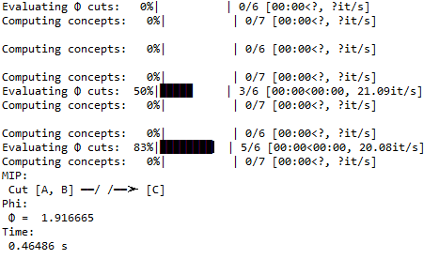

* **KLD-Tripartición-con CM**

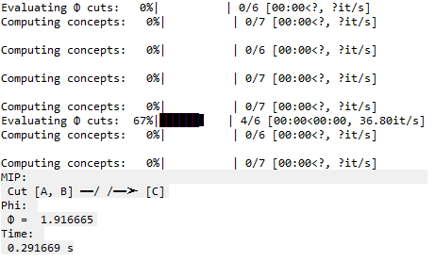

* **KLD-Tripartición-sin CM**

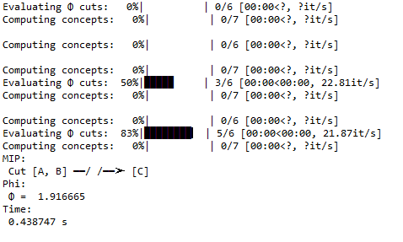

**Grafo 6**

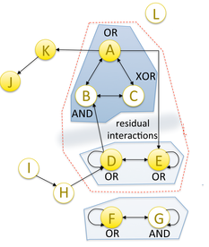

Estado inicial : (1, 0, 0, 1, 1, 1, 0)

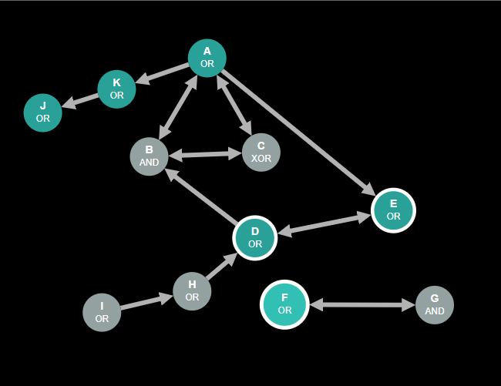

* **Estado-nodo**

|  |  |  |  |  |
| --- | --- | --- | --- | --- |
| Entrada de datos | Medida de distancia | Esquema de partición | Resultados con CM | Resultados sin CM |
| Grafo: | EMD | biparticion | MIP:  Cut [A, B] ━━/ /━━➤ [C]  Phi:  Φ = 1.916665  Time:  1.149807 s | MIP:  Cut [A, B] ━━/ /━━➤ [C]  Phi:  Φ = 1.916665  Time:  1.138073 s |
| EMD | tripartición | MIP:  Cut [A, B] ━━/ /━━➤ [C]  Phi:  Φ = 1.916665  Time:  1.088171 s | MIP:  Cut [A, B] ━━/ /━━➤ [C]  Phi:  Φ = 1.916665  Time:  1.114285 s |
| KLD | bipartición | MIP:  Cut [A, B] ━━/ /━━➤ [C]  Phi:  Φ = 1.916665  Time:  1.087204 s | IP:  Cut [A, B] ━━/ /━━➤ [C]  Phi:  Φ = 1.916665  Time:  1.08725 s |
| KLD | tripartición | MIP:  Cut [A, B] ━━/ /━━➤ [C]  Phi:  Φ = 1.916665  Time:  1.102643 s | MIP:  Cut [A, B] ━━/ /━━➤ [C]  Phi:  Φ = 1.916665  Time:  1.10255 s |

* **EMD-Bipartición-con CM**

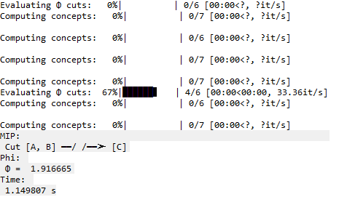

* **EMD-Bipartición-sin CM**

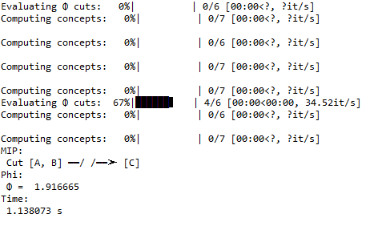

* **EMD-Tripartición-con CM**

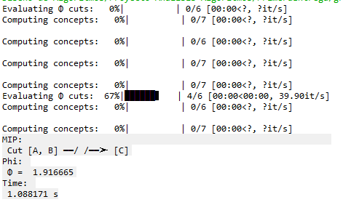

* **EMD-Tripartición-sin CM**

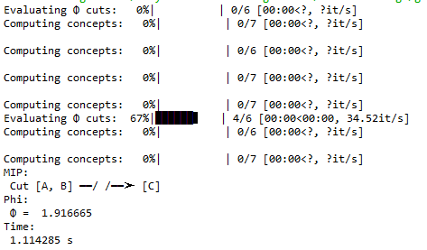

* **KLD-Bipartición-con CM**

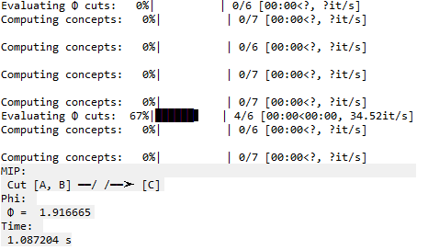

* **KLD-Bipartición-sin CM**

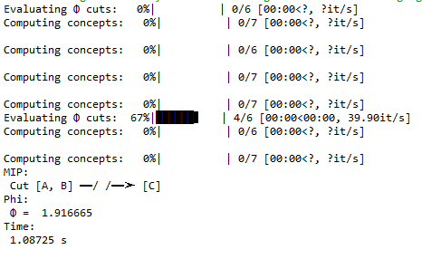

* **KLD-Tripartición-con CM**

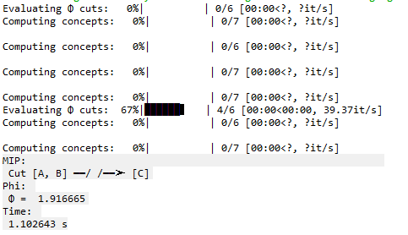

* **KLD-Tripartición-sin CM**

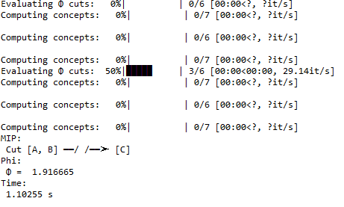

**Grafo 7**



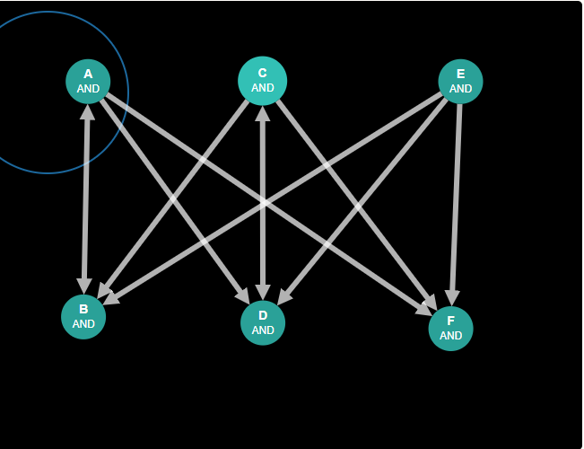

* **Estado-nodo**

|  |  |  |  |  |
| --- | --- | --- | --- | --- |
| Entrada de datos | Medida de distancia | Esquema de partición | Resultados con CM | Resultados sin CM |
| Grafo: | EMD | biparticion | MIP:  Cut [A, B] ━━/ /━━➤ [C, D]  Phi:  Φ = 0.3125  Time:  0.398937 s | MIP:  Cut [A, B] ━━/ /━━➤ [C, D]  Phi:  Φ = 0.3125  Time:  0.400629 s |
| EMD | tripartición | MIP:  Cut [A, B] ━━/ /━━➤ [C, D]  Phi:  Φ = 0.3125  Time:  0.369676 s | MIP:  Cut [A, B] ━━/ /━━➤ [C, D]  Phi:  Φ = 0.3125  Time:  0.369705 s |
| KLD | bipartición | MIP:  Cut [A, B] ━━/ /━━➤ [C, D]  Phi:  Φ = 0.3125  Time:  0.378836 s | MIP:  Cut [A, B] ━━/ /━━➤ [C, D]  Phi:  Φ = 0.3125  Time:  0.384262 s |
| KLD | tripartición | MIP:  Cut [A, B] ━━/ /━━➤ [C, D]  Phi:  Φ = 0.3125  Time:  0.365484 s | MIP:  Cut [A, B] ━━/ /━━➤ [C, D]  Phi:  Φ = 0.3125  Time:  0.413015 s |

* **EMD-Bipartición-con CM**

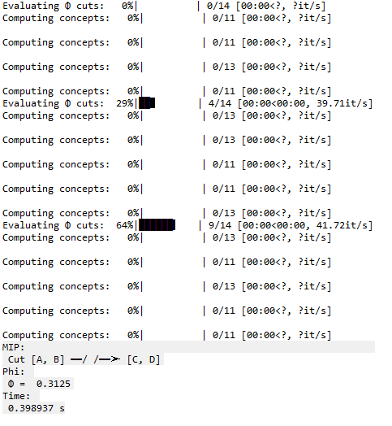

* **EMD-Bipartición-sin CM**

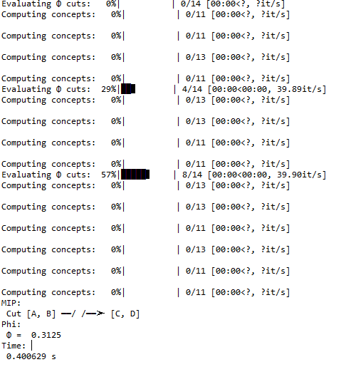

* **EMD-Tripartición-con CM**

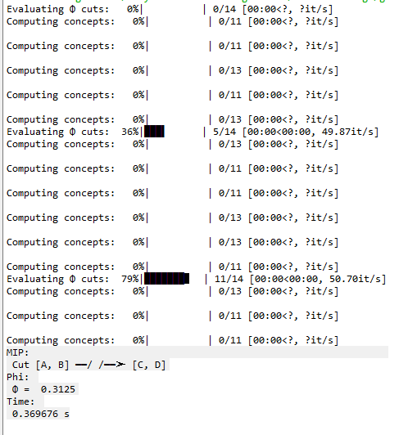

* **EMD-Tripartición-sin CM**

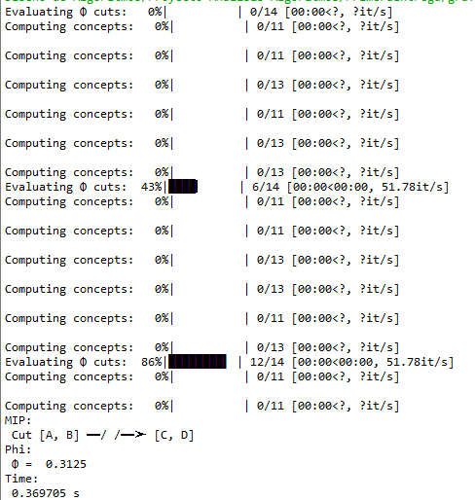

* **KLD-Bipartición-con CM**

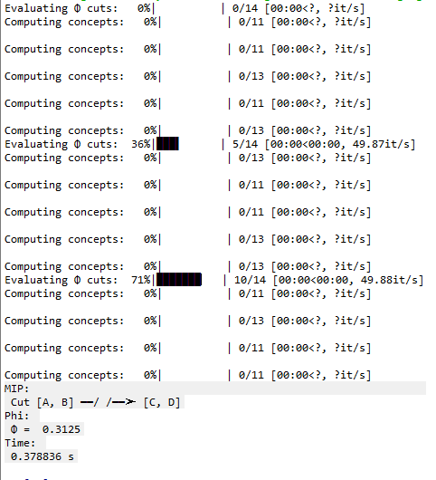

* **KLD-Bipartición-sin CM**

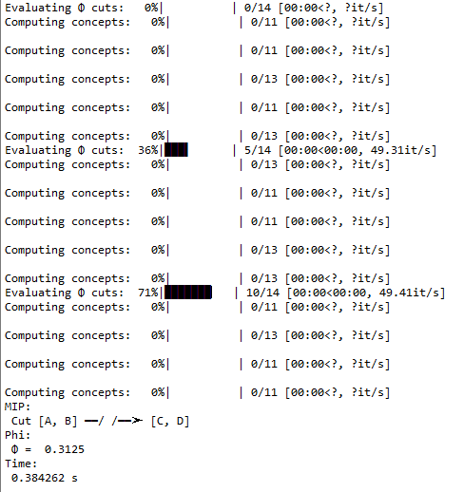

* **KLD-Tripatición-con CM**

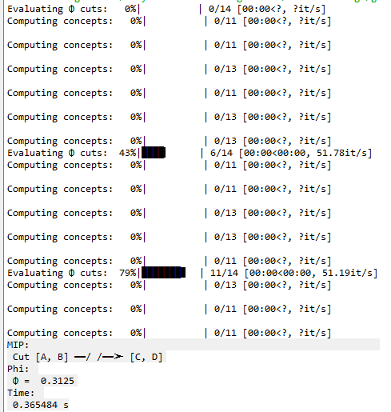

* **KLD-Tripartición-sin CM**

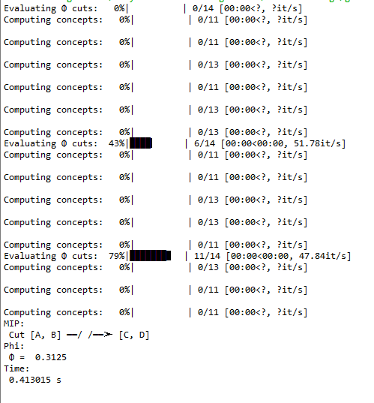

**Grafo 8**



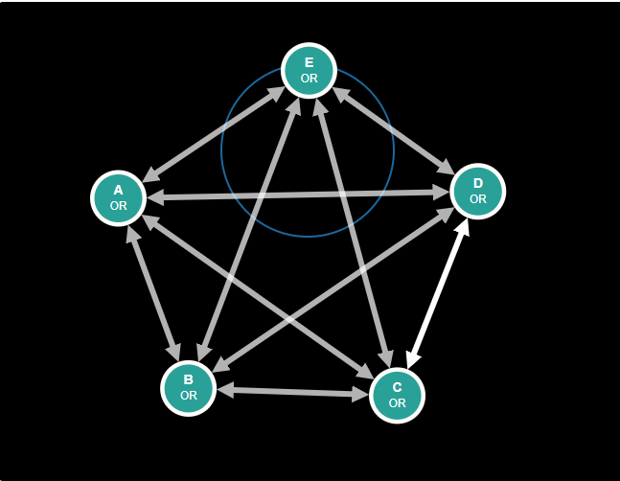

* **Estado-nodo**

|  |  |  |  |  |
| --- | --- | --- | --- | --- |
| Entrada de datos | Medida de distancia | Esquema de partición | Resultados con CM | Resultados sin CM |
| Grafo: | EMD | biparticion | MIP:  Cut [A] ━━/ /━━➤ [B, C, D, E]  Phi:  Φ = 0.003057  Time:  180.102077 s | MIP:  Cut [A] ━━/ /━━➤ [B, C, D, E]  Phi:  Φ = 0.003057  Time:  175.997137 s |
| EMD | tripartición | MIP:  Cut [A] ━━/ /━━➤ [B, C, D, E]  Phi:  Φ = 0.003057  Time:  189.102577 s | MIP:  Cut [A] ━━/ /━━➤ [B, C, D, E]  Phi:  Φ = 0.003057  Time:  178.882237 s |
| KLD | bipartición | MIP:  Cut [A] ━━/ /━━➤ [B, C, D, E]  Phi:  Φ = 0.003057  Time:  183.202997 s | MIP:  Cut [A] ━━/ /━━➤ [B, C, D, E]  Phi:  Φ = 0.003057  Time:  175.23443 s |
| KLD | tripartición | MIP:  Cut [A] ━━/ /━━➤ [B, C, D, E]  Phi:  Φ = 0.003057  Time:  179.102077 s | MIP:  Cut [A] ━━/ /━━➤ [B, C, D, E]  Phi:  Φ = 0.003057  Time:  176.00092 s |

* **Variación en el tiempo y consumo de las particiones con CM**

Computing concepts: 77%|███████▋ | 20/26 [00:04<00:01, 4.01it/s]

Computing concepts: 81%|████████ | 21/26 [00:05<00:01, 3.61it/s]

Computing concepts: 92%|█████████▏| 24/26 [00:05<00:00, 4.53it/s]

Computing concepts: 96%|█████████▌| 25/26 [00:05<00:00, 4.29it/s]

Computing concepts: 100%|██████████| 26/26 [00:05<00:00, 4.73it/s]

Evaluating Φ cuts: 23%|██▎ | 7/30 [00:43<02:21, 6.17s/it]

Computing concepts: 0%| | 0/20 [00:00<?, ?it/s]

Computing concepts: 5%|▌ | 1/20 [00:00<00:02, 6.38it/s]

Computing concepts: 10%|█ | 2/20 [00:00<00:03, 4.90it/s]

Computing concepts: 15%|█▌ | 3/20 [00:01<00:08, 2.10it/s]

Computing concepts: 20%|██ | 4/20 [00:01<00:06, 2.61it/s]

Computing concepts: 25%|██▌ | 5/20 [00:02<00:06, 2.32it/s]

Computing concepts: 35%|███▌ | 7/20 [00:02<00:04, 2.92it/s]

Computing concepts: 45%|████▌ | 9/20 [00:03<00:03, 3.03it/s]

Computing concepts: 50%|█████ | 10/20 [00:03<00:03, 3.15it/s]

Computing concepts: 55%|█████▌ | 11/20 [00:03<00:03, 2.65it/s]

Computing concepts: 60%|██████ | 12/20 [00:04<00:02, 3.24it/s]

Computing concepts: 70%|███████ | 14/20 [00:04<00:01, 3.83it/s]

Computing concepts: 75%|███████▌ | 15/20 [00:04<00:01, 3.00it/s]

Computing concepts: 90%|█████████ | 18/20 [00:05<00:00, 3.79it/s]

Computing concepts: 95%|█████████▌| 19/20 [00:05<00:00, 3.67it/s]

Computing concepts: 100%|██████████| 20/20 [00:05<00:00, 4.18it/s]

Evaluating Φ cuts: 27%|██▋ | 8/30 [00:49<02:12, 6.04s/it]

Computing concepts: 0%| | 0/26 [00:00<?, ?it/s]

Computing concepts: 4%|▍ | 1/26 [00:00<00:04, 5.36it/s]

Computing concepts: 8%|▊ | 2/26 [00:00<00:05, 4.62it/s]

Computing concepts: 12%|█▏ | 3/26 [00:00<00:05, 4.53it/s]

Computing concepts: 15%|█▌ | 4/26 [00:01<00:08, 2.63it/s]

Computing concepts: 19%|█▉ | 5/26 [00:01<00:07, 2.83it/s]

Computing concepts: 23%|██▎ | 6/26 [00:02<00:07, 2.77it/s]

Computing concepts: 31%|███ | 8/26 [00:02<00:05, 3.49it/s]

Computing concepts: 38%|███▊ | 10/26 [00:02<00:03, 4.43it/s]

Computing concepts: 42%|████▏ | 11/26 [00:02<00:03, 4.02it/s]

Computing concepts: 46%|████▌ | 12/26 [00:03<00:04, 3.46it/s]

Computing concepts: 50%|█████ | 13/26 [00:03<00:03, 3.53it/s]

Computing concepts: 54%|█████▍ | 14/26 [00:03<00:03, 3.18it/s]

Computing concepts: 58%|█████▊ | 15/26 [00:04<00:03, 3.66it/s]

Computing concepts: 62%|██████▏ | 16/26 [00:04<00:02, 4.18it/s]

Computing concepts: 69%|██████▉ | 18/26 [00:04<00:01, 4.98it/s]

Computing concepts: 73%|███████▎ | 19/26 [00:04<00:02, 3.34it/s]

Computing concepts: 77%|███████▋ | 20/26 [00:05<00:02, 2.66it/s]

Computing concepts: 88%|████████▊ | 23/26 [00:05<00:00, 3.40it/s]

Computing concepts: 92%|█████████▏| 24/26 [00:06<00:00, 3.38it/s]

Computing concepts: 96%|█████████▌| 25/26 [00:06<00:00, 3.91it/s]

Computing concepts: 100%|██████████| 26/26 [00:06<00:00, 4.45it/s]

Evaluating Φ cuts: 30%|███ | 9/30 [00:55<02:09, 6.17s/it]

Computing concepts: 0%| | 0/26 [00:00<?, ?it/s]

Computing concepts: 4%|▍ | 1/26 [00:00<00:07, 3.20it/s]

Computing concepts: 8%|▊ | 2/26 [00:00<00:07, 3.36it/s]

Computing concepts: 12%|█▏ | 3/26 [00:01<00:10, 2.27it/s]

Computing concepts: 15%|█▌ | 4/26 [00:01<00:08, 2.49it/s]

Computing concepts: 19%|█▉ | 5/26 [00:01<00:07, 2.98it/s]

Computing concepts: 23%|██▎ | 6/26 [00:01<00:05, 3.54it/s]

Computing concepts: 27%|██▋ | 7/26 [00:02<00:06, 3.11it/s]

Computing concepts: 35%|███▍ | 9/26 [00:02<00:04, 3.69it/s]

Computing concepts: 42%|████▏ | 11/26 [00:03<00:03, 4.00it/s]

Computing concepts: 46%|████▌ | 12/26 [00:03<00:03, 4.44it/s]

Computing concepts: 50%|█████ | 13/26 [00:03<00:02, 4.44it/s]

Computing concepts: 54%|█████▍ | 14/26 [00:04<00:03, 3.13it/s]

Computing concepts: 58%|█████▊ | 15/26 [00:04<00:03, 3.64it/s]

Computing concepts: 62%|██████▏ | 16/26 [00:04<00:02, 3.59it/s]

Computing concepts: 65%|██████▌ | 17/26 [00:04<00:02, 4.01it/s]

Computing concepts: 73%|███████▎ | 19/26 [00:04<00:01, 4.53it/s]

Computing concepts: 77%|███████▋ | 20/26 [00:05<00:01, 3.86it/s]

Computing concepts: 81%|████████ | 21/26 [00:05<00:01, 3.01it/s]

Computing concepts: 92%|█████████▏| 24/26 [00:06<00:00, 3.94it/s]

Computing concepts: 96%|█████████▌| 25/26 [00:06<00:00, 3.85it/s]

Computing concepts: 100%|██████████| 26/26 [00:06<00:00, 4.36it/s]

Evaluating Φ cuts: 33%|███▎ | 10/30 [01:02<02:05, 6.28s/it]

Computing concepts: 0%| | 0/26 [00:00<?, ?it/s]

Computing concepts: 4%|▍ | 1/26 [00:00<00:05, 4.28it/s]

Computing concepts: 8%|▊ | 2/26 [00:00<00:08, 2.68it/s]

Computing concepts: 12%|█▏ | 3/26 [00:01<00:07, 3.04it/s]

Computing concepts: 15%|█▌ | 4/26 [00:01<00:06, 3.62it/s]

Computing concepts: 19%|█▉ | 5/26 [00:01<00:06, 3.32it/s]

Computing concepts: 27%|██▋ | 7/26 [00:01<00:04, 4.09it/s]

Computing concepts: 35%|███▍ | 9/26 [00:02<00:03, 5.10it/s]

Computing concepts: 38%|███▊ | 10/26 [00:02<00:03, 4.51it/s]

Computing concepts: 42%|████▏ | 11/26 [00:02<00:03, 3.81it/s]

Computing concepts: 46%|████▌ | 12/26 [00:02<00:03, 4.34it/s]

Computing concepts: 50%|█████ | 13/26 [00:03<00:02, 4.47it/s]

Computing concepts: 54%|█████▍ | 14/26 [00:03<00:03, 3.74it/s]

Computing concepts: 58%|█████▊ | 15/26 [00:03<00:02, 4.24it/s]

Computing concepts: 62%|██████▏ | 16/26 [00:03<00:02, 4.04it/s]

Computing concepts: 69%|██████▉ | 18/26 [00:04<00:01, 4.86it/s]

Computing concepts: 73%|███████▎ | 19/26 [00:04<00:01, 3.86it/s]

Computing concepts: 77%|███████▋ | 20/26 [00:04<00:01, 3.45it/s]

Computing concepts: 88%|████████▊ | 23/26 [00:05<00:00, 4.45it/s]

Computing concepts: 92%|█████████▏| 24/26 [00:05<00:00, 3.89it/s]

Computing concepts: 96%|█████████▌| 25/26 [00:05<00:00, 4.12it/s]

Computing concepts: 100%|██████████| 26/26 [00:05<00:00, 4.16it/s]

Evaluating Φ cuts: 37%|███▋ | 11/30 [01:08<01:57, 6.17s/it]

Computing concepts: 0%| | 0/26 [00:00<?, ?it/s]

Computing concepts: 4%|▍ | 1/26 [00:00<00:05, 4.50it/s]

Computing concepts: 8%|▊ | 2/26 [00:00<00:05, 4.02it/s]

Computing concepts: 12%|█▏ | 3/26 [00:00<00:05, 4.36it/s]

Computing concepts: 15%|█▌ | 4/26 [00:00<00:05, 4.23it/s]

Computing concepts: 19%|█▉ | 5/26 [00:01<00:08, 2.59it/s]

Computing concepts: 23%|██▎ | 6/26 [00:01<00:06, 3.10it/s]

Computing concepts: 27%|██▋ | 7/26 [00:02<00:05, 3.59it/s]

Computing concepts: 31%|███ | 8/26 [00:02<00:06, 2.89it/s]

Computing concepts: 38%|███▊ | 10/26 [00:02<00:04, 3.60it/s]

Computing concepts: 46%|████▌ | 12/26 [00:03<00:03, 4.26it/s]

Computing concepts: 50%|█████ | 13/26 [00:03<00:03, 3.42it/s]

Computing concepts: 54%|█████▍ | 14/26 [00:03<00:03, 3.60it/s]

Computing concepts: 58%|█████▊ | 15/26 [00:04<00:03, 3.27it/s]

Computing concepts: 62%|██████▏ | 16/26 [00:04<00:03, 3.33it/s]

Computing concepts: 69%|██████▉ | 18/26 [00:04<00:02, 3.99it/s]

Computing concepts: 73%|███████▎ | 19/26 [00:05<00:02, 3.46it/s]

Computing concepts: 77%|███████▋ | 20/26 [00:05<00:02, 2.83it/s]

Computing concepts: 88%|████████▊ | 23/26 [00:05<00:00, 3.62it/s]

Computing concepts: 92%|█████████▏| 24/26 [00:06<00:00, 3.86it/s]

Computing concepts: 96%|█████████▌| 25/26 [00:06<00:00, 4.36it/s]

Computing concepts: 100%|██████████| 26/26 [00:06<00:00, 4.84it/s]

Evaluating Φ cuts: 40%|████ | 12/30 [01:14<01:52, 6.24s/it]

Computing concepts: 0%| | 0/26 [00:00<?, ?it/s]

Computing concepts: 4%|▍ | 1/26 [00:00<00:04, 5.66it/s]

Computing concepts: 8%|▊ | 2/26 [00:00<00:04, 5.16it/s]

Computing concepts: 12%|█▏ | 3/26 [00:00<00:04, 5.03it/s]

Computing concepts: 15%|█▌ | 4/26 [00:01<00:07, 2.84it/s]

Computing concepts: 19%|█▉ | 5/26 [00:01<00:06, 3.01it/s]

Computing concepts: 23%|██▎ | 6/26 [00:01<00:05, 3.53it/s]

Computing concepts: 27%|██▋ | 7/26 [00:02<00:05, 3.26it/s]

Computing concepts: 38%|███▊ | 10/26 [00:02<00:03, 4.32it/s]

Computing concepts: 42%|████▏ | 11/26 [00:02<00:03, 4.39it/s]

Computing concepts: 46%|████▌ | 12/26 [00:02<00:03, 3.84it/s]

Computing concepts: 50%|█████ | 13/26 [00:03<00:03, 3.89it/s]

Computing concepts: 54%|█████▍ | 14/26 [00:03<00:03, 3.41it/s]

Computing concepts: 58%|█████▊ | 15/26 [00:03<00:03, 3.38it/s]

Computing concepts: 62%|██████▏ | 16/26 [00:03<00:02, 3.92it/s]

Computing concepts: 69%|██████▉ | 18/26 [00:04<00:01, 4.72it/s]

Computing concepts: 73%|███████▎ | 19/26 [00:04<00:01, 3.95it/s]

Computing concepts: 77%|███████▋ | 20/26 [00:04<00:01, 3.54it/s]

Computing concepts: 88%|████████▊ | 23/26 [00:05<00:00, 4.37it/s]

Computing concepts: 92%|█████████▏| 24/26 [00:05<00:00, 4.32it/s]

Computing concepts: 96%|█████████▌| 25/26 [00:05<00:00, 4.48it/s]

Computing concepts: 100%|██████████| 26/26 [00:05<00:00, 4.92it/s]

Evaluating Φ cuts: 43%|████▎ | 13/30 [01:20<01:44, 6.13s/it]

Computing concepts: 0%| | 0/26 [00:00<?, ?it/s]

Computing concepts: 4%|▍ | 1/26 [00:00<00:07, 3.19it/s]

Computing concepts: 8%|▊ | 2/26 [00:00<00:06, 3.74it/s]

Computing concepts: 12%|█▏ | 3/26 [00:00<00:06, 3.74it/s]

Computing concepts: 15%|█▌ | 4/26 [00:01<00:08, 2.46it/s]

Computing concepts: 19%|█▉ | 5/26 [00:01<00:07, 2.64it/s]

Computing concepts: 23%|██▎ | 6/26 [00:01<00:06, 3.16it/s]

Computing concepts: 27%|██▋ | 7/26 [00:02<00:06, 2.89it/s]

Computing concepts: 35%|███▍ | 9/26 [00:02<00:04, 3.57it/s]

Computing concepts: 42%|████▏ | 11/26 [00:02<00:03, 4.12it/s]

Computing concepts: 46%|████▌ | 12/26 [00:03<00:03, 3.58it/s]

Computing concepts: 50%|█████ | 13/26 [00:03<00:03, 3.92it/s]

Computing concepts: 54%|█████▍ | 14/26 [00:03<00:03, 3.37it/s]

Computing concepts: 58%|█████▊ | 15/26 [00:04<00:03, 3.53it/s]

Computing concepts: 62%|██████▏ | 16/26 [00:04<00:02, 4.06it/s]

Computing concepts: 69%|██████▉ | 18/26 [00:04<00:01, 4.68it/s]

Computing concepts: 73%|███████▎ | 19/26 [00:04<00:01, 3.95it/s]

Computing concepts: 77%|███████▋ | 20/26 [00:05<00:01, 3.62it/s]

Computing concepts: 88%|████████▊ | 23/26 [00:05<00:00, 4.64it/s]

Computing concepts: 92%|█████████▏| 24/26 [00:05<00:00, 4.62it/s]

Computing concepts: 96%|█████████▌| 25/26 [00:05<00:00, 5.06it/s]

Computing concepts: 100%|██████████| 26/26 [00:06<00:00, 5.41it/s]

Evaluating Φ cuts: 47%|████▋ | 14/30 [01:26<01:37, 6.11s/it]

Computing concepts: 0%| | 0/20 [00:00<?, ?it/s]

Computing concepts: 5%|▌ | 1/20 [00:00<00:10, 1.75it/s]

Computing concepts: 10%|█ | 2/20 [00:00<00:08, 2.23it/s]

Computing concepts: 15%|█▌ | 3/20 [00:01<00:06, 2.48it/s]

Computing concepts: 30%|███ | 6/20 [00:01<00:04, 3.35it/s]

Computing concepts: 35%|███▌ | 7/20 [00:01<00:03, 3.78it/s]

Computing concepts: 40%|████ | 8/20 [00:01<00:02, 4.38it/s]

Computing concepts: 45%|████▌ | 9/20 [00:01<00:02, 4.02it/s]

Computing concepts: 50%|█████ | 10/20 [00:01<00:02, 4.39it/s]

Computing concepts: 60%|██████ | 12/20 [00:02<00:01, 5.38it/s]

Computing concepts: 65%|██████▌ | 13/20 [00:02<00:01, 4.60it/s]

Computing concepts: 70%|███████ | 14/20 [00:02<00:01, 4.20it/s]

Computing concepts: 85%|████████▌ | 17/20 [00:02<00:00, 5.41it/s]

Computing concepts: 90%|█████████ | 18/20 [00:03<00:00, 5.45it/s]

Computing concepts: 95%|█████████▌| 19/20 [00:03<00:00, 5.76it/s]

Computing concepts: 100%|██████████| 20/20 [00:03<00:00, 6.10it/s]

Evaluating Φ cuts: 50%|█████ | 15/30 [01:29<01:19, 5.31s/it]

Computing concepts: 0%| | 0/20 [00:00<?, ?it/s]

Computing concepts: 5%|▌ | 1/20 [00:01<00:21, 1.12s/it]

Computing concepts: 10%|█ | 2/20 [00:01<00:15, 1.14it/s]

Computing concepts: 15%|█▌ | 3/20 [00:01<00:13, 1.30it/s]

Computing concepts: 30%|███ | 6/20 [00:02<00:07, 1.80it/s]

Computing concepts: 35%|███▌ | 7/20 [00:02<00:06, 2.10it/s]

Computing concepts: 40%|████ | 8/20 [00:02<00:04, 2.62it/s]

Computing concepts: 45%|████▌ | 9/20 [00:03<00:04, 2.34it/s]

Computing concepts: 50%|█████ | 10/20 [00:03<00:03, 2.61it/s]

Computing concepts: 60%|██████ | 12/20 [00:03<00:02, 3.21it/s]

Computing concepts: 65%|██████▌ | 13/20 [00:04<00:02, 2.66it/s]

Computing concepts: 70%|███████ | 14/20 [00:04<00:02, 2.39it/s]

Computing concepts: 85%|████████▌ | 17/20 [00:05<00:00, 3.09it/s]

Computing concepts: 90%|█████████ | 18/20 [00:05<00:00, 3.20it/s]

Computing concepts: 95%|█████████▌| 19/20 [00:05<00:00, 3.75it/s]

Computing concepts: 100%|██████████| 20/20 [00:05<00:00, 4.26it/s]

Evaluating Φ cuts: 53%|█████▎ | 16/30 [01:35<01:15, 5.42s/it]

Computing concepts: 0%| | 0/26 [00:00<?, ?it/s]

Computing concepts: 4%|▍ | 1/26 [00:00<00:07, 3.33it/s]

Computing concepts: 8%|▊ | 2/26 [00:00<00:06, 3.88it/s]

Computing concepts: 12%|█▏ | 3/26 [00:00<00:06, 3.60it/s]

Computing concepts: 15%|█▌ | 4/26 [00:01<00:09, 2.42it/s]

Computing concepts: 19%|█▉ | 5/26 [00:01<00:07, 2.80it/s]

Computing concepts: 23%|██▎ | 6/26 [00:01<00:05, 3.34it/s]

Computing concepts: 27%|██▋ | 7/26 [00:02<00:06, 3.12it/s]

Computing concepts: 35%|███▍ | 9/26 [00:02<00:04, 3.73it/s]

Computing concepts: 42%|████▏ | 11/26 [00:02<00:03, 4.51it/s]

Computing concepts: 46%|████▌ | 12/26 [00:03<00:04, 3.18it/s]

Computing concepts: 50%|█████ | 13/26 [00:03<00:03, 3.69it/s]

Computing concepts: 54%|█████▍ | 14/26 [00:03<00:03, 3.27it/s]

Computing concepts: 58%|█████▊ | 15/26 [00:04<00:03, 3.31it/s]

Computing concepts: 62%|██████▏ | 16/26 [00:04<00:02, 3.84it/s]

Computing concepts: 69%|██████▉ | 18/26 [00:04<00:01, 4.57it/s]

Computing concepts: 73%|███████▎ | 19/26 [00:05<00:02, 3.19it/s]

Computing concepts: 77%|███████▋ | 20/26 [00:05<00:01, 3.02it/s]

Computing concepts: 88%|████████▊ | 23/26 [00:05<00:00, 3.82it/s]

Computing concepts: 92%|█████████▏| 24/26 [00:06<00:00, 3.71it/s]

Computing concepts: 96%|█████████▌| 25/26 [00:06<00:00, 4.19it/s]

Computing concepts: 100%|██████████| 26/26 [00:06<00:00, 4.54it/s]

Evaluating Φ cuts: 57%|█████▋ | 17/30 [01:42<01:14, 5.74s/it]

Computing concepts: 0%| | 0/26 [00:00<?, ?it/s]

Computing concepts: 4%|▍ | 1/26 [00:00<00:04, 5.91it/s]

Computing concepts: 8%|▊ | 2/26 [00:00<00:05, 4.75it/s]

Computing concepts: 12%|█▏ | 3/26 [00:00<00:05, 4.25it/s]

Computing concepts: 15%|█▌ | 4/26 [00:01<00:08, 2.57it/s]

Computing concepts: 19%|█▉ | 5/26 [00:01<00:07, 2.91it/s]

Computing concepts: 23%|██▎ | 6/26 [00:01<00:05, 3.44it/s]

Computing concepts: 27%|██▋ | 7/26 [00:02<00:06, 3.10it/s]

Computing concepts: 38%|███▊ | 10/26 [00:02<00:03, 4.12it/s]

Computing concepts: 42%|████▏ | 11/26 [00:02<00:03, 3.89it/s]

Computing concepts: 46%|████▌ | 12/26 [00:03<00:04, 2.95it/s]

Computing concepts: 50%|█████ | 13/26 [00:03<00:04, 3.10it/s]

Computing concepts: 54%|█████▍ | 14/26 [00:04<00:04, 2.63it/s]

Computing concepts: 58%|█████▊ | 15/26 [00:04<00:03, 3.01it/s]

Computing concepts: 62%|██████▏ | 16/26 [00:04<00:02, 3.52it/s]

Computing concepts: 69%|██████▉ | 18/26 [00:04<00:01, 4.13it/s]

Computing concepts: 73%|███████▎ | 19/26 [00:05<00:01, 3.53it/s]

Computing concepts: 77%|███████▋ | 20/26 [00:05<00:01, 3.12it/s]

Computing concepts: 88%|████████▊ | 23/26 [00:05<00:00, 4.07it/s]

Computing concepts: 92%|█████████▏| 24/26 [00:06<00:00, 3.95it/s]

Computing concepts: 96%|█████████▌| 25/26 [00:06<00:00, 4.29it/s]

Computing concepts: 100%|██████████| 26/26 [00:06<00:00, 4.66it/s]

Evaluating Φ cuts: 60%|██████ | 18/30 [01:48<01:11, 5.96s/it]

Computing concepts: 0%| | 0/26 [00:00<?, ?it/s]

Computing concepts: 4%|▍ | 1/26 [00:00<00:04, 5.83it/s]

Computing concepts: 8%|▊ | 2/26 [00:00<00:04, 5.25it/s]

Computing concepts: 12%|█▏ | 3/26 [00:00<00:04, 5.56it/s]

Computing concepts: 15%|█▌ | 4/26 [00:00<00:04, 5.16it/s]

Computing concepts: 19%|█▉ | 5/26 [00:01<00:07, 2.89it/s]

Computing concepts: 23%|██▎ | 6/26 [00:01<00:05, 3.46it/s]

Computing concepts: 27%|██▋ | 7/26 [00:01<00:04, 4.00it/s]

Computing concepts: 31%|███ | 8/26 [00:02<00:05, 3.54it/s]

Computing concepts: 38%|███▊ | 10/26 [00:02<00:03, 4.16it/s]

Computing concepts: 46%|████▌ | 12/26 [00:02<00:02, 5.04it/s]

Computing concepts: 50%|█████ | 13/26 [00:03<00:03, 4.05it/s]

Computing concepts: 54%|█████▍ | 14/26 [00:03<00:03, 3.93it/s]

Computing concepts: 58%|█████▊ | 15/26 [00:03<00:03, 3.50it/s]

Computing concepts: 62%|██████▏ | 16/26 [00:03<00:02, 3.78it/s]

Computing concepts: 69%|██████▉ | 18/26 [00:04<00:01, 4.69it/s]

Computing concepts: 73%|███████▎ | 19/26 [00:04<00:01, 3.88it/s]

Computing concepts: 77%|███████▋ | 20/26 [00:04<00:01, 3.57it/s]

Computing concepts: 88%|████████▊ | 23/26 [00:04<00:00, 4.63it/s]

Computing concepts: 92%|█████████▏| 24/26 [00:05<00:00, 4.27it/s]

Computing concepts: 96%|█████████▌| 25/26 [00:05<00:00, 4.45it/s]

Computing concepts: 100%|██████████| 26/26 [00:05<00:00, 4.87it/s]

Evaluating Φ cuts: 63%|██████▎ | 19/30 [01:54<01:04, 5.86s/it]

Computing concepts: 0%| | 0/26 [00:00<?, ?it/s]

Computing concepts: 4%|▍ | 1/26 [00:00<00:07, 3.16it/s]

Computing concepts: 8%|▊ | 2/26 [00:01<00:11, 2.14it/s]

Computing concepts: 12%|█▏ | 3/26 [00:01<00:09, 2.42it/s]

Computing concepts: 15%|█▌ | 4/26 [00:01<00:07, 2.94it/s]

Computing concepts: 19%|█▉ | 5/26 [00:02<00:08, 2.47it/s]

Computing concepts: 27%|██▋ | 7/26 [00:02<00:06, 3.05it/s]

Computing concepts: 35%|███▍ | 9/26 [00:02<00:04, 3.91it/s]

Computing concepts: 38%|███▊ | 10/26 [00:02<00:04, 3.92it/s]

Computing concepts: 42%|████▏ | 11/26 [00:03<00:05, 2.94it/s]

Computing concepts: 46%|████▌ | 12/26 [00:03<00:04, 3.47it/s]

Computing concepts: 50%|█████ | 13/26 [00:03<00:03, 3.47it/s]

Computing concepts: 54%|█████▍ | 14/26 [00:04<00:03, 3.10it/s]

Computing concepts: 58%|█████▊ | 15/26 [00:04<00:02, 3.67it/s]

Computing concepts: 62%|██████▏ | 16/26 [00:04<00:02, 3.75it/s]

Computing concepts: 69%|██████▉ | 18/26 [00:04<00:01, 4.32it/s]

Computing concepts: 73%|███████▎ | 19/26 [00:05<00:01, 3.59it/s]

Computing concepts: 77%|███████▋ | 20/26 [00:05<00:01, 3.12it/s]

Computing concepts: 88%|████████▊ | 23/26 [00:06<00:00, 3.95it/s]

Computing concepts: 92%|█████████▏| 24/26 [00:06<00:00, 4.16it/s]

Computing concepts: 96%|█████████▌| 25/26 [00:06<00:00, 4.55it/s]

Computing concepts: 100%|██████████| 26/26 [00:06<00:00, 4.90it/s]

Evaluating Φ cuts: 67%|██████▋ | 20/30 [02:00<01:01, 6.10s/it]

Computing concepts: 0%| | 0/26 [00:00<?, ?it/s]

Computing concepts: 4%|▍ | 1/26 [00:00<00:05, 4.36it/s]

Computing concepts: 8%|▊ | 2/26 [00:00<00:06, 3.99it/s]

Computing concepts: 12%|█▏ | 3/26 [00:01<00:08, 2.61it/s]

Computing concepts: 15%|█▌ | 4/26 [00:01<00:07, 3.01it/s]

Computing concepts: 19%|█▉ | 5/26 [00:01<00:05, 3.58it/s]

Computing concepts: 23%|██▎ | 6/26 [00:01<00:04, 4.06it/s]

Computing concepts: 27%|██▋ | 7/26 [00:02<00:05, 3.58it/s]

Computing concepts: 35%|███▍ | 9/26 [00:02<00:03, 4.43it/s]

Computing concepts: 42%|████▏ | 11/26 [00:02<00:03, 4.67it/s]

Computing concepts: 46%|████▌ | 12/26 [00:02<00:02, 5.02it/s]

Computing concepts: 50%|█████ | 13/26 [00:03<00:02, 4.48it/s]

Computing concepts: 54%|█████▍ | 14/26 [00:03<00:03, 3.67it/s]

Computing concepts: 58%|█████▊ | 15/26 [00:03<00:02, 4.18it/s]

Computing concepts: 62%|██████▏ | 16/26 [00:03<00:02, 4.14it/s]

Computing concepts: 65%|██████▌ | 17/26 [00:04<00:01, 4.56it/s]

Computing concepts: 73%|███████▎ | 19/26 [00:04<00:01, 5.35it/s]

Computing concepts: 77%|███████▋ | 20/26 [00:04<00:01, 4.00it/s]

Computing concepts: 81%|████████ | 21/26 [00:05<00:01, 3.42it/s]

Computing concepts: 92%|█████████▏| 24/26 [00:05<00:00, 4.26it/s]

Computing concepts: 96%|█████████▌| 25/26 [00:05<00:00, 4.30it/s]

Computing concepts: 100%|██████████| 26/26 [00:05<00:00, 4.73it/s]

Evaluating Φ cuts: 70%|███████ | 21/30 [02:06<00:54, 6.03s/it]

Computing concepts: 0%| | 0/26 [00:00<?, ?it/s]

Computing concepts: 4%|▍ | 1/26 [00:00<00:04, 6.23it/s]

Computing concepts: 8%|▊ | 2/26 [00:00<00:04, 5.30it/s]

Computing concepts: 12%|█▏ | 3/26 [00:00<00:05, 4.16it/s]

Computing concepts: 15%|█▌ | 4/26 [00:01<00:08, 2.60it/s]

Computing concepts: 19%|█▉ | 5/26 [00:01<00:07, 2.94it/s]

Computing concepts: 23%|██▎ | 6/26 [00:02<00:07, 2.76it/s]

Computing concepts: 31%|███ | 8/26 [00:02<00:05, 3.39it/s]

Computing concepts: 38%|███▊ | 10/26 [00:02<00:03, 4.33it/s]

Computing concepts: 42%|████▏ | 11/26 [00:02<00:03, 4.28it/s]

Computing concepts: 46%|████▌ | 12/26 [00:03<00:03, 3.59it/s]

Computing concepts: 50%|█████ | 13/26 [00:03<00:03, 3.88it/s]

Computing concepts: 54%|█████▍ | 14/26 [00:03<00:03, 3.37it/s]

Computing concepts: 58%|█████▊ | 15/26 [00:03<00:02, 4.00it/s]

Computing concepts: 62%|██████▏ | 16/26 [00:04<00:02, 4.43it/s]

Computing concepts: 69%|██████▉ | 18/26 [00:04<00:01, 5.01it/s]

Computing concepts: 73%|███████▎ | 19/26 [00:04<00:01, 4.00it/s]

Computing concepts: 77%|███████▋ | 20/26 [00:05<00:01, 3.36it/s]

Computing concepts: 88%|████████▊ | 23/26 [00:05<00:00, 4.34it/s]

Computing concepts: 92%|█████████▏| 24/26 [00:05<00:00, 4.37it/s]

Computing concepts: 96%|█████████▌| 25/26 [00:05<00:00, 4.75it/s]

Computing concepts: 100%|██████████| 26/26 [00:05<00:00, 5.09it/s]

Evaluating Φ cuts: 73%|███████▎ | 22/30 [02:12<00:48, 6.02s/it]

Computing concepts: 0%| | 0/20 [00:00<?, ?it/s]

Computing concepts: 5%|▌ | 1/20 [00:00<00:02, 6.64it/s]

Computing concepts: 10%|█ | 2/20 [00:00<00:02, 6.24it/s]

Computing concepts: 15%|█▌ | 3/20 [00:00<00:04, 3.47it/s]

Computing concepts: 20%|██ | 4/20 [00:01<00:03, 4.10it/s]

Computing concepts: 25%|██▌ | 5/20 [00:01<00:03, 3.87it/s]

Computing concepts: 35%|███▌ | 7/20 [00:01<00:02, 4.77it/s]

Computing concepts: 45%|████▌ | 9/20 [00:01<00:02, 5.23it/s]

Computing concepts: 50%|█████ | 10/20 [00:02<00:01, 5.30it/s]

Computing concepts: 55%|█████▌ | 11/20 [00:02<00:02, 4.49it/s]

Computing concepts: 60%|██████ | 12/20 [00:02<00:01, 5.11it/s]

Computing concepts: 70%|███████ | 14/20 [00:02<00:00, 6.03it/s]

Computing concepts: 75%|███████▌ | 15/20 [00:02<00:01, 4.73it/s]

Computing concepts: 90%|█████████ | 18/20 [00:03<00:00, 5.90it/s]

Computing concepts: 95%|█████████▌| 19/20 [00:03<00:00, 5.90it/s]

Computing concepts: 100%|██████████| 20/20 [00:03<00:00, 6.08it/s]

Evaluating Φ cuts: 77%|███████▋ | 23/30 [02:16<00:36, 5.28s/it]

Computing concepts: 0%| | 0/26 [00:00<?, ?it/s]

Computing concepts: 4%|▍ | 1/26 [00:00<00:04, 5.54it/s]

Computing concepts: 8%|▊ | 2/26 [00:00<00:05, 4.52it/s]

Computing concepts: 12%|█▏ | 3/26 [00:01<00:10, 2.24it/s]

Computing concepts: 15%|█▌ | 4/26 [00:01<00:08, 2.49it/s]

Computing concepts: 19%|█▉ | 5/26 [00:01<00:06, 3.00it/s]

Computing concepts: 23%|██▎ | 6/26 [00:02<00:07, 2.71it/s]

Computing concepts: 31%|███ | 8/26 [00:02<00:05, 3.30it/s]

Computing concepts: 38%|███▊ | 10/26 [00:02<00:03, 4.20it/s]

Computing concepts: 42%|████▏ | 11/26 [00:03<00:03, 3.94it/s]

Computing concepts: 46%|████▌ | 12/26 [00:03<00:04, 2.94it/s]

Computing concepts: 50%|█████ | 13/26 [00:03<00:03, 3.45it/s]

Computing concepts: 54%|█████▍ | 14/26 [00:04<00:03, 3.43it/s]

Computing concepts: 58%|█████▊ | 15/26 [00:04<00:03, 2.84it/s]

Computing concepts: 62%|██████▏ | 16/26 [00:04<00:02, 3.37it/s]

Computing concepts: 65%|██████▌ | 17/26 [00:05<00:02, 3.42it/s]

Computing concepts: 73%|███████▎ | 19/26 [00:05<00:01, 4.13it/s]

Computing concepts: 77%|███████▋ | 20/26 [00:05<00:01, 3.29it/s]

Computing concepts: 81%|████████ | 21/26 [00:06<00:01, 2.67it/s]

Computing concepts: 92%|█████████▏| 24/26 [00:06<00:00, 3.47it/s]

Computing concepts: 96%|█████████▌| 25/26 [00:06<00:00, 3.59it/s]

Computing concepts: 100%|██████████| 26/26 [00:07<00:00, 4.04it/s]

Evaluating Φ cuts: 80%|████████ | 24/30 [02:23<00:34, 5.82s/it]

Computing concepts: 0%| | 0/26 [00:00<?, ?it/s]

Computing concepts: 4%|▍ | 1/26 [00:00<00:04, 5.36it/s]

Computing concepts: 8%|▊ | 2/26 [00:00<00:05, 4.48it/s]

Computing concepts: 12%|█▏ | 3/26 [00:00<00:04, 4.87it/s]

Computing concepts: 15%|█▌ | 4/26 [00:00<00:04, 4.89it/s]

Computing concepts: 19%|█▉ | 5/26 [00:01<00:07, 2.83it/s]

Computing concepts: 23%|██▎ | 6/26 [00:01<00:06, 3.09it/s]

Computing concepts: 27%|██▋ | 7/26 [00:02<00:06, 2.94it/s]

Computing concepts: 35%|███▍ | 9/26 [00:02<00:04, 3.58it/s]

Computing concepts: 42%|████▏ | 11/26 [00:02<00:03, 4.34it/s]

Computing concepts: 46%|████▌ | 12/26 [00:03<00:04, 3.50it/s]

Computing concepts: 50%|█████ | 13/26 [00:03<00:03, 3.72it/s]

Computing concepts: 54%|█████▍ | 14/26 [00:03<00:03, 3.68it/s]

Computing concepts: 58%|█████▊ | 15/26 [00:04<00:03, 3.27it/s]

Computing concepts: 62%|██████▏ | 16/26 [00:04<00:02, 3.80it/s]

Computing concepts: 65%|██████▌ | 17/26 [00:04<00:02, 3.54it/s]

Computing concepts: 69%|██████▉ | 18/26 [00:04<00:01, 4.05it/s]

Computing concepts: 77%|███████▋ | 20/26 [00:05<00:01, 4.15it/s]

Computing concepts: 81%|████████ | 21/26 [00:05<00:01, 3.64it/s]

Computing concepts: 92%|█████████▏| 24/26 [00:05<00:00, 4.48it/s]

Computing concepts: 96%|█████████▌| 25/26 [00:06<00:00, 4.20it/s]

Computing concepts: 100%|██████████| 26/26 [00:06<00:00, 4.52it/s]

Evaluating Φ cuts: 83%|████████▎ | 25/30 [02:29<00:29, 5.96s/it]

Computing concepts: 0%| | 0/26 [00:00<?, ?it/s]

Computing concepts: 4%|▍ | 1/26 [00:00<00:08, 2.86it/s]

Computing concepts: 8%|▊ | 2/26 [00:00<00:07, 3.14it/s]

Computing concepts: 12%|█▏ | 3/26 [00:01<00:10, 2.23it/s]

Computing concepts: 15%|█▌ | 4/26 [00:01<00:08, 2.50it/s]

Computing concepts: 19%|█▉ | 5/26 [00:01<00:06, 3.04it/s]

Computing concepts: 23%|██▎ | 6/26 [00:01<00:05, 3.61it/s]

Computing concepts: 27%|██▋ | 7/26 [00:02<00:05, 3.25it/s]

Computing concepts: 35%|███▍ | 9/26 [00:02<00:04, 3.85it/s]

Computing concepts: 42%|████▏ | 11/26 [00:02<00:03, 4.81it/s]

Computing concepts: 46%|████▌ | 12/26 [00:03<00:03, 4.40it/s]

Computing concepts: 50%|█████ | 13/26 [00:03<00:03, 3.65it/s]

Computing concepts: 54%|█████▍ | 14/26 [00:03<00:03, 3.91it/s]

Computing concepts: 58%|█████▊ | 15/26 [00:04<00:03, 3.26it/s]

Computing concepts: 62%|██████▏ | 16/26 [00:04<00:02, 3.81it/s]

Computing concepts: 65%|██████▌ | 17/26 [00:04<00:02, 4.04it/s]

Computing concepts: 69%|██████▉ | 18/26 [00:04<00:01, 4.45it/s]

Computing concepts: 77%|███████▋ | 20/26 [00:04<00:01, 5.16it/s]

Computing concepts: 81%|████████ | 21/26 [00:05<00:01, 4.16it/s]

Computing concepts: 85%|████████▍ | 22/26 [00:05<00:01, 3.52it/s]

Computing concepts: 96%|█████████▌| 25/26 [00:05<00:00, 4.49it/s]

Computing concepts: 100%|██████████| 26/26 [00:06<00:00, 4.88it/s]

Evaluating Φ cuts: 87%|████████▋ | 26/30 [02:35<00:23, 6.00s/it]

Computing concepts: 0%| | 0/20 [00:00<?, ?it/s]

Computing concepts: 5%|▌ | 1/20 [00:00<00:03, 4.94it/s]

Computing concepts: 10%|█ | 2/20 [00:00<00:03, 5.37it/s]

Computing concepts: 15%|█▌ | 3/20 [00:01<00:06, 2.81it/s]

Computing concepts: 20%|██ | 4/20 [00:01<00:04, 3.38it/s]

Computing concepts: 30%|███ | 6/20 [00:01<00:03, 4.20it/s]

Computing concepts: 40%|████ | 8/20 [00:01<00:02, 5.06it/s]

Computing concepts: 45%|████▌ | 9/20 [00:02<00:02, 4.18it/s]

Computing concepts: 50%|█████ | 10/20 [00:02<00:02, 4.31it/s]

Computing concepts: 55%|█████▌ | 11/20 [00:02<00:03, 2.97it/s]

Computing concepts: 60%|██████ | 12/20 [00:02<00:02, 3.57it/s]

Computing concepts: 65%|██████▌ | 13/20 [00:03<00:01, 3.98it/s]

Computing concepts: 75%|███████▌ | 15/20 [00:03<00:01, 4.53it/s]

Computing concepts: 80%|████████ | 16/20 [00:03<00:00, 4.20it/s]

Computing concepts: 95%|█████████▌| 19/20 [00:03<00:00, 5.29it/s]

Computing concepts: 100%|██████████| 20/20 [00:04<00:00, 5.52it/s]

Evaluating Φ cuts: 90%|█████████ | 27/30 [02:39<00:16, 5.45s/it]

Computing concepts: 0%| | 0/26 [00:00<?, ?it/s]

Computing concepts: 4%|▍ | 1/26 [00:00<00:04, 5.42it/s]

Computing concepts: 8%|▊ | 2/26 [00:00<00:05, 4.46it/s]

Computing concepts: 12%|█▏ | 3/26 [00:00<00:05, 4.12it/s]

Computing concepts: 15%|█▌ | 4/26 [00:01<00:09, 2.44it/s]

Computing concepts: 19%|█▉ | 5/26 [00:01<00:07, 2.68it/s]

Computing concepts: 23%|██▎ | 6/26 [00:02<00:06, 3.16it/s]

Computing concepts: 27%|██▋ | 7/26 [00:02<00:05, 3.64it/s]

Computing concepts: 31%|███ | 8/26 [00:02<00:05, 3.13it/s]

Computing concepts: 38%|███▊ | 10/26 [00:02<00:04, 3.87it/s]

Computing concepts: 46%|████▌ | 12/26 [00:03<00:02, 4.87it/s]

Computing concepts: 50%|█████ | 13/26 [00:03<00:02, 4.55it/s]

Computing concepts: 54%|█████▍ | 14/26 [00:03<00:03, 3.59it/s]

Computing concepts: 58%|█████▊ | 15/26 [00:03<00:02, 4.23it/s]

Computing concepts: 62%|██████▏ | 16/26 [00:04<00:02, 4.34it/s]

Computing concepts: 65%|██████▌ | 17/26 [00:04<00:02, 3.77it/s]

Computing concepts: 69%|██████▉ | 18/26 [00:04<00:02, 3.99it/s]

Computing concepts: 77%|███████▋ | 20/26 [00:04<00:01, 4.58it/s]

Computing concepts: 81%|████████ | 21/26 [00:05<00:01, 3.79it/s]

Computing concepts: 85%|████████▍ | 22/26 [00:05<00:01, 3.28it/s]

Computing concepts: 96%|█████████▌| 25/26 [00:05<00:00, 4.23it/s]

Computing concepts: 100%|██████████| 26/26 [00:06<00:00, 4.83it/s]

Evaluating Φ cuts: 93%|█████████▎| 28/30 [02:45<00:11, 5.65s/it]

Computing concepts: 0%| | 0/20 [00:00<?, ?it/s]

Computing concepts: 5%|▌ | 1/20 [00:00<00:02, 7.24it/s]

Computing concepts: 10%|█ | 2/20 [00:00<00:02, 6.66it/s]

Computing concepts: 15%|█▌ | 3/20 [00:00<00:02, 6.42it/s]

Computing concepts: 20%|██ | 4/20 [00:01<00:04, 3.79it/s]

Computing concepts: 25%|██▌ | 5/20 [00:01<00:03, 4.24it/s]

Computing concepts: 30%|███ | 6/20 [00:01<00:02, 4.89it/s]

Computing concepts: 35%|███▌ | 7/20 [00:01<00:02, 4.47it/s]

Computing concepts: 50%|█████ | 10/20 [00:01<00:01, 5.22it/s]

Computing concepts: 55%|█████▌ | 11/20 [00:02<00:01, 5.57it/s]

Computing concepts: 60%|██████ | 12/20 [00:02<00:01, 5.00it/s]

Computing concepts: 65%|██████▌ | 13/20 [00:02<00:01, 4.84it/s]

Computing concepts: 70%|███████ | 14/20 [00:02<00:01, 5.05it/s]

Computing concepts: 80%|████████ | 16/20 [00:03<00:00, 5.34it/s]

Computing concepts: 85%|████████▌ | 17/20 [00:03<00:00, 4.76it/s]

Computing concepts: 100%|██████████| 20/20 [00:03<00:00, 5.93it/s]

Evaluating Φ cuts: 97%|█████████▋| 29/30 [02:49<00:05, 5.03s/it]

Computing concepts: 0%| | 0/20 [00:00<?, ?it/s]

Computing concepts: 5%|▌ | 1/20 [00:00<00:03, 5.42it/s]

Computing concepts: 10%|█ | 2/20 [00:00<00:03, 5.28it/s]

Computing concepts: 15%|█▌ | 3/20 [00:00<00:04, 3.42it/s]

Computing concepts: 20%|██ | 4/20 [00:01<00:04, 3.78it/s]

Computing concepts: 25%|██▌ | 5/20 [00:01<00:03, 4.20it/s]

Computing concepts: 30%|███ | 6/20 [00:01<00:03, 3.62it/s]

Computing concepts: 40%|████ | 8/20 [00:01<00:02, 4.44it/s]

Computing concepts: 50%|█████ | 10/20 [00:02<00:01, 5.62it/s]

Computing concepts: 55%|█████▌ | 11/20 [00:02<00:01, 5.55it/s]

Computing concepts: 60%|██████ | 12/20 [00:02<00:01, 4.73it/s]

Computing concepts: 65%|██████▌ | 13/20 [00:02<00:01, 4.20it/s]

Computing concepts: 70%|███████ | 14/20 [00:02<00:01, 4.85it/s]

Computing concepts: 80%|████████ | 16/20 [00:03<00:00, 5.73it/s]

Computing concepts: 85%|████████▌ | 17/20 [00:03<00:00, 4.82it/s]

Computing concepts: 100%|██████████| 20/20 [00:03<00:00,

* **Variación en el tiempo y consumo de las particiones sin CM**

Computing concepts: 77%|███████▋ | 20/26 [00:04<00:01, 4.32it/s]

Computing concepts: 81%|████████ | 21/26 [00:04<00:01, 3.60it/s]

Computing concepts: 92%|█████████▏| 24/26 [00:05<00:00, 4.33it/s]

Computing concepts: 96%|█████████▌| 25/26 [00:05<00:00, 3.90it/s]

Computing concepts: 100%|██████████| 26/26 [00:05<00:00, 4.26it/s]

Evaluating Φ cuts: 23%|██▎ | 7/30 [00:43<02:18, 6.03s/it]

Computing concepts: 0%| | 0/20 [00:00<?, ?it/s]

Computing concepts: 5%|▌ | 1/20 [00:00<00:03, 5.41it/s]

Computing concepts: 10%|█ | 2/20 [00:00<00:04, 4.25it/s]

Computing concepts: 15%|█▌ | 3/20 [00:01<00:09, 1.78it/s]

Computing concepts: 20%|██ | 4/20 [00:02<00:07, 2.19it/s]

Computing concepts: 25%|██▌ | 5/20 [00:02<00:07, 1.98it/s]

Computing concepts: 35%|███▌ | 7/20 [00:03<00:05, 2.43it/s]

Computing concepts: 45%|████▌ | 9/20 [00:03<00:04, 2.59it/s]

Computing concepts: 50%|█████ | 10/20 [00:04<00:03, 2.70it/s]

Computing concepts: 55%|█████▌ | 11/20 [00:04<00:04, 2.15it/s]

Computing concepts: 60%|██████ | 12/20 [00:04<00:03, 2.53it/s]

Computing concepts: 70%|███████ | 14/20 [00:05<00:01, 3.04it/s]

Computing concepts: 75%|███████▌ | 15/20 [00:06<00:02, 2.33it/s]

Computing concepts: 90%|█████████ | 18/20 [00:06<00:00, 2.98it/s]

Computing concepts: 95%|█████████▌| 19/20 [00:06<00:00, 2.89it/s]

Computing concepts: 100%|██████████| 20/20 [00:06<00:00, 3.34it/s]

Evaluating Φ cuts: 27%|██▋ | 8/30 [00:50<02:19, 6.32s/it]

Computing concepts: 0%| | 0/26 [00:00<?, ?it/s]

Computing concepts: 4%|▍ | 1/26 [00:00<00:05, 4.23it/s]

Computing concepts: 8%|▊ | 2/26 [00:00<00:06, 3.56it/s]

Computing concepts: 12%|█▏ | 3/26 [00:00<00:06, 3.63it/s]

Computing concepts: 15%|█▌ | 4/26 [00:01<00:09, 2.23it/s]

Computing concepts: 19%|█▉ | 5/26 [00:02<00:08, 2.36it/s]

Computing concepts: 23%|██▎ | 6/26 [00:02<00:08, 2.34it/s]

Computing concepts: 31%|███ | 8/26 [00:02<00:06, 2.95it/s]

Computing concepts: 38%|███▊ | 10/26 [00:03<00:04, 3.75it/s]

Computing concepts: 42%|████▏ | 11/26 [00:03<00:04, 3.40it/s]

Computing concepts: 46%|████▌ | 12/26 [00:03<00:04, 2.98it/s]

Computing concepts: 50%|█████ | 13/26 [00:04<00:04, 2.94it/s]

Computing concepts: 54%|█████▍ | 14/26 [00:04<00:04, 2.72it/s]

Computing concepts: 58%|█████▊ | 15/26 [00:04<00:03, 3.15it/s]

Computing concepts: 62%|██████▏ | 16/26 [00:04<00:02, 3.55it/s]

Computing concepts: 69%|██████▉ | 18/26 [00:05<00:01, 4.20it/s]

Computing concepts: 73%|███████▎ | 19/26 [00:05<00:02, 2.77it/s]

Computing concepts: 77%|███████▋ | 20/26 [00:06<00:02, 2.45it/s]

Computing concepts: 88%|████████▊ | 23/26 [00:06<00:00, 3.20it/s]

Computing concepts: 92%|█████████▏| 24/26 [00:06<00:00, 3.40it/s]

Computing concepts: 96%|█████████▌| 25/26 [00:07<00:00, 3.92it/s]

Computing concepts: 100%|██████████| 26/26 [00:07<00:00, 4.36it/s]

Evaluating Φ cuts: 30%|███ | 9/30 [00:57<02:18, 6.62s/it]

Computing concepts: 0%| | 0/26 [00:00<?, ?it/s]

Computing concepts: 4%|▍ | 1/26 [00:00<00:06, 3.60it/s]

Computing concepts: 8%|▊ | 2/26 [00:00<00:06, 3.63it/s]

Computing concepts: 12%|█▏ | 3/26 [00:01<00:09, 2.45it/s]

Computing concepts: 15%|█▌ | 4/26 [00:01<00:08, 2.70it/s]

Computing concepts: 19%|█▉ | 5/26 [00:01<00:06, 3.24it/s]

Computing concepts: 23%|██▎ | 6/26 [00:01<00:05, 3.82it/s]

Computing concepts: 27%|██▋ | 7/26 [00:02<00:05, 3.40it/s]

Computing concepts: 35%|███▍ | 9/26 [00:02<00:04, 4.07it/s]

Computing concepts: 42%|████▏ | 11/26 [00:02<00:03, 4.45it/s]

Computing concepts: 46%|████▌ | 12/26 [00:03<00:02, 4.96it/s]

Computing concepts: 50%|█████ | 13/26 [00:03<00:02, 4.86it/s]

Computing concepts: 54%|█████▍ | 14/26 [00:03<00:03, 3.45it/s]

Computing concepts: 58%|█████▊ | 15/26 [00:03<00:02, 4.02it/s]

Computing concepts: 62%|██████▏ | 16/26 [00:04<00:02, 3.85it/s]

Computing concepts: 65%|██████▌ | 17/26 [00:04<00:02, 4.34it/s]

Computing concepts: 73%|███████▎ | 19/26 [00:04<00:01, 4.84it/s]

Computing concepts: 77%|███████▋ | 20/26 [00:04<00:01, 3.91it/s]

Computing concepts: 81%|████████ | 21/26 [00:05<00:01, 2.78it/s]

Computing concepts: 92%|█████████▏| 24/26 [00:05<00:00, 3.59it/s]

Computing concepts: 96%|█████████▌| 25/26 [00:06<00:00, 3.34it/s]

Computing concepts: 100%|██████████| 26/26 [00:06<00:00, 3.79it/s]

Evaluating Φ cuts: 33%|███▎ | 10/30 [01:04<02:11, 6.56s/it]

Computing concepts: 0%| | 0/26 [00:00<?, ?it/s]

Computing concepts: 4%|▍ | 1/26 [00:00<00:06, 3.81it/s]

Computing concepts: 8%|▊ | 2/26 [00:01<00:10, 2.38it/s]

Computing concepts: 12%|█▏ | 3/26 [00:01<00:08, 2.70it/s]

Computing concepts: 15%|█▌ | 4/26 [00:01<00:07, 3.14it/s]

Computing concepts: 19%|█▉ | 5/26 [00:01<00:07, 2.87it/s]

Computing concepts: 27%|██▋ | 7/26 [00:02<00:05, 3.56it/s]

Computing concepts: 35%|███▍ | 9/26 [00:02<00:03, 4.37it/s]

Computing concepts: 38%|███▊ | 10/26 [00:02<00:04, 3.82it/s]

Computing concepts: 42%|████▏ | 11/26 [00:03<00:04, 3.29it/s]

Computing concepts: 46%|████▌ | 12/26 [00:03<00:03, 3.67it/s]

Computing concepts: 50%|█████ | 13/26 [00:03<00:03, 3.56it/s]

Computing concepts: 54%|█████▍ | 14/26 [00:04<00:03, 3.21it/s]

Computing concepts: 58%|█████▊ | 15/26 [00:04<00:03, 3.42it/s]

Computing concepts: 62%|██████▏ | 16/26 [00:04<00:03, 3.24it/s]

Computing concepts: 69%|██████▉ | 18/26 [00:04<00:02, 3.90it/s]

Computing concepts: 73%|███████▎ | 19/26 [00:05<00:02, 3.23it/s]

Computing concepts: 77%|███████▋ | 20/26 [00:05<00:02, 2.84it/s]

Computing concepts: 88%|████████▊ | 23/26 [00:06<00:00, 3.65it/s]

Computing concepts: 92%|█████████▏| 24/26 [00:06<00:00, 3.21it/s]

Computing concepts: 96%|█████████▌| 25/26 [00:06<00:00, 3.59it/s]

Computing concepts: 100%|██████████| 26/26 [00:06<00:00, 3.92it/s]

Evaluating Φ cuts: 37%|███▋ | 11/30 [01:11<02:06, 6.67s/it]

Computing concepts: 0%| | 0/26 [00:00<?, ?it/s]

Computing concepts: 4%|▍ | 1/26 [00:00<00:04, 5.23it/s]

Computing concepts: 8%|▊ | 2/26 [00:00<00:05, 4.09it/s]

Computing concepts: 12%|█▏ | 3/26 [00:00<00:05, 4.22it/s]

Computing concepts: 15%|█▌ | 4/26 [00:01<00:06, 3.63it/s]

Computing concepts: 19%|█▉ | 5/26 [00:02<00:09, 2.18it/s]

Computing concepts: 23%|██▎ | 6/26 [00:02<00:07, 2.59it/s]

Computing concepts: 27%|██▋ | 7/26 [00:02<00:06, 3.07it/s]

Computing concepts: 31%|███ | 8/26 [00:02<00:06, 2.58it/s]

Computing concepts: 38%|███▊ | 10/26 [00:03<00:04, 3.27it/s]

Computing concepts: 46%|████▌ | 12/26 [00:03<00:03, 3.93it/s]

Computing concepts: 50%|█████ | 13/26 [00:03<00:03, 3.35it/s]

Computing concepts: 54%|█████▍ | 14/26 [00:04<00:03, 3.59it/s]

Computing concepts: 58%|█████▊ | 15/26 [00:04<00:03, 3.32it/s]

Computing concepts: 62%|██████▏ | 16/26 [00:04<00:02, 3.37it/s]

Computing concepts: 69%|██████▉ | 18/26 [00:05<00:01, 4.02it/s]

Computing concepts: 73%|███████▎ | 19/26 [00:05<00:01, 3.61it/s]

Computing concepts: 77%|███████▋ | 20/26 [00:05<00:02, 2.95it/s]

Computing concepts: 88%|████████▊ | 23/26 [00:06<00:00, 3.76it/s]

Computing concepts: 92%|█████████▏| 24/26 [00:06<00:00, 4.06it/s]

Computing concepts: 96%|█████████▌| 25/26 [00:06<00:00, 4.62it/s]

Computing concepts: 100%|██████████| 26/26 [00:06<00:00, 4.95it/s]

Evaluating Φ cuts: 40%|████ | 12/30 [01:17<02:00, 6.67s/it]

Computing concepts: 0%| | 0/26 [00:00<?, ?it/s]

Computing concepts: 4%|▍ | 1/26 [00:00<00:04, 5.96it/s]

Computing concepts: 8%|▊ | 2/26 [00:00<00:04, 5.49it/s]

Computing concepts: 12%|█▏ | 3/26 [00:00<00:04, 5.33it/s]

Computing concepts: 15%|█▌ | 4/26 [00:01<00:07, 3.11it/s]

Computing concepts: 19%|█▉ | 5/26 [00:01<00:06, 3.27it/s]

Computing concepts: 23%|██▎ | 6/26 [00:01<00:05, 3.78it/s]

Computing concepts: 27%|██▋ | 7/26 [00:02<00:05, 3.44it/s]

Computing concepts: 38%|███▊ | 10/26 [00:02<00:03, 4.58it/s]

Computing concepts: 42%|████▏ | 11/26 [00:02<00:03, 4.32it/s]

Computing concepts: 46%|████▌ | 12/26 [00:02<00:04, 3.30it/s]

Computing concepts: 50%|█████ | 13/26 [00:03<00:03, 3.41it/s]

Computing concepts: 54%|█████▍ | 14/26 [00:03<00:03, 3.23it/s]

Computing concepts: 58%|█████▊ | 15/26 [00:03<00:03, 3.31it/s]

Computing concepts: 62%|██████▏ | 16/26 [00:03<00:02, 3.74it/s]

Computing concepts: 69%|██████▉ | 18/26 [00:04<00:01, 4.61it/s]

Computing concepts: 73%|███████▎ | 19/26 [00:04<00:01, 3.55it/s]

Computing concepts: 77%|███████▋ | 20/26 [00:05<00:01, 3.15it/s]

Computing concepts: 88%|████████▊ | 23/26 [00:05<00:00, 4.01it/s]

Computing concepts: 92%|█████████▏| 24/26 [00:05<00:00, 4.18it/s]

Computing concepts: 96%|█████████▌| 25/26 [00:05<00:00, 4.39it/s]

Computing concepts: 100%|██████████| 26/26 [00:05<00:00, 4.87it/s]

Evaluating Φ cuts: 43%|████▎ | 13/30 [01:23<01:49, 6.45s/it]

Computing concepts: 0%| | 0/26 [00:00<?, ?it/s]

Computing concepts: 4%|▍ | 1/26 [00:00<00:06, 3.97it/s]

Computing concepts: 8%|▊ | 2/26 [00:00<00:06, 3.99it/s]

Computing concepts: 12%|█▏ | 3/26 [00:00<00:05, 3.99it/s]

Computing concepts: 15%|█▌ | 4/26 [00:01<00:08, 2.70it/s]

Computing concepts: 19%|█▉ | 5/26 [00:01<00:07, 2.94it/s]

Computing concepts: 23%|██▎ | 6/26 [00:01<00:05, 3.48it/s]

Computing concepts: 27%|██▋ | 7/26 [00:02<00:05, 3.32it/s]

Computing concepts: 35%|███▍ | 9/26 [00:02<00:04, 4.10it/s]

Computing concepts: 42%|████▏ | 11/26 [00:02<00:03, 4.74it/s]

Computing concepts: 46%|████▌ | 12/26 [00:02<00:03, 4.04it/s]

Computing concepts: 50%|█████ | 13/26 [00:03<00:02, 4.61it/s]

Computing concepts: 54%|█████▍ | 14/26 [00:03<00:03, 3.87it/s]

Computing concepts: 58%|█████▊ | 15/26 [00:03<00:02, 4.15it/s]

Computing concepts: 62%|██████▏ | 16/26 [00:03<00:02, 4.62it/s]

Computing concepts: 69%|██████▉ | 18/26 [00:04<00:01, 5.25it/s]

Computing concepts: 73%|███████▎ | 19/26 [00:04<00:01, 4.30it/s]

Computing concepts: 77%|███████▋ | 20/26 [00:04<00:01, 3.61it/s]

Computing concepts: 88%|████████▊ | 23/26 [00:05<00:00, 4.67it/s]

Computing concepts: 92%|█████████▏| 24/26 [00:05<00:00, 4.76it/s]

Computing concepts: 96%|█████████▌| 25/26 [00:05<00:00, 5.31it/s]

Computing concepts: 100%|██████████| 26/26 [00:05<00:00, 5.53it/s]

Evaluating Φ cuts: 47%|████▋ | 14/30 [01:29<01:38, 6.18s/it]

Computing concepts: 0%| | 0/20 [00:00<?, ?it/s]

Computing concepts: 5%|▌ | 1/20 [00:00<00:10, 1.87it/s]

Computing concepts: 10%|█ | 2/20 [00:00<00:07, 2.38it/s]

Computing concepts: 15%|█▌ | 3/20 [00:00<00:06, 2.69it/s]

Computing concepts: 30%|███ | 6/20 [00:01<00:03, 3.64it/s]

Computing concepts: 35%|███▌ | 7/20 [00:01<00:03, 4.07it/s]

Computing concepts: 40%|████ | 8/20 [00:01<00:02, 4.79it/s]

Computing concepts: 45%|████▌ | 9/20 [00:01<00:02, 4.45it/s]

Computing concepts: 50%|█████ | 10/20 [00:01<00:02, 4.80it/s]

Computing concepts: 60%|██████ | 12/20 [00:02<00:01, 5.76it/s]

Computing concepts: 65%|██████▌ | 13/20 [00:02<00:01, 4.88it/s]

Computing concepts: 70%|███████ | 14/20 [00:02<00:01, 4.45it/s]

Computing concepts: 85%|████████▌ | 17/20 [00:02<00:00, 5.74it/s]

Computing concepts: 90%|█████████ | 18/20 [00:02<00:00, 5.79it/s]

Computing concepts: 95%|█████████▌| 19/20 [00:03<00:00, 6.43it/s]

Computing concepts: 100%|██████████| 20/20 [00:03<00:00, 6.74it/s]

Evaluating Φ cuts: 50%|█████ | 15/30 [01:32<01:19, 5.29s/it]

Computing concepts: 0%| | 0/20 [00:00<?, ?it/s]

Computing concepts: 5%|▌ | 1/20 [00:01<00:19, 1.03s/it]

Computing concepts: 10%|█ | 2/20 [00:01<00:14, 1.25it/s]

Computing concepts: 15%|█▌ | 3/20 [00:01<00:12, 1.41it/s]

Computing concepts: 30%|███ | 6/20 [00:01<00:07, 1.94it/s]

Computing concepts: 35%|███▌ | 7/20 [00:02<00:05, 2.27it/s]

Computing concepts: 40%|████ | 8/20 [00:02<00:04, 2.82it/s]

Computing concepts: 45%|████▌ | 9/20 [00:02<00:04, 2.48it/s]

Computing concepts: 50%|█████ | 10/20 [00:03<00:03, 2.77it/s]

Computing concepts: 60%|██████ | 12/20 [00:03<00:02, 3.41it/s]

Computing concepts: 65%|██████▌ | 13/20 [00:03<00:02, 2.81it/s]

Computing concepts: 70%|███████ | 14/20 [00:04<00:02, 2.51it/s]

Computing concepts: 85%|████████▌ | 17/20 [00:04<00:00, 3.25it/s]

Computing concepts: 90%|█████████ | 18/20 [00:04<00:00, 3.40it/s]

Computing concepts: 95%|█████████▌| 19/20 [00:05<00:00, 3.97it/s]

Computing concepts: 100%|██████████| 20/20 [00:05<00:00, 4.49it/s]

Evaluating Φ cuts: 53%|█████▎ | 16/30 [01:37<01:14, 5.31s/it]

Computing concepts: 0%| | 0/26 [00:00<?, ?it/s]

Computing concepts: 4%|▍ | 1/26 [00:00<00:07, 3.51it/s]

Computing concepts: 8%|▊ | 2/26 [00:00<00:05, 4.10it/s]

Computing concepts: 12%|█▏ | 3/26 [00:00<00:05, 3.92it/s]

Computing concepts: 15%|█▌ | 4/26 [00:01<00:08, 2.66it/s]

Computing concepts: 19%|█▉ | 5/26 [00:01<00:06, 3.09it/s]

Computing concepts: 23%|██▎ | 6/26 [00:01<00:05, 3.63it/s]

Computing concepts: 27%|██▋ | 7/26 [00:02<00:05, 3.46it/s]

Computing concepts: 35%|███▍ | 9/26 [00:02<00:04, 4.09it/s]

Computing concepts: 42%|████▏ | 11/26 [00:02<00:03, 4.97it/s]

Computing concepts: 46%|████▌ | 12/26 [00:03<00:04, 3.44it/s]

Computing concepts: 50%|█████ | 13/26 [00:03<00:03, 3.90it/s]

Computing concepts: 54%|█████▍ | 14/26 [00:03<00:03, 3.52it/s]

Computing concepts: 58%|█████▊ | 15/26 [00:03<00:03, 3.52it/s]

Computing concepts: 62%|██████▏ | 16/26 [00:03<00:02, 4.11it/s]

Computing concepts: 69%|██████▉ | 18/26 [00:04<00:01, 4.99it/s]

Computing concepts: 73%|███████▎ | 19/26 [00:04<00:02, 3.44it/s]

Computing concepts: 77%|███████▋ | 20/26 [00:05<00:01, 3.18it/s]

Computing concepts: 88%|████████▊ | 23/26 [00:05<00:00, 4.06it/s]

Computing concepts: 92%|█████████▏| 24/26 [00:05<00:00, 3.81it/s]

Computing concepts: 96%|█████████▌| 25/26 [00:05<00:00, 4.35it/s]

Computing concepts: 100%|██████████| 26/26 [00:05<00:00, 4.75it/s]

Evaluating Φ cuts: 57%|█████▋ | 17/30 [01:43<01:11, 5.51s/it]

Computing concepts: 0%| | 0/26 [00:00<?, ?it/s]

Computing concepts: 4%|▍ | 1/26 [00:00<00:04, 6.14it/s]

Computing concepts: 8%|▊ | 2/26 [00:00<00:04, 5.01it/s]

Computing concepts: 12%|█▏ | 3/26 [00:00<00:04, 4.63it/s]

Computing concepts: 15%|█▌ | 4/26 [00:01<00:08, 2.73it/s]

Computing concepts: 19%|█▉ | 5/26 [00:01<00:06, 3.07it/s]

Computing concepts: 23%|██▎ | 6/26 [00:01<00:05, 3.64it/s]

Computing concepts: 27%|██▋ | 7/26 [00:02<00:05, 3.31it/s]

Computing concepts: 38%|███▊ | 10/26 [00:02<00:03, 4.39it/s]

Computing concepts: 42%|████▏ | 11/26 [00:02<00:03, 4.16it/s]

Computing concepts: 46%|████▌ | 12/26 [00:03<00:04, 3.09it/s]

Computing concepts: 50%|█████ | 13/26 [00:03<00:03, 3.26it/s]

Computing concepts: 54%|█████▍ | 14/26 [00:03<00:04, 2.74it/s]

Computing concepts: 58%|█████▊ | 15/26 [00:04<00:03, 3.17it/s]

Computing concepts: 62%|██████▏ | 16/26 [00:04<00:02, 3.70it/s]

Computing concepts: 69%|██████▉ | 18/26 [00:04<00:01, 4.31it/s]

Computing concepts: 73%|███████▎ | 19/26 [00:04<00:01, 3.73it/s]

Computing concepts: 77%|███████▋ | 20/26 [00:05<00:01, 3.37it/s]

Computing concepts: 88%|████████▊ | 23/26 [00:05<00:00, 4.36it/s]

Computing concepts: 92%|█████████▏| 24/26 [00:05<00:00, 4.14it/s]

Computing concepts: 96%|█████████▌| 25/26 [00:05<00:00, 4.65it/s]

Computing concepts: 100%|██████████| 26/26 [00:06<00:00, 5.02it/s]

Evaluating Φ cuts: 60%|██████ | 18/30 [01:50<01:08, 5.69s/it]

Computing concepts: 0%| | 0/26 [00:00<?, ?it/s]

Computing concepts: 4%|▍ | 1/26 [00:00<00:03, 6.80it/s]

Computing concepts: 8%|▊ | 2/26 [00:00<00:04, 5.89it/s]

Computing concepts: 12%|█▏ | 3/26 [00:00<00:03, 6.13it/s]

Computing concepts: 15%|█▌ | 4/26 [00:00<00:03, 5.59it/s]

Computing concepts: 19%|█▉ | 5/26 [00:01<00:06, 3.06it/s]

Computing concepts: 23%|██▎ | 6/26 [00:01<00:05, 3.72it/s]

Computing concepts: 27%|██▋ | 7/26 [00:01<00:04, 4.29it/s]

Computing concepts: 31%|███ | 8/26 [00:02<00:04, 3.80it/s]

Computing concepts: 38%|███▊ | 10/26 [00:02<00:03, 4.50it/s]

Computing concepts: 46%|████▌ | 12/26 [00:02<00:02, 5.39it/s]

Computing concepts: 50%|█████ | 13/26 [00:02<00:02, 4.36it/s]

Computing concepts: 54%|█████▍ | 14/26 [00:03<00:02, 4.26it/s]

Computing concepts: 58%|█████▊ | 15/26 [00:03<00:02, 3.76it/s]

Computing concepts: 62%|██████▏ | 16/26 [00:03<00:02, 4.06it/s]

Computing concepts: 69%|██████▉ | 18/26 [00:03<00:01, 4.94it/s]

Computing concepts: 73%|███████▎ | 19/26 [00:04<00:01, 4.23it/s]

Computing concepts: 77%|███████▋ | 20/26 [00:04<00:01, 3.84it/s]

Computing concepts: 88%|████████▊ | 23/26 [00:04<00:00, 4.94it/s]

Computing concepts: 92%|█████████▏| 24/26 [00:04<00:00, 4.63it/s]

Computing concepts: 96%|█████████▌| 25/26 [00:05<00:00, 5.07it/s]

Computing concepts: 100%|██████████| 26/26 [00:05<00:00, 5.43it/s]

Evaluating Φ cuts: 63%|██████▎ | 19/30 [01:55<01:01, 5.55s/it]

Computing concepts: 0%| | 0/26 [00:00<?, ?it/s]

Computing concepts: 4%|▍ | 1/26 [00:00<00:07, 3.51it/s]

Computing concepts: 8%|▊ | 2/26 [00:01<00:10, 2.30it/s]

Computing concepts: 12%|█▏ | 3/26 [00:01<00:08, 2.61it/s]

Computing concepts: 15%|█▌ | 4/26 [00:01<00:06, 3.18it/s]

Computing concepts: 19%|█▉ | 5/26 [00:01<00:07, 2.70it/s]

Computing concepts: 27%|██▋ | 7/26 [00:02<00:05, 3.34it/s]

Computing concepts: 35%|███▍ | 9/26 [00:02<00:03, 4.27it/s]

Computing concepts: 38%|███▊ | 10/26 [00:02<00:03, 4.17it/s]

Computing concepts: 42%|████▏ | 11/26 [00:03<00:04, 3.01it/s]

Computing concepts: 46%|████▌ | 12/26 [00:03<00:03, 3.53it/s]

Computing concepts: 50%|█████ | 13/26 [00:03<00:03, 3.58it/s]

Computing concepts: 54%|█████▍ | 14/26 [00:04<00:03, 3.28it/s]

Computing concepts: 58%|█████▊ | 15/26 [00:04<00:02, 3.86it/s]

Computing concepts: 62%|██████▏ | 16/26 [00:04<00:02, 4.06it/s]

Computing concepts: 69%|██████▉ | 18/26 [00:04<00:01, 4.70it/s]

Computing concepts: 73%|███████▎ | 19/26 [00:05<00:01, 3.95it/s]

Computing concepts: 77%|███████▋ | 20/26 [00:05<00:01, 3.31it/s]

Computing concepts: 88%|████████▊ | 23/26 [00:05<00:00, 4.06it/s]

Computing concepts: 92%|█████████▏| 24/26 [00:05<00:00, 4.21it/s]

Computing concepts: 96%|█████████▌| 25/26 [00:06<00:00, 4.71it/s]

Computing concepts: 100%|██████████| 26/26 [00:06<00:00, 5.02it/s]

Evaluating Φ cuts: 67%|██████▋ | 20/30 [02:01<00:57, 5.80s/it]

Computing concepts: 0%| | 0/26 [00:00<?, ?it/s]

Computing concepts: 4%|▍ | 1/26 [00:00<00:05, 4.31it/s]

Computing concepts: 8%|▊ | 2/26 [00:00<00:05, 4.11it/s]

Computing concepts: 12%|█▏ | 3/26 [00:01<00:08, 2.69it/s]

Computing concepts: 15%|█▌ | 4/26 [00:01<00:07, 3.13it/s]

Computing concepts: 19%|█▉ | 5/26 [00:01<00:05, 3.73it/s]

Computing concepts: 23%|██▎ | 6/26 [00:01<00:04, 4.28it/s]

Computing concepts: 27%|██▋ | 7/26 [00:02<00:05, 3.80it/s]

Computing concepts: 35%|███▍ | 9/26 [00:02<00:03, 4.67it/s]

Computing concepts: 42%|████▏ | 11/26 [00:02<00:02, 5.01it/s]

Computing concepts: 46%|████▌ | 12/26 [00:02<00:02, 5.38it/s]

Computing concepts: 50%|█████ | 13/26 [00:02<00:02, 4.85it/s]

Computing concepts: 54%|█████▍ | 14/26 [00:03<00:02, 4.10it/s]

Computing concepts: 58%|█████▊ | 15/26 [00:03<00:02, 4.65it/s]

Computing concepts: 62%|██████▏ | 16/26 [00:03<00:02, 4.60it/s]

Computing concepts: 65%|██████▌ | 17/26 [00:03<00:01, 5.22it/s]

Computing concepts: 73%|███████▎ | 19/26 [00:03<00:01, 6.09it/s]

Computing concepts: 77%|███████▋ | 20/26 [00:04<00:01, 4.56it/s]

Computing concepts: 81%|████████ | 21/26 [00:04<00:01, 3.92it/s]

Computing concepts: 92%|█████████▏| 24/26 [00:04<00:00, 4.88it/s]

Computing concepts: 96%|█████████▌| 25/26 [00:05<00:00, 4.91it/s]

Computing concepts: 100%|██████████| 26/26 [00:05<00:00, 5.30it/s]

Evaluating Φ cuts: 70%|███████ | 21/30 [02:06<00:50, 5.66s/it]

Computing concepts: 0%| | 0/26 [00:00<?, ?it/s]

Computing concepts: 4%|▍ | 1/26 [00:00<00:03, 6.51it/s]

Computing concepts: 8%|▊ | 2/26 [00:00<00:04, 5.50it/s]

Computing concepts: 12%|█▏ | 3/26 [00:00<00:04, 4.92it/s]

Computing concepts: 15%|█▌ | 4/26 [00:01<00:08, 2.73it/s]

Computing concepts: 19%|█▉ | 5/26 [00:01<00:07, 2.96it/s]

Computing concepts: 23%|██▎ | 6/26 [00:02<00:06, 2.92it/s]

Computing concepts: 31%|███ | 8/26 [00:02<00:05, 3.57it/s]

Computing concepts: 38%|███▊ | 10/26 [00:02<00:03, 4.58it/s]

Computing concepts: 42%|████▏ | 11/26 [00:02<00:03, 4.50it/s]

Computing concepts: 46%|████▌ | 12/26 [00:03<00:03, 3.82it/s]

Computing concepts: 50%|█████ | 13/26 [00:03<00:03, 4.11it/s]

Computing concepts: 54%|█████▍ | 14/26 [00:03<00:03, 3.58it/s]

Computing concepts: 58%|█████▊ | 15/26 [00:03<00:02, 4.22it/s]

Computing concepts: 62%|██████▏ | 16/26 [00:03<00:02, 4.76it/s]

Computing concepts: 69%|██████▉ | 18/26 [00:04<00:01, 5.33it/s]

Computing concepts: 73%|███████▎ | 19/26 [00:04<00:01, 4.33it/s]

Computing concepts: 77%|███████▋ | 20/26 [00:04<00:01, 3.67it/s]

Computing concepts: 88%|████████▊ | 23/26 [00:05<00:00, 4.75it/s]

Computing concepts: 92%|█████████▏| 24/26 [00:05<00:00, 4.93it/s]

Computing concepts: 96%|█████████▌| 25/26 [00:05<00:00, 5.24it/s]

Computing concepts: 100%|██████████| 26/26 [00:05<00:00, 5.56it/s]

Evaluating Φ cuts: 73%|███████▎ | 22/30 [02:12<00:45, 5.64s/it]

Computing concepts: 0%| | 0/20 [00:00<?, ?it/s]

Computing concepts: 5%|▌ | 1/20 [00:00<00:02, 7.24it/s]

Computing concepts: 10%|█ | 2/20 [00:00<00:02, 6.87it/s]

Computing concepts: 15%|█▌ | 3/20 [00:00<00:04, 3.79it/s]

Computing concepts: 20%|██ | 4/20 [00:00<00:03, 4.47it/s]

Computing concepts: 25%|██▌ | 5/20 [00:01<00:03, 4.13it/s]

Computing concepts: 35%|███▌ | 7/20 [00:01<00:02, 5.13it/s]

Computing concepts: 45%|████▌ | 9/20 [00:01<00:01, 5.68it/s]

Computing concepts: 50%|█████ | 10/20 [00:01<00:01, 5.75it/s]

Computing concepts: 55%|█████▌ | 11/20 [00:02<00:01, 4.94it/s]

Computing concepts: 60%|██████ | 12/20 [00:02<00:01, 5.52it/s]

Computing concepts: 70%|███████ | 14/20 [00:02<00:00, 6.57it/s]

Computing concepts: 75%|███████▌ | 15/20 [00:02<00:00, 5.53it/s]

Computing concepts: 90%|█████████ | 18/20 [00:02<00:00, 6.82it/s]

Computing concepts: 95%|█████████▌| 19/20 [00:03<00:00, 6.72it/s]

Computing concepts: 100%|██████████| 20/20 [00:03<00:00, 6.97it/s]

Evaluating Φ cuts: 77%|███████▋ | 23/30 [02:15<00:34, 4.92s/it]

Computing concepts: 0%| | 0/26 [00:00<?, ?it/s]

Computing concepts: 4%|▍ | 1/26 [00:00<00:03, 6.51it/s]

Computing concepts: 8%|▊ | 2/26 [00:00<00:04, 5.18it/s]

Computing concepts: 12%|█▏ | 3/26 [00:01<00:09, 2.44it/s]

Computing concepts: 15%|█▌ | 4/26 [00:01<00:07, 2.75it/s]

Computing concepts: 19%|█▉ | 5/26 [00:01<00:06, 3.30it/s]

Computing concepts: 23%|██▎ | 6/26 [00:02<00:06, 2.97it/s]

Computing concepts: 31%|███ | 8/26 [00:02<00:04, 3.62it/s]

Computing concepts: 38%|███▊ | 10/26 [00:02<00:03, 4.57it/s]

Computing concepts: 42%|████▏ | 11/26 [00:02<00:03, 4.31it/s]

Computing concepts: 46%|████▌ | 12/26 [00:03<00:04, 3.20it/s]

Computing concepts: 50%|█████ | 13/26 [00:03<00:03, 3.77it/s]

Computing concepts: 54%|█████▍ | 14/26 [00:03<00:03, 3.75it/s]

Computing concepts: 58%|█████▊ | 15/26 [00:04<00:03, 3.21it/s]

Computing concepts: 62%|██████▏ | 16/26 [00:04<00:02, 3.75it/s]

Computing concepts: 65%|██████▌ | 17/26 [00:04<00:02, 3.80it/s]

Computing concepts: 73%|███████▎ | 19/26 [00:04<00:01, 4.57it/s]

Computing concepts: 77%|███████▋ | 20/26 [00:05<00:01, 3.60it/s]

Computing concepts: 81%|████████ | 21/26 [00:05<00:01, 2.90it/s]

Computing concepts: 92%|█████████▏| 24/26 [00:06<00:00, 3.77it/s]

Computing concepts: 96%|█████████▌| 25/26 [00:06<00:00, 3.92it/s]

Computing concepts: 100%|██████████| 26/26 [00:06<00:00, 4.45it/s]

Evaluating Φ cuts: 80%|████████ | 24/30 [02:22<00:32, 5.39s/it]

Computing concepts: 0%| | 0/26 [00:00<?, ?it/s]

Computing concepts: 4%|▍ | 1/26 [00:00<00:03, 6.51it/s]

Computing concepts: 8%|▊ | 2/26 [00:00<00:04, 5.33it/s]

Computing concepts: 12%|█▏ | 3/26 [00:00<00:04, 5.68it/s]

Computing concepts: 15%|█▌ | 4/26 [00:00<00:03, 5.59it/s]

Computing concepts: 19%|█▉ | 5/26 [00:01<00:06, 3.13it/s]

Computing concepts: 23%|██▎ | 6/26 [00:01<00:05, 3.52it/s]

Computing concepts: 27%|██▋ | 7/26 [00:01<00:05, 3.33it/s]

Computing concepts: 35%|███▍ | 9/26 [00:02<00:04, 4.15it/s]

Computing concepts: 42%|████▏ | 11/26 [00:02<00:02, 5.05it/s]

Computing concepts: 46%|████▌ | 12/26 [00:02<00:03, 4.20it/s]

Computing concepts: 50%|█████ | 13/26 [00:02<00:02, 4.60it/s]

Computing concepts: 54%|█████▍ | 14/26 [00:03<00:02, 4.42it/s]

Computing concepts: 58%|█████▊ | 15/26 [00:03<00:02, 3.78it/s]

Computing concepts: 62%|██████▏ | 16/26 [00:03<00:02, 3.92it/s]

Computing concepts: 65%|██████▌ | 17/26 [00:03<00:02, 3.66it/s]

Computing concepts: 69%|██████▉ | 18/26 [00:04<00:02, 3.98it/s]

Computing concepts: 77%|███████▋ | 20/26 [00:04<00:01, 4.10it/s]

Computing concepts: 81%|████████ | 21/26 [00:04<00:01, 3.70it/s]

Computing concepts: 92%|█████████▏| 24/26 [00:05<00:00, 4.71it/s]

Computing concepts: 96%|█████████▌| 25/26 [00:05<00:00, 4.45it/s]

Computing concepts: 100%|██████████| 26/26 [00:05<00:00, 4.60it/s]

Evaluating Φ cuts: 83%|████████▎ | 25/30 [02:27<00:27, 5.49s/it]

Computing concepts: 0%| | 0/26 [00:00<?, ?it/s]

Computing concepts: 4%|▍ | 1/26 [00:00<00:06, 3.71it/s]

Computing concepts: 8%|▊ | 2/26 [00:00<00:06, 3.65it/s]

Computing concepts: 12%|█▏ | 3/26 [00:01<00:08, 2.56it/s]

Computing concepts: 15%|█▌ | 4/26 [00:01<00:07, 2.94it/s]

Computing concepts: 19%|█▉ | 5/26 [00:01<00:06, 3.48it/s]

Computing concepts: 23%|██▎ | 6/26 [00:01<00:05, 3.70it/s]

Computing concepts: 27%|██▋ | 7/26 [00:02<00:05, 3.28it/s]

Computing concepts: 35%|███▍ | 9/26 [00:02<00:04, 3.80it/s]

Computing concepts: 42%|████▏ | 11/26 [00:02<00:03, 4.79it/s]

Computing concepts: 46%|████▌ | 12/26 [00:03<00:03, 4.32it/s]

Computing concepts: 50%|█████ | 13/26 [00:03<00:03, 3.74it/s]

Computing concepts: 54%|█████▍ | 14/26 [00:03<00:02, 4.06it/s]

Computing concepts: 58%|█████▊ | 15/26 [00:03<00:03, 3.42it/s]

Computing concepts: 62%|██████▏ | 16/26 [00:04<00:02, 3.98it/s]

Computing concepts: 65%|██████▌ | 17/26 [00:04<00:02, 4.24it/s]

Computing concepts: 69%|██████▉ | 18/26 [00:04<00:01, 4.78it/s]

Computing concepts: 77%|███████▋ | 20/26 [00:04<00:01, 5.49it/s]

Computing concepts: 81%|████████ | 21/26 [00:05<00:01, 4.49it/s]

Computing concepts: 85%|████████▍ | 22/26 [00:05<00:01, 3.85it/s]

Computing concepts: 96%|█████████▌| 25/26 [00:05<00:00, 4.87it/s]

Computing concepts: 100%|██████████| 26/26 [00:05<00:00, 5.27it/s]

Evaluating Φ cuts: 87%|████████▋ | 26/30 [02:33<00:22, 5.58s/it]

Computing concepts: 0%| | 0/20 [00:00<?, ?it/s]

Computing concepts: 5%|▌ | 1/20 [00:00<00:03, 5.61it/s]

Computing concepts: 10%|█ | 2/20 [00:00<00:02, 6.19it/s]

Computing concepts: 15%|█▌ | 3/20 [00:00<00:04, 3.73it/s]

Computing concepts: 20%|██ | 4/20 [00:00<00:03, 4.40it/s]

Computing concepts: 30%|███ | 6/20 [00:01<00:02, 5.42it/s]

Computing concepts: 40%|████ | 8/20 [00:01<00:01, 6.42it/s]

Computing concepts: 45%|████▌ | 9/20 [00:01<00:02, 5.40it/s]

Computing concepts: 50%|█████ | 10/20 [00:01<00:01, 5.69it/s]

Computing concepts: 55%|█████▌ | 11/20 [00:01<00:01, 4.95it/s]

Computing concepts: 60%|██████ | 12/20 [00:02<00:01, 5.52it/s]

Computing concepts: 65%|██████▌ | 13/20 [00:02<00:01, 5.80it/s]

Computing concepts: 75%|███████▌ | 15/20 [00:02<00:00, 6.20it/s]

Computing concepts: 80%|████████ | 16/20 [00:02<00:00, 5.22it/s]

Computing concepts: 95%|█████████▌| 19/20 [00:03<00:00, 6.42it/s]

Computing concepts: 100%|██████████| 20/20 [00:03<00:00, 6.86it/s]

Evaluating Φ cuts: 90%|█████████ | 27/30 [02:36<00:14, 4.86s/it]

Computing concepts: 0%| | 0/26 [00:00<?, ?it/s]

Computing concepts: 4%|▍ | 1/26 [00:00<00:04, 5.77it/s]

Computing concepts: 8%|▊ | 2/26 [00:00<00:04, 4.86it/s]

Computing concepts: 12%|█▏ | 3/26 [00:00<00:05, 4.58it/s]

Computing concepts: 15%|█▌ | 4/26 [00:01<00:08, 2.72it/s]

Computing concepts: 19%|█▉ | 5/26 [00:01<00:07, 2.92it/s]

Computing concepts: 23%|██▎ | 6/26 [00:01<00:05, 3.49it/s]

Computing concepts: 27%|██▋ | 7/26 [00:02<00:04, 4.01it/s]

Computing concepts: 31%|███ | 8/26 [00:02<00:05, 3.51it/s]

Computing concepts: 38%|███▊ | 10/26 [00:02<00:03, 4.27it/s]

Computing concepts: 46%|████▌ | 12/26 [00:02<00:02, 5.28it/s]

Computing concepts: 50%|█████ | 13/26 [00:03<00:02, 5.07it/s]

Computing concepts: 54%|█████▍ | 14/26 [00:03<00:03, 3.87it/s]

Computing concepts: 58%|█████▊ | 15/26 [00:03<00:02, 4.50it/s]

Computing concepts: 62%|██████▏ | 16/26 [00:03<00:02, 4.44it/s]

Computing concepts: 65%|██████▌ | 17/26 [00:04<00:02, 3.82it/s]

Computing concepts: 69%|██████▉ | 18/26 [00:04<00:02, 4.00it/s]

Computing concepts: 77%|███████▋ | 20/26 [00:04<00:01, 4.82it/s]

Computing concepts: 81%|████████ | 21/26 [00:04<00:01, 3.93it/s]

Computing concepts: 85%|████████▍ | 22/26 [00:05<00:01, 3.46it/s]

Computing concepts: 96%|█████████▌| 25/26 [00:05<00:00, 4.44it/s]

Computing concepts: 100%|██████████| 26/26 [00:05<00:00, 4.90it/s]

Evaluating Φ cuts: 93%|█████████▎| 28/30 [02:42<00:10, 5.12s/it]

Computing concepts: 0%| | 0/20 [00:00<?, ?it/s]

Computing concepts: 5%|▌ | 1/20 [00:00<00:03, 5.91it/s]

Computing concepts: 10%|█ | 2/20 [00:00<00:03, 5.75it/s]

Computing concepts: 15%|█▌ | 3/20 [00:00<00:02, 5.80it/s]

Computing concepts: 20%|██ | 4/20 [00:01<00:04, 3.63it/s]

Computing concepts: 25%|██▌ | 5/20 [00:01<00:03, 4.11it/s]

Computing concepts: 30%|███ | 6/20 [00:01<00:02, 4.75it/s]

Computing concepts: 35%|███▌ | 7/20 [00:01<00:02, 4.42it/s]

Computing concepts: 50%|█████ | 10/20 [00:01<00:01, 5.35it/s]

Computing concepts: 55%|█████▌ | 11/20 [00:02<00:01, 5.87it/s]

Computing concepts: 60%|██████ | 12/20 [00:02<00:01, 5.73it/s]

Computing concepts: 65%|██████▌ | 13/20 [00:02<00:01, 5.63it/s]

Computing concepts: 70%|███████ | 14/20 [00:02<00:00, 6.03it/s]

Computing concepts: 80%|████████ | 16/20 [00:02<00:00, 6.20it/s]

Computing concepts: 85%|████████▌ | 17/20 [00:03<00:00, 5.22it/s]

Computing concepts: 100%|██████████| 20/20 [00:03<00:00, 6.42it/s]

Evaluating Φ cuts: 97%|█████████▋| 29/30 [02:46<00:04, 4.59s/it]

Computing concepts: 0%| | 0/20 [00:00<?, ?it/s]

Computing concepts: 5%|▌ | 1/20 [00:00<00:03, 4.99it/s]

Computing concepts: 10%|█ | 2/20 [00:00<00:03, 4.99it/s]

Computing concepts: 15%|█▌ | 3/20 [00:00<00:05, 3.33it/s]

Computing concepts: 20%|██ | 4/20 [00:01<00:04, 3.77it/s]

Computing concepts: 25%|██▌ | 5/20 [00:01<00:03, 4.38it/s]

Computing concepts: 30%|███ | 6/20 [00:01<00:03, 4.13it/s]

Computing concepts: 40%|████ | 8/20 [00:01<00:02, 5.01it/s]

Computing concepts: 50%|█████ | 10/20 [00:01<00:01, 6.23it/s]

Computing concepts: 55%|█████▌ | 11/20 [00:02<00:01, 5.80it/s]

Computing concepts: 60%|██████ | 12/20 [00:02<00:01, 4.78it/s]

Computing concepts: 65%|██████▌ | 13/20 [00:02<00:01, 4.31it/s]

Computing concepts: 70%|███████ | 14/20 [00:02<00:01, 5.03it/s]

Computing concepts: 80%|████████ | 16/20 [00:02<00:00, 5.90it/s]

Computing concepts: 85%|████████▌ | 17/20 [00:03<00:00, 5.06it/s]

Computing concepts: 100%|██████████| 20/20 [00:03<00:00, 6.58it/s]

**Grafo 9**



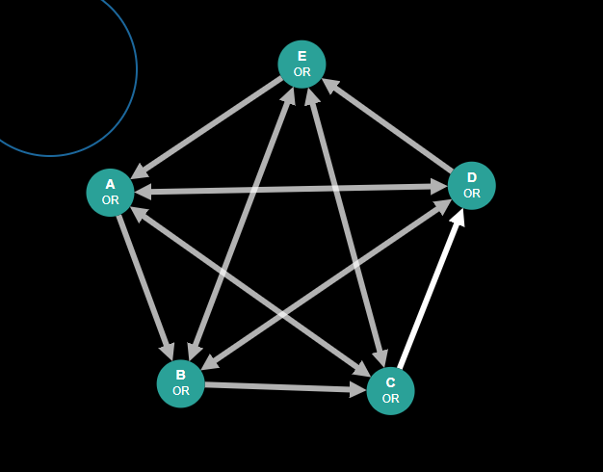

* **Estado-nodo**

|  |  |  |  |  |
| --- | --- | --- | --- | --- |
| Entrada de datos | Medida de distancia | Esquema de partición | Resultados con CM | Resultados sin CM |
| Grafo: | EMD | biparticion | MIP:  Cut [A, C] ━━/ /━━➤ [B, D, E]  Phi:  Φ = 0.056123  Time:  58.900532 s | MIP:  Cut [A, C] ━━/ /━━➤ [B, D, E]  Phi:  Φ = 0.056123  Time:  92.620368 s |
| EMD | tripartición | MIP:  Cut [A, C] ━━/ /━━➤ [B, D, E]  Phi:  Φ = 0.056123  Time:  59.000532 s | MIP:  Cut [A, C] ━━/ /━━➤ [B, D, E]  Phi:  Φ = 0.056123  Time:  92.634038 s |
| KLD | bipartición | MIP:  Cut [A, C] ━━/ /━━➤ [B, D, E]  Phi:  Φ = 0.056123  Time:  57.287965 s | MIP:  Cut [A, C] ━━/ /━━➤ [B, D, E]  Phi:  Φ = 0.056123  Time:  94.820368 s |
| KLD | tripartición | MIP:  Cut [A, C] ━━/ /━━➤ [B, D, E]  Phi:  Φ = 0.056123  Time:  58.809456 s | MIP:  Cut [A, C] ━━/ /━━➤ [B, D, E]  Phi:  Φ = 0.056123  Time:  93.314567 s |

* **Variación en el tiempo y consumo en las diferentes particiones con CM**

Evaluating Φ cuts: 0%| | 0/30 [00:00<?, ?it/s]

Computing concepts: 0%| | 0/20 [00:00<?, ?it/s]

Computing concepts: 10%|█ | 2/20 [00:00<00:00, 19.95it/s]

Computing concepts: 15%|█▌ | 3/20 [00:00<00:01, 10.37it/s]

Computing concepts: 30%|███ | 6/20 [00:00<00:01, 12.00it/s]

Computing concepts: 55%|█████▌ | 11/20 [00:00<00:00, 15.22it/s]

Computing concepts: 65%|██████▌ | 13/20 [00:00<00:00, 13.75it/s]

Computing concepts: 85%|████████▌ | 17/20 [00:00<00:00, 16.01it/s]

Evaluating Φ cuts: 3%|▎ | 1/30 [00:00<00:27, 1.05it/s]

Computing concepts: 0%| | 0/20 [00:00<?, ?it/s]

Computing concepts: 15%|█▌ | 3/20 [00:00<00:00, 21.74it/s]

Computing concepts: 20%|██ | 4/20 [00:00<00:01, 11.41it/s]

Computing concepts: 35%|███▌ | 7/20 [00:00<00:00, 13.15it/s]

Computing concepts: 50%|█████ | 10/20 [00:00<00:00, 15.78it/s]

Computing concepts: 70%|███████ | 14/20 [00:00<00:00, 18.88it/s]

Computing concepts: 85%|████████▌ | 17/20 [00:00<00:00, 18.52it/s]

Evaluating Φ cuts: 7%|▋ | 2/30 [00:01<00:26, 1.06it/s]

Computing concepts: 0%| | 0/26 [00:00<?, ?it/s]

Computing concepts: 15%|█▌ | 4/26 [00:00<00:01, 17.29it/s]

Computing concepts: 31%|███ | 8/26 [00:00<00:00, 19.86it/s]

Computing concepts: 54%|█████▍ | 14/26 [00:00<00:00, 24.17it/s]

Computing concepts: 69%|██████▉ | 18/26 [00:00<00:00, 27.41it/s]

Computing concepts: 85%|████████▍ | 22/26 [00:00<00:00, 27.35it/s]

Evaluating Φ cuts: 10%|█ | 3/30 [00:02<00:24, 1.11it/s]

Computing concepts: 0%| | 0/20 [00:00<?, ?it/s]

Computing concepts: 15%|█▌ | 3/20 [00:00<00:01, 11.41it/s]

Computing concepts: 40%|████ | 8/20 [00:00<00:00, 14.36it/s]

Computing concepts: 50%|█████ | 10/20 [00:00<00:00, 14.60it/s]

Computing concepts: 60%|██████ | 12/20 [00:00<00:00, 15.88it/s]

Computing concepts: 75%|███████▌ | 15/20 [00:00<00:00, 17.01it/s]

Computing concepts: 95%|█████████▌| 19/20 [00:00<00:00, 19.87it/s]

Evaluating Φ cuts: 13%|█▎ | 4/30 [00:03<00:23, 1.09it/s]

Computing concepts: 0%| | 0/26 [00:00<?, ?it/s]

Computing concepts: 4%|▍ | 1/26 [00:00<00:05, 4.49it/s]

Computing concepts: 12%|█▏ | 3/26 [00:01<00:06, 3.43it/s]

Computing concepts: 27%|██▋ | 7/26 [00:01<00:04, 4.63it/s]

Computing concepts: 35%|███▍ | 9/26 [00:01<00:03, 5.59it/s]

Computing concepts: 46%|████▌ | 12/26 [00:01<00:02, 6.57it/s]

Computing concepts: 50%|█████ | 13/26 [00:02<00:02, 4.75it/s]

Computing concepts: 58%|█████▊ | 15/26 [00:02<00:02, 4.64it/s]

Computing concepts: 69%|██████▉ | 18/26 [00:02<00:01, 6.21it/s]

Computing concepts: 81%|████████ | 21/26 [00:02<00:00, 7.95it/s]

Computing concepts: 88%|████████▊ | 23/26 [00:03<00:00, 6.40it/s]

Evaluating Φ cuts: 17%|█▋ | 5/30 [00:07<00:41, 1.65s/it]

Computing concepts: 0%| | 0/26 [00:00<?, ?it/s]

Computing concepts: 15%|█▌ | 4/26 [00:00<00:00, 34.52it/s]

Computing concepts: 23%|██▎ | 6/26 [00:00<00:00, 21.90it/s]

Computing concepts: 42%|████▏ | 11/26 [00:00<00:00, 26.33it/s]

Computing concepts: 54%|█████▍ | 14/26 [00:00<00:00, 25.17it/s]

Computing concepts: 65%|██████▌ | 17/26 [00:00<00:00, 25.38it/s]

Computing concepts: 81%|████████ | 21/26 [00:00<00:00, 25.57it/s]

Evaluating Φ cuts: 20%|██ | 6/30 [00:07<00:33, 1.41s/it]

Computing concepts: 0%| | 0/26 [00:00<?, ?it/s]

Computing concepts: 23%|██▎ | 6/26 [00:00<00:00, 59.06it/s]

Computing concepts: 42%|████▏ | 11/26 [00:00<00:00, 37.04it/s]

Computing concepts: 65%|██████▌ | 17/26 [00:00<00:00, 36.99it/s]

Computing concepts: 81%|████████ | 21/26 [00:00<00:00, 18.46it/s]

Evaluating Φ cuts: 23%|██▎ | 7/30 [00:08<00:29, 1.30s/it]

Computing concepts: 0%| | 0/20 [00:00<?, ?it/s]

Computing concepts: 15%|█▌ | 3/20 [00:00<00:01, 10.53it/s]

Computing concepts: 25%|██▌ | 5/20 [00:00<00:01, 12.27it/s]

Computing concepts: 45%|████▌ | 9/20 [00:00<00:00, 14.69it/s]

Computing concepts: 55%|█████▌ | 11/20 [00:00<00:00, 14.84it/s]

Computing concepts: 75%|███████▌ | 15/20 [00:00<00:00, 16.71it/s]

Evaluating Φ cuts: 27%|██▋ | 8/30 [00:09<00:26, 1.20s/it]

Computing concepts: 0%| | 0/26 [00:00<?, ?it/s]

Computing concepts: 12%|█▏ | 3/26 [00:00<00:02, 10.53it/s]

Computing concepts: 15%|█▌ | 4/26 [00:01<00:07, 2.76it/s]

Computing concepts: 23%|██▎ | 6/26 [00:01<00:06, 3.11it/s]

Computing concepts: 31%|███ | 8/26 [00:01<00:04, 3.77it/s]

Computing concepts: 46%|████▌ | 12/26 [00:02<00:03, 4.31it/s]

Computing concepts: 54%|█████▍ | 14/26 [00:03<00:02, 4.21it/s]

Computing concepts: 69%|██████▉ | 18/26 [00:03<00:01, 5.40it/s]

Computing concepts: 73%|███████▎ | 19/26 [00:03<00:01, 6.26it/s]

Computing concepts: 77%|███████▋ | 20/26 [00:03<00:00, 6.82it/s]

Computing concepts: 92%|█████████▏| 24/26 [00:03<00:00, 9.08it/s]

Evaluating Φ cuts: 30%|███ | 9/30 [00:13<00:41, 1.98s/it]

Computing concepts: 0%| | 0/26 [00:00<?, ?it/s]

Computing concepts: 4%|▍ | 1/26 [00:00<00:03, 6.71it/s]

Computing concepts: 8%|▊ | 2/26 [00:00<00:04, 5.02it/s]

Computing concepts: 12%|█▏ | 3/26 [00:01<00:10, 2.26it/s]

Computing concepts: 27%|██▋ | 7/26 [00:01<00:06, 2.90it/s]

Computing concepts: 42%|████▏ | 11/26 [00:02<00:04, 3.51it/s]

Computing concepts: 50%|█████ | 13/26 [00:02<00:03, 4.25it/s]

Computing concepts: 54%|█████▍ | 14/26 [00:02<00:02, 5.13it/s]

Computing concepts: 73%|███████▎ | 19/26 [00:02<00:01, 6.98it/s]

Computing concepts: 81%|████████ | 21/26 [00:03<00:00, 6.05it/s]

Computing concepts: 92%|█████████▏| 24/26 [00:03<00:00, 7.54it/s]

Evaluating Φ cuts: 33%|███▎ | 10/30 [00:17<00:49, 2.50s/it]

Computing concepts: 0%| | 0/26 [00:00<?, ?it/s]

Computing concepts: 8%|▊ | 2/26 [00:00<00:10, 2.22it/s]

Computing concepts: 19%|█▉ | 5/26 [00:01<00:07, 2.77it/s]

Computing concepts: 27%|██▋ | 7/26 [00:01<00:05, 3.54it/s]

Computing concepts: 42%|████▏ | 11/26 [00:02<00:03, 4.28it/s]

Computing concepts: 50%|█████ | 13/26 [00:02<00:02, 5.10it/s]

Computing concepts: 54%|█████▍ | 14/26 [00:02<00:03, 3.86it/s]

Computing concepts: 69%|██████▉ | 18/26 [00:02<00:01, 5.00it/s]

Computing concepts: 73%|███████▎ | 19/26 [00:03<00:01, 4.26it/s]

Computing concepts: 85%|████████▍ | 22/26 [00:03<00:00, 5.73it/s]

Computing concepts: 92%|█████████▏| 24/26 [00:03<00:00, 6.47it/s]

Evaluating Φ cuts: 37%|███▋ | 11/30 [00:20<00:53, 2.83s/it]

Computing concepts: 0%| | 0/26 [00:00<?, ?it/s]

Computing concepts: 19%|█▉ | 5/26 [00:00<00:00, 21.58it/s]

Computing concepts: 38%|███▊ | 10/26 [00:00<00:00, 25.38it/s]

Computing concepts: 54%|█████▍ | 14/26 [00:00<00:00, 26.37it/s]

Computing concepts: 73%|███████▎ | 19/26 [00:00<00:00, 27.54it/s]

Computing concepts: 92%|█████████▏| 24/26 [00:00<00:00, 31.42it/s]

Evaluating Φ cuts: 40%|████ | 12/30 [00:21<00:39, 2.22s/it]

Computing concepts: 0%| | 0/26 [00:00<?, ?it/s]

Computing concepts: 8%|▊ | 2/26 [00:00<00:02, 8.54it/s]

Computing concepts: 12%|█▏ | 3/26 [00:00<00:03, 7.32it/s]

Computing concepts: 15%|█▌ | 4/26 [00:01<00:07, 3.00it/s]

Computing concepts: 27%|██▋ | 7/26 [00:01<00:05, 3.73it/s]

Computing concepts: 42%|████▏ | 11/26 [00:01<00:03, 4.91it/s]

Computing concepts: 46%|████▌ | 12/26 [00:02<00:03, 3.57it/s]

Computing concepts: 54%|█████▍ | 14/26 [00:02<00:03, 3.74it/s]

Computing concepts: 69%|██████▉ | 18/26 [00:03<00:01, 4.78it/s]

Computing concepts: 77%|███████▋ | 20/26 [00:03<00:01, 4.71it/s]

Computing concepts: 92%|█████████▏| 24/26 [00:03<00:00, 6.41it/s]

Evaluating Φ cuts: 43%|████▎ | 13/30 [00:25<00:44, 2.63s/it]

Computing concepts: 0%| | 0/26 [00:00<?, ?it/s]

Computing concepts: 12%|█▏ | 3/26 [00:00<00:01, 12.13it/s]

Computing concepts: 35%|███▍ | 9/26 [00:00<00:01, 15.49it/s]

Computing concepts: 46%|████▌ | 12/26 [00:00<00:01, 10.65it/s]

Computing concepts: 96%|█████████▌| 25/26 [00:00<00:00, 14.69it/s]

Evaluating Φ cuts: 47%|████▋ | 14/30 [00:26<00:34, 2.14s/it]

Computing concepts: 0%| | 0/20 [00:00<?, ?it/s]

Computing concepts: 60%|██████ | 12/20 [00:00<00:00, 106.79it/s]

Evaluating Φ cuts: 50%|█████ | 15/30 [00:26<00:23, 1.57s/it]

Computing concepts: 0%| | 0/20 [00:00<?, ?it/s]

Computing concepts: 5%|▌ | 1/20 [00:00<00:03, 4.99it/s]

Computing concepts: 15%|█▌ | 3/20 [00:00<00:02, 5.87it/s]

Computing concepts: 40%|████ | 8/20 [00:00<00:01, 7.98it/s]

Computing concepts: 50%|█████ | 10/20 [00:00<00:01, 9.03it/s]

Computing concepts: 65%|██████▌ | 13/20 [00:00<00:00, 10.84it/s]

Computing concepts: 85%|████████▌ | 17/20 [00:00<00:00, 13.23it/s]

Computing concepts: 100%|██████████| 20/20 [00:01<00:00, 15.89it/s]

Evaluating Φ cuts: 53%|█████▎ | 16/30 [00:27<00:19, 1.42s/it]

Computing concepts: 0%| | 0/26 [00:00<?, ?it/s]

Computing concepts: 15%|█▌ | 4/26 [00:00<00:01, 14.34it/s]

Computing concepts: 27%|██▋ | 7/26 [00:00<00:01, 14.87it/s]

Computing concepts: 35%|███▍ | 9/26 [00:00<00:01, 13.35it/s]

Computing concepts: 42%|████▏ | 11/26 [00:00<00:01, 14.46it/s]

Computing concepts: 50%|█████ | 13/26 [00:00<00:00, 15.62it/s]

Computing concepts: 58%|█████▊ | 15/26 [00:01<00:00, 11.07it/s]

Computing concepts: 69%|██████▉ | 18/26 [00:01<00:00, 13.45it/s]

Computing concepts: 85%|████████▍ | 22/26 [00:01<00:00, 16.55it/s]

Evaluating Φ cuts: 57%|█████▋ | 17/30 [00:29<00:18, 1.44s/it]

Computing concepts: 0%| | 0/26 [00:00<?, ?it/s]

Computing concepts: 8%|▊ | 2/26 [00:00<00:02, 11.21it/s]

Computing concepts: 12%|█▏ | 3/26 [00:00<00:02, 10.09it/s]

Computing concepts: 15%|█▌ | 4/26 [00:01<00:08, 2.45it/s]

Computing concepts: 19%|█▉ | 5/26 [00:01<00:08, 2.35it/s]

Computing concepts: 27%|██▋ | 7/26 [00:02<00:07, 2.55it/s]

Computing concepts: 46%|████▌ | 12/26 [00:02<00:03, 3.54it/s]

Computing concepts: 54%|█████▍ | 14/26 [00:02<00:02, 4.56it/s]

Computing concepts: 62%|██████▏ | 16/26 [00:03<00:01, 5.17it/s]

Computing concepts: 73%|███████▎ | 19/26 [00:03<00:01, 5.25it/s]

Computing concepts: 77%|███████▋ | 20/26 [00:04<00:01, 3.74it/s]

Computing concepts: 88%|████████▊ | 23/26 [00:04<00:00, 4.74it/s]

Evaluating Φ cuts: 60%|██████ | 18/30 [00:33<00:28, 2.33s/it]

Computing concepts: 0%| | 0/26 [00:00<?, ?it/s]

Computing concepts: 31%|███ | 8/26 [00:00<00:01, 15.51it/s]

Computing concepts: 69%|██████▉ | 18/26 [00:00<00:00, 20.58it/s]

Computing concepts: 88%|████████▊ | 23/26 [00:00<00:00, 22.14it/s]

Evaluating Φ cuts: 63%|██████▎ | 19/30 [00:34<00:20, 1.91s/it]

Computing concepts: 0%| | 0/26 [00:00<?, ?it/s]

Computing concepts: 8%|▊ | 2/26 [00:01<00:12, 1.97it/s]

Computing concepts: 19%|█▉ | 5/26 [00:01<00:07, 2.69it/s]

Computing concepts: 38%|███▊ | 10/26 [00:01<00:04, 3.66it/s]

Computing concepts: 46%|████▌ | 12/26 [00:01<00:02, 4.80it/s]

Computing concepts: 54%|█████▍ | 14/26 [00:01<00:02, 4.75it/s]

Computing concepts: 62%|██████▏ | 16/26 [00:02<00:01, 5.32it/s]

Computing concepts: 73%|███████▎ | 19/26 [00:02<00:01, 5.35it/s]

Computing concepts: 77%|███████▋ | 20/26 [00:03<00:01, 3.98it/s]

Computing concepts: 92%|█████████▏| 24/26 [00:03<00:00, 5.11it/s]

Evaluating Φ cuts: 67%|██████▋ | 20/30 [00:37<00:23, 2.38s/it]

Computing concepts: 0%| | 0/26 [00:00<?, ?it/s]

Computing concepts: 4%|▍ | 1/26 [00:00<00:05, 4.85it/s]

Computing concepts: 12%|█▏ | 3/26 [00:00<00:06, 3.81it/s]

Computing concepts: 27%|██▋ | 7/26 [00:01<00:03, 5.14it/s]

Computing concepts: 35%|███▍ | 9/26 [00:01<00:02, 6.10it/s]

Computing concepts: 42%|████▏ | 11/26 [00:01<00:02, 6.25it/s]

Computing concepts: 54%|█████▍ | 14/26 [00:02<00:02, 5.87it/s]

Computing concepts: 62%|██████▏ | 16/26 [00:02<00:01, 6.69it/s]

Computing concepts: 77%|███████▋ | 20/26 [00:02<00:00, 7.43it/s]

Computing concepts: 81%|████████ | 21/26 [00:03<00:01, 4.24it/s]

Computing concepts: 96%|█████████▌| 25/26 [00:03<00:00, 5.42it/s]

Evaluating Φ cuts: 70%|███████ | 21/30 [00:41<00:24, 2.75s/it]

Computing concepts: 0%| | 0/26 [00:00<?, ?it/s]

Computing concepts: 12%|█▏ | 3/26 [00:00<00:00, 25.89it/s]

Computing concepts: 15%|█▌ | 4/26 [00:00<00:05, 3.80it/s]

Computing concepts: 19%|█▉ | 5/26 [00:01<00:05, 3.94it/s]

Computing concepts: 23%|██▎ | 6/26 [00:01<00:05, 3.53it/s]

Computing concepts: 42%|████▏ | 11/26 [00:01<00:03, 4.75it/s]

Computing concepts: 50%|█████ | 13/26 [00:01<00:02, 5.90it/s]

Computing concepts: 58%|█████▊ | 15/26 [00:02<00:01, 6.11it/s]

Computing concepts: 73%|███████▎ | 19/26 [00:02<00:01, 6.85it/s]

Computing concepts: 77%|███████▋ | 20/26 [00:02<00:01, 4.40it/s]

Computing concepts: 88%|████████▊ | 23/26 [00:03<00:00, 5.63it/s]

Computing concepts: 96%|█████████▌| 25/26 [00:03<00:00, 6.58it/s]

Evaluating Φ cuts: 73%|███████▎ | 22/30 [00:44<00:23, 2.94s/it]

Computing concepts: 0%| | 0/20 [00:00<?, ?it/s]

Computing concepts: 60%|██████ | 12/20 [00:00<00:00, 119.71it/s]

Evaluating Φ cuts: 77%|███████▋ | 23/30 [00:45<00:14, 2.11s/it]

Computing concepts: 0%| | 0/26 [00:00<?, ?it/s]

Computing concepts: 12%|█▏ | 3/26 [00:00<00:01, 14.96it/s]

Computing concepts: 31%|███ | 8/26 [00:00<00:00, 18.61it/s]

Computing concepts: 54%|█████▍ | 14/26 [00:00<00:00, 23.28it/s]

Computing concepts: 65%|██████▌ | 17/26 [00:00<00:00, 24.02it/s]

Computing concepts: 77%|███████▋ | 20/26 [00:00<00:00, 23.65it/s]

Computing concepts: 92%|█████████▏| 24/26 [00:00<00:00, 26.94it/s]

Evaluating Φ cuts: 80%|████████ | 24/30 [00:45<00:10, 1.74s/it]

Computing concepts: 0%| | 0/26 [00:00<?, ?it/s]

Computing concepts: 35%|███▍ | 9/26 [00:00<00:00, 38.84it/s]

Computing concepts: 58%|█████▊ | 15/26 [00:00<00:00, 23.65it/s]

Computing concepts: 96%|█████████▌| 25/26 [00:00<00:00, 30.24it/s]

Evaluating Φ cuts: 83%|████████▎ | 25/30 [00:46<00:07, 1.48s/it]

Computing concepts: 0%| | 0/26 [00:00<?, ?it/s]

Computing concepts: 8%|▊ | 2/26 [00:00<00:02, 8.63it/s]

Computing concepts: 12%|█▏ | 3/26 [00:00<00:07, 3.25it/s]

Computing concepts: 15%|█▌ | 4/26 [00:01<00:05, 3.72it/s]

Computing concepts: 27%|██▋ | 7/26 [00:01<00:04, 4.38it/s]

Computing concepts: 50%|█████ | 13/26 [00:01<00:02, 5.54it/s]

Computing concepts: 54%|█████▍ | 14/26 [00:02<00:02, 5.17it/s]

Computing concepts: 62%|██████▏ | 16/26 [00:02<00:01, 6.65it/s]

Computing concepts: 69%|██████▉ | 18/26 [00:02<00:01, 7.58it/s]

Computing concepts: 81%|████████ | 21/26 [00:02<00:00, 7.26it/s]

Computing concepts: 85%|████████▍ | 22/26 [00:03<00:00, 5.36it/s]

Evaluating Φ cuts: 87%|████████▋ | 26/30 [00:50<00:08, 2.03s/it]

Computing concepts: 0%| | 0/20 [00:00<?, ?it/s]

Computing concepts: 55%|█████▌ | 11/20 [00:00<00:00, 109.70it/s]

Evaluating Φ cuts: 90%|█████████ | 27/30 [00:50<00:04, 1.48s/it]

Computing concepts: 0%| | 0/26 [00:00<?, ?it/s]

Computing concepts: 50%|█████ | 13/26 [00:00<00:00, 129.69it/s]

Computing concepts: 69%|██████▉ | 18/26 [00:00<00:00, 49.41it/s]

Computing concepts: 85%|████████▍ | 22/26 [00:00<00:00, 21.24it/s]

Evaluating Φ cuts: 93%|█████████▎| 28/30 [00:51<00:02, 1.30s/it]

Computing concepts: 0%| | 0/20 [00:00<?, ?it/s]

Computing concepts: 50%|█████ | 10/20 [00:00<00:00, 99.75it/s]

Evaluating Φ cuts: 97%|█████████▋| 29/30 [00:51<00:00, 1.03it/s]

Computing concepts: 0%| | 0/20 [00:00<?, ?it/s]

Computing concepts: 50%|█████ | 10/20 [00:00<00:00, 99.76it/s]

* **Variación en el tiempo y consumo en las diferentes particiones sin CM**

Evaluating Φ cuts: 0%| | 0/30 [00:00<?, ?it/s]

Computing concepts: 0%| | 0/20 [00:00<?, ?it/s]

Computing concepts: 5%|▌ | 1/20 [00:00<00:04, 4.16it/s]

Computing concepts: 10%|█ | 2/20 [00:00<00:03, 4.65it/s]

Computing concepts: 15%|█▌ | 3/20 [00:00<00:03, 4.64it/s]

Computing concepts: 20%|██ | 4/20 [00:00<00:02, 5.51it/s]

Computing concepts: 30%|███ | 6/20 [00:00<00:02, 6.57it/s]

Computing concepts: 50%|█████ | 10/20 [00:01<00:01, 8.60it/s]

Computing concepts: 60%|██████ | 12/20 [00:01<00:00, 8.85it/s]

Computing concepts: 70%|███████ | 14/20 [00:01<00:00, 9.46it/s]

Computing concepts: 80%|████████ | 16/20 [00:01<00:00, 11.18it/s]

Computing concepts: 90%|█████████ | 18/20 [00:01<00:00, 10.84it/s]

Evaluating Φ cuts: 3%|▎ | 1/30 [00:01<00:52, 1.81s/it]

Computing concepts: 0%| | 0/20 [00:00<?, ?it/s]

Computing concepts: 10%|█ | 2/20 [00:00<00:01, 10.90it/s]

Computing concepts: 15%|█▌ | 3/20 [00:00<00:01, 10.26it/s]

Computing concepts: 20%|██ | 4/20 [00:00<00:02, 6.66it/s]

Computing concepts: 30%|███ | 6/20 [00:00<00:01, 8.26it/s]

Computing concepts: 35%|███▌ | 7/20 [00:00<00:01, 7.76it/s]

Computing concepts: 50%|█████ | 10/20 [00:00<00:01, 9.52it/s]

Computing concepts: 60%|██████ | 12/20 [00:01<00:00, 10.93it/s]

Computing concepts: 70%|███████ | 14/20 [00:01<00:00, 11.61it/s]

Computing concepts: 80%|████████ | 16/20 [00:01<00:00, 12.64it/s]

Computing concepts: 90%|█████████ | 18/20 [00:01<00:00, 13.41it/s]

Evaluating Φ cuts: 7%|▋ | 2/30 [00:03<00:48, 1.75s/it]

Computing concepts: 0%| | 0/26 [00:00<?, ?it/s]

Computing concepts: 8%|▊ | 2/26 [00:00<00:01, 14.87it/s]

Computing concepts: 15%|█▌ | 4/26 [00:00<00:02, 10.86it/s]

Computing concepts: 23%|██▎ | 6/26 [00:00<00:01, 12.51it/s]

Computing concepts: 31%|███ | 8/26 [00:00<00:01, 12.73it/s]

Computing concepts: 50%|█████ | 13/26 [00:00<00:00, 15.89it/s]

Computing concepts: 58%|█████▊ | 15/26 [00:00<00:00, 14.45it/s]

Computing concepts: 65%|██████▌ | 17/26 [00:01<00:00, 14.68it/s]

Computing concepts: 73%|███████▎ | 19/26 [00:01<00:00, 15.94it/s]

Computing concepts: 81%|████████ | 21/26 [00:01<00:00, 15.12it/s]

Computing concepts: 88%|████████▊ | 23/26 [00:01<00:00, 14.98it/s]

Computing concepts: 100%|██████████| 26/26 [00:01<00:00, 17.15it/s]

Evaluating Φ cuts: 10%|█ | 3/30 [00:05<00:46, 1.72s/it]

Computing concepts: 0%| | 0/20 [00:00<?, ?it/s]

Computing concepts: 10%|█ | 2/20 [00:00<00:01, 14.33it/s]

Computing concepts: 15%|█▌ | 3/20 [00:00<00:02, 7.59it/s]

Computing concepts: 30%|███ | 6/20 [00:00<00:01, 8.20it/s]

Computing concepts: 40%|████ | 8/20 [00:00<00:01, 9.49it/s]

Computing concepts: 45%|████▌ | 9/20 [00:00<00:01, 8.60it/s]

Computing concepts: 55%|█████▌ | 11/20 [00:01<00:01, 8.63it/s]

Computing concepts: 65%|██████▌ | 13/20 [00:01<00:00, 9.82it/s]

Computing concepts: 75%|███████▌ | 15/20 [00:01<00:00, 10.63it/s]

Computing concepts: 85%|████████▌ | 17/20 [00:01<00:00, 11.46it/s]

Computing concepts: 100%|██████████| 20/20 [00:01<00:00, 13.37it/s]

Evaluating Φ cuts: 13%|█▎ | 4/30 [00:06<00:45, 1.75s/it]

Computing concepts: 0%| | 0/26 [00:00<?, ?it/s]

Computing concepts: 4%|▍ | 1/26 [00:00<00:06, 3.69it/s]

Computing concepts: 12%|█▏ | 3/26 [00:01<00:08, 2.86it/s]

Computing concepts: 19%|█▉ | 5/26 [00:01<00:05, 3.77it/s]

Computing concepts: 27%|██▋ | 7/26 [00:01<00:04, 4.69it/s]

Computing concepts: 35%|███▍ | 9/26 [00:01<00:03, 5.39it/s]

Computing concepts: 46%|████▌ | 12/26 [00:02<00:02, 6.15it/s]

Computing concepts: 50%|█████ | 13/26 [00:02<00:03, 3.88it/s]

Computing concepts: 54%|█████▍ | 14/26 [00:02<00:02, 4.68it/s]

Computing concepts: 58%|█████▊ | 15/26 [00:03<00:03, 3.48it/s]

Computing concepts: 65%|██████▌ | 17/26 [00:03<00:02, 4.47it/s]

Computing concepts: 77%|███████▋ | 20/26 [00:03<00:01, 6.00it/s]

Computing concepts: 85%|████████▍ | 22/26 [00:04<00:00, 4.68it/s]

Computing concepts: 100%|██████████| 26/26 [00:04<00:00, 6.19it/s]

Evaluating Φ cuts: 17%|█▋ | 5/30 [00:11<01:03, 2.53s/it]

Computing concepts: 0%| | 0/26 [00:00<?, ?it/s]

Computing concepts: 8%|▊ | 2/26 [00:00<00:01, 15.17it/s]

Computing concepts: 15%|█▌ | 4/26 [00:00<00:01, 16.14it/s]

Computing concepts: 19%|█▉ | 5/26 [00:00<00:02, 8.55it/s]

Computing concepts: 27%|██▋ | 7/26 [00:00<00:01, 9.76it/s]

Computing concepts: 42%|████▏ | 11/26 [00:00<00:01, 11.82it/s]

Computing concepts: 50%|█████ | 13/26 [00:00<00:01, 11.50it/s]

Computing concepts: 58%|█████▊ | 15/26 [00:01<00:01, 10.87it/s]

Computing concepts: 65%|██████▌ | 17/26 [00:01<00:00, 12.04it/s]

Computing concepts: 77%|███████▋ | 20/26 [00:01<00:00, 13.32it/s]

Computing concepts: 85%|████████▍ | 22/26 [00:01<00:00, 13.84it/s]

Computing concepts: 96%|█████████▌| 25/26 [00:01<00:00, 15.87it/s]

Evaluating Φ cuts: 20%|██ | 6/30 [00:13<00:55, 2.32s/it]

Computing concepts: 0%| | 0/26 [00:00<?, ?it/s]

Computing concepts: 8%|▊ | 2/26 [00:00<00:01, 15.62it/s]

Computing concepts: 12%|█▏ | 3/26 [00:00<00:04, 4.93it/s]

Computing concepts: 19%|█▉ | 5/26 [00:00<00:03, 6.27it/s]

Computing concepts: 31%|███ | 8/26 [00:01<00:02, 7.06it/s]

Computing concepts: 42%|████▏ | 11/26 [00:01<00:01, 7.84it/s]

Computing concepts: 46%|████▌ | 12/26 [00:01<00:03, 4.09it/s]

Computing concepts: 54%|█████▍ | 14/26 [00:01<00:02, 5.29it/s]

Computing concepts: 58%|█████▊ | 15/26 [00:02<00:02, 4.72it/s]

Computing concepts: 65%|██████▌ | 17/26 [00:02<00:01, 6.13it/s]

Computing concepts: 77%|███████▋ | 20/26 [00:02<00:00, 7.84it/s]

Computing concepts: 85%|████████▍ | 22/26 [00:02<00:00, 6.10it/s]

Computing concepts: 96%|█████████▌| 25/26 [00:03<00:00, 7.96it/s]

Evaluating Φ cuts: 23%|██▎ | 7/30 [00:16<00:59, 2.58s/it]

Computing concepts: 0%| | 0/20 [00:00<?, ?it/s]

Computing concepts: 10%|█ | 2/20 [00:00<00:01, 15.15it/s]

Computing concepts: 15%|█▌ | 3/20 [00:00<00:02, 8.13it/s]

Computing concepts: 25%|██▌ | 5/20 [00:00<00:01, 8.64it/s]

Computing concepts: 35%|███▌ | 7/20 [00:00<00:01, 10.41it/s]

Computing concepts: 45%|████▌ | 9/20 [00:00<00:00, 11.50it/s]

Computing concepts: 55%|█████▌ | 11/20 [00:01<00:00, 10.72it/s]

Computing concepts: 70%|███████ | 14/20 [00:01<00:00, 12.40it/s]

Computing concepts: 80%|████████ | 16/20 [00:01<00:00, 12.74it/s]

Computing concepts: 90%|█████████ | 18/20 [00:01<00:00, 13.73it/s]

Computing concepts: 100%|██████████| 20/20 [00:01<00:00, 13.61it/s]

Evaluating Φ cuts: 27%|██▋ | 8/30 [00:17<00:50, 2.30s/it]

Computing concepts: 0%| | 0/26 [00:00<?, ?it/s]

Computing concepts: 8%|▊ | 2/26 [00:00<00:01, 14.49it/s]

Computing concepts: 12%|█▏ | 3/26 [00:00<00:02, 8.15it/s]

Computing concepts: 15%|█▌ | 4/26 [00:01<00:08, 2.69it/s]

Computing concepts: 23%|██▎ | 6/26 [00:01<00:06, 2.98it/s]

Computing concepts: 31%|███ | 8/26 [00:02<00:04, 3.60it/s]

Computing concepts: 42%|████▏ | 11/26 [00:02<00:03, 4.76it/s]

Computing concepts: 46%|████▌ | 12/26 [00:02<00:04, 3.45it/s]

Computing concepts: 54%|█████▍ | 14/26 [00:03<00:03, 3.47it/s]

Computing concepts: 69%|██████▉ | 18/26 [00:03<00:01, 4.43it/s]

Computing concepts: 73%|███████▎ | 19/26 [00:03<00:01, 5.03it/s]

Computing concepts: 77%|███████▋ | 20/26 [00:03<00:01, 5.80it/s]

Computing concepts: 92%|█████████▏| 24/26 [00:04<00:00, 7.39it/s]

Evaluating Φ cuts: 30%|███ | 9/30 [00:22<01:00, 2.88s/it]

Computing concepts: 0%| | 0/26 [00:00<?, ?it/s]

Computing concepts: 8%|▊ | 2/26 [00:00<00:04, 5.46it/s]

Computing concepts: 12%|█▏ | 3/26 [00:01<00:10, 2.26it/s]

Computing concepts: 19%|█▉ | 5/26 [00:01<00:06, 3.03it/s]

Computing concepts: 27%|██▋ | 7/26 [00:02<00:05, 3.23it/s]

Computing concepts: 38%|███▊ | 10/26 [00:02<00:03, 4.38it/s]

Computing concepts: 46%|████▌ | 12/26 [00:02<00:03, 4.12it/s]

Computing concepts: 50%|█████ | 13/26 [00:03<00:03, 4.00it/s]

Computing concepts: 54%|█████▍ | 14/26 [00:03<00:02, 4.65it/s]

Computing concepts: 62%|██████▏ | 16/26 [00:03<00:01, 5.79it/s]

Computing concepts: 73%|███████▎ | 19/26 [00:03<00:00, 7.34it/s]

Computing concepts: 81%|████████ | 21/26 [00:04<00:01, 4.47it/s]

Computing concepts: 92%|█████████▏| 24/26 [00:04<00:00, 5.35it/s]

Computing concepts: 96%|█████████▌| 25/26 [00:04<00:00, 5.57it/s]

Evaluating Φ cuts: 33%|███▎ | 10/30 [00:26<01:09, 3.47s/it]

Computing concepts: 0%| | 0/26 [00:00<?, ?it/s]

Computing concepts: 8%|▊ | 2/26 [00:00<00:11, 2.06it/s]

Computing concepts: 15%|█▌ | 4/26 [00:01<00:07, 2.82it/s]

Computing concepts: 19%|█▉ | 5/26 [00:01<00:08, 2.54it/s]

Computing concepts: 27%|██▋ | 7/26 [00:01<00:05, 3.20it/s]

Computing concepts: 42%|████▏ | 11/26 [00:02<00:03, 3.90it/s]

Computing concepts: 50%|█████ | 13/26 [00:02<00:02, 4.50it/s]

Computing concepts: 54%|█████▍ | 14/26 [00:02<00:03, 3.63it/s]

Computing concepts: 62%|██████▏ | 16/26 [00:03<00:02, 4.68it/s]

Computing concepts: 69%|██████▉ | 18/26 [00:03<00:01, 5.36it/s]

Computing concepts: 73%|███████▎ | 19/26 [00:03<00:01, 4.06it/s]

Computing concepts: 77%|███████▋ | 20/26 [00:03<00:01, 4.83it/s]

Computing concepts: 88%|████████▊ | 23/26 [00:04<00:00, 5.87it/s]

Computing concepts: 92%|█████████▏| 24/26 [00:04<00:00, 6.70it/s]

Evaluating Φ cuts: 37%|███▋ | 11/30 [00:31<01:10, 3.73s/it]

Computing concepts: 0%| | 0/26 [00:00<?, ?it/s]

Computing concepts: 8%|▊ | 2/26 [00:00<00:01, 17.28it/s]

Computing concepts: 15%|█▌ | 4/26 [00:00<00:01, 17.28it/s]

Computing concepts: 19%|█▉ | 5/26 [00:00<00:02, 8.72it/s]

Computing concepts: 27%|██▋ | 7/26 [00:00<00:01, 10.50it/s]

Computing concepts: 35%|███▍ | 9/26 [00:00<00:01, 11.58it/s]

Computing concepts: 46%|████▌ | 12/26 [00:00<00:01, 13.36it/s]

Computing concepts: 54%|█████▍ | 14/26 [00:01<00:00, 12.25it/s]

Computing concepts: 62%|██████▏ | 16/26 [00:01<00:00, 11.59it/s]

Computing concepts: 73%|███████▎ | 19/26 [00:01<00:00, 11.79it/s]

Computing concepts: 88%|████████▊ | 23/26 [00:01<00:00, 13.74it/s]

Computing concepts: 96%|█████████▌| 25/26 [00:01<00:00, 13.97it/s]

Evaluating Φ cuts: 40%|████ | 12/30 [00:33<00:57, 3.18s/it]

Computing concepts: 0%| | 0/26 [00:00<?, ?it/s]

Computing concepts: 8%|▊ | 2/26 [00:00<00:03, 6.65it/s]

Computing concepts: 12%|█▏ | 3/26 [00:00<00:04, 5.58it/s]

Computing concepts: 15%|█▌ | 4/26 [00:01<00:08, 2.53it/s]

Computing concepts: 23%|██▎ | 6/26 [00:01<00:05, 3.40it/s]

Computing concepts: 27%|██▋ | 7/26 [00:01<00:06, 3.03it/s]

Computing concepts: 42%|████▏ | 11/26 [00:02<00:03, 3.96it/s]

Computing concepts: 46%|████▌ | 12/26 [00:02<00:04, 3.26it/s]

Computing concepts: 54%|█████▍ | 14/26 [00:03<00:03, 3.24it/s]

Computing concepts: 58%|█████▊ | 15/26 [00:03<00:02, 3.90it/s]

Computing concepts: 69%|██████▉ | 18/26 [00:03<00:01, 4.74it/s]

Computing concepts: 73%|███████▎ | 19/26 [00:03<00:01, 5.29it/s]

Computing concepts: 77%|███████▋ | 20/26 [00:04<00:01, 3.54it/s]

Computing concepts: 88%|████████▊ | 23/26 [00:04<00:00, 4.71it/s]

Computing concepts: 96%|█████████▌| 25/26 [00:04<00:00, 5.82it/s]

Evaluating Φ cuts: 43%|████▎ | 13/30 [00:38<01:02, 3.67s/it]

Computing concepts: 0%| | 0/26 [00:00<?, ?it/s]

Computing concepts: 8%|▊ | 2/26 [00:00<00:01, 13.84it/s]

Computing concepts: 12%|█▏ | 3/26 [00:00<00:03, 7.56it/s]

Computing concepts: 15%|█▌ | 4/26 [00:01<00:08, 2.61it/s]

Computing concepts: 23%|██▎ | 6/26 [00:01<00:05, 3.47it/s]

Computing concepts: 27%|██▋ | 7/26 [00:01<00:06, 3.02it/s]

Computing concepts: 35%|███▍ | 9/26 [00:02<00:04, 4.05it/s]

Computing concepts: 46%|████▌ | 12/26 [00:02<00:03, 4.44it/s]

Computing concepts: 54%|█████▍ | 14/26 [00:02<00:02, 5.43it/s]

Computing concepts: 58%|█████▊ | 15/26 [00:02<00:01, 6.11it/s]

Computing concepts: 73%|███████▎ | 19/26 [00:03<00:01, 6.35it/s]

Computing concepts: 77%|███████▋ | 20/26 [00:03<00:00, 6.65it/s]

Computing concepts: 88%|████████▊ | 23/26 [00:03<00:00, 7.76it/s]

Computing concepts: 96%|█████████▌| 25/26 [00:03<00:00, 9.10it/s]

Evaluating Φ cuts: 47%|████▋ | 14/30 [00:42<01:00, 3.78s/it]

Computing concepts: 0%| | 0/20 [00:00<?, ?it/s]

Computing concepts: 5%|▌ | 1/20 [00:00<00:17, 1.11it/s]

Computing concepts: 15%|█▌ | 3/20 [00:01<00:11, 1.42it/s]

Computing concepts: 35%|███▌ | 7/20 [00:01<00:06, 1.96it/s]

Computing concepts: 45%|████▌ | 9/20 [00:02<00:04, 2.35it/s]

Computing concepts: 60%|██████ | 12/20 [00:02<00:02, 3.09it/s]

Computing concepts: 65%|██████▌ | 13/20 [00:02<00:02, 2.88it/s]

Computing concepts: 70%|███████ | 14/20 [00:03<00:02, 2.78it/s]

Computing concepts: 85%|████████▌ | 17/20 [00:03<00:00, 3.67it/s]

Computing concepts: 95%|█████████▌| 19/20 [00:03<00:00, 4.84it/s]

Evaluating Φ cuts: 50%|█████ | 15/30 [00:45<00:55, 3.71s/it]

Computing concepts: 0%| | 0/20 [00:00<?, ?it/s]

Computing concepts: 5%|▌ | 1/20 [00:00<00:04, 3.95it/s]

Computing concepts: 10%|█ | 2/20 [00:00<00:03, 4.82it/s]

Computing concepts: 15%|█▌ | 3/20 [00:00<00:03, 5.42it/s]

Computing concepts: 35%|███▌ | 7/20 [00:00<00:01, 7.10it/s]

Computing concepts: 45%|████▌ | 9/20 [00:00<00:01, 7.69it/s]

Computing concepts: 55%|█████▌ | 11/20 [00:00<00:00, 9.37it/s]

Computing concepts: 65%|██████▌ | 13/20 [00:01<00:00, 9.13it/s]

Computing concepts: 75%|███████▌ | 15/20 [00:01<00:00, 9.80it/s]

Computing concepts: 85%|████████▌ | 17/20 [00:01<00:00, 11.57it/s]

Computing concepts: 95%|█████████▌| 19/20 [00:01<00:00, 11.65it/s]

Evaluating Φ cuts: 53%|█████▎ | 16/30 [00:47<00:43, 3.12s/it]

Computing concepts: 0%| | 0/26 [00:00<?, ?it/s]

Computing concepts: 8%|▊ | 2/26 [00:00<00:01, 15.24it/s]

Computing concepts: 15%|█▌ | 4/26 [00:00<00:01, 11.59it/s]

Computing concepts: 23%|██▎ | 6/26 [00:00<00:01, 12.48it/s]

Computing concepts: 27%|██▋ | 7/26 [00:00<00:01, 11.01it/s]

Computing concepts: 42%|████▏ | 11/26 [00:00<00:01, 13.32it/s]

Computing concepts: 50%|█████ | 13/26 [00:00<00:00, 13.41it/s]

Computing concepts: 58%|█████▊ | 15/26 [00:01<00:00, 13.20it/s]

Computing concepts: 73%|███████▎ | 19/26 [00:01<00:00, 15.11it/s]

Computing concepts: 81%|████████ | 21/26 [00:01<00:00, 16.00it/s]

Computing concepts: 92%|█████████▏| 24/26 [00:01<00:00, 18.12it/s]

Evaluating Φ cuts: 57%|█████▋ | 17/30 [00:48<00:34, 2.66s/it]

Computing concepts: 0%| | 0/26 [00:00<?, ?it/s]

Computing concepts: 8%|▊ | 2/26 [00:00<00:01, 14.11it/s]

Computing concepts: 12%|█▏ | 3/26 [00:00<00:01, 12.20it/s]

Computing concepts: 15%|█▌ | 4/26 [00:01<00:06, 3.21it/s]

Computing concepts: 19%|█▉ | 5/26 [00:01<00:06, 3.41it/s]

Computing concepts: 27%|██▋ | 7/26 [00:01<00:05, 3.57it/s]

Computing concepts: 42%|████▏ | 11/26 [00:01<00:03, 4.85it/s]

Computing concepts: 50%|█████ | 13/26 [00:02<00:02, 5.73it/s]

Computing concepts: 58%|█████▊ | 15/26 [00:02<00:01, 5.66it/s]

Computing concepts: 69%|██████▉ | 18/26 [00:02<00:01, 7.12it/s]

Computing concepts: 77%|███████▋ | 20/26 [00:03<00:01, 4.43it/s]

Computing concepts: 88%|████████▊ | 23/26 [00:03<00:00, 5.45it/s]

Computing concepts: 92%|█████████▏| 24/26 [00:03<00:00, 6.31it/s]

Computing concepts: 100%|██████████| 26/26 [00:04<00:00, 7.66it/s]

Evaluating Φ cuts: 60%|██████ | 18/30 [00:53<00:37, 3.10s/it]

Computing concepts: 0%| | 0/26 [00:00<?, ?it/s]

Computing concepts: 8%|▊ | 2/26 [00:00<00:01, 14.48it/s]

Computing concepts: 15%|█▌ | 4/26 [00:00<00:01, 15.71it/s]

Computing concepts: 19%|█▉ | 5/26 [00:00<00:02, 7.69it/s]

Computing concepts: 31%|███ | 8/26 [00:01<00:02, 6.93it/s]

Computing concepts: 46%|████▌ | 12/26 [00:01<00:01, 9.21it/s]

Computing concepts: 54%|█████▍ | 14/26 [00:01<00:01, 10.40it/s]

Computing concepts: 62%|██████▏ | 16/26 [00:01<00:00, 10.57it/s]

Computing concepts: 73%|███████▎ | 19/26 [00:01<00:00, 11.31it/s]

Computing concepts: 81%|████████ | 21/26 [00:01<00:00, 9.65it/s]

Computing concepts: 88%|████████▊ | 23/26 [00:02<00:00, 9.44it/s]

Computing concepts: 100%|██████████| 26/26 [00:02<00:00, 11.89it/s]

Evaluating Φ cuts: 63%|██████▎ | 19/30 [00:55<00:31, 2.87s/it]

Computing concepts: 0%| | 0/26 [00:00<?, ?it/s]

Computing concepts: 8%|▊ | 2/26 [00:00<00:11, 2.01it/s]

Computing concepts: 15%|█▌ | 4/26 [00:01<00:08, 2.71it/s]

Computing concepts: 19%|█▉ | 5/26 [00:01<00:06, 3.31it/s]

Computing concepts: 35%|███▍ | 9/26 [00:01<00:03, 4.56it/s]

Computing concepts: 42%|████▏ | 11/26 [00:01<00:03, 4.98it/s]

Computing concepts: 50%|█████ | 13/26 [00:01<00:02, 6.02it/s]

Computing concepts: 58%|█████▊ | 15/26 [00:02<00:02, 5.48it/s]

Computing concepts: 62%|██████▏ | 16/26 [00:02<00:02, 4.91it/s]

Computing concepts: 69%|██████▉ | 18/26 [00:02<00:01, 6.31it/s]

Computing concepts: 77%|███████▋ | 20/26 [00:03<00:01, 4.06it/s]

Computing concepts: 88%|████████▊ | 23/26 [00:03<00:00, 5.44it/s]

Computing concepts: 96%|█████████▌| 25/26 [00:04<00:00, 5.68it/s]

Evaluating Φ cuts: 67%|██████▋ | 20/30 [00:59<00:32, 3.24s/it]

Computing concepts: 0%| | 0/26 [00:00<?, ?it/s]

Computing concepts: 4%|▍ | 1/26 [00:00<00:06, 3.89it/s]

Computing concepts: 12%|█▏ | 3/26 [00:01<00:07, 3.17it/s]

Computing concepts: 19%|█▉ | 5/26 [00:01<00:05, 4.17it/s]

Computing concepts: 27%|██▋ | 7/26 [00:01<00:03, 5.14it/s]

Computing concepts: 35%|███▍ | 9/26 [00:01<00:02, 5.78it/s]

Computing concepts: 42%|████▏ | 11/26 [00:02<00:02, 5.41it/s]

Computing concepts: 50%|█████ | 13/26 [00:02<00:01, 6.88it/s]

Computing concepts: 58%|█████▊ | 15/26 [00:02<00:01, 5.68it/s]

Computing concepts: 62%|██████▏ | 16/26 [00:02<00:01, 5.46it/s]

Computing concepts: 73%|███████▎ | 19/26 [00:03<00:00, 7.23it/s]

Computing concepts: 81%|████████ | 21/26 [00:03<00:01, 4.60it/s]

Computing concepts: 96%|█████████▌| 25/26 [00:04<00:00, 5.77it/s]

Evaluating Φ cuts: 70%|███████ | 21/30 [01:03<00:31, 3.53s/it]

Computing concepts: 0%| | 0/26 [00:00<?, ?it/s]

Computing concepts: 8%|▊ | 2/26 [00:00<00:01, 13.39it/s]

Computing concepts: 15%|█▌ | 4/26 [00:00<00:03, 5.57it/s]

Computing concepts: 19%|█▉ | 5/26 [00:01<00:04, 5.12it/s]

Computing concepts: 23%|██▎ | 6/26 [00:01<00:05, 3.89it/s]

Computing concepts: 38%|███▊ | 10/26 [00:01<00:03, 5.33it/s]

Computing concepts: 46%|████▌ | 12/26 [00:02<00:02, 5.50it/s]

Computing concepts: 54%|█████▍ | 14/26 [00:02<00:02, 5.08it/s]

Computing concepts: 69%|██████▉ | 18/26 [00:02<00:01, 6.70it/s]

Computing concepts: 77%|███████▋ | 20/26 [00:03<00:01, 4.36it/s]

Computing concepts: 88%|████████▊ | 23/26 [00:03<00:00, 5.44it/s]

Computing concepts: 96%|█████████▌| 25/26 [00:04<00:00, 5.83it/s]

Evaluating Φ cuts: 73%|███████▎ | 22/30 [01:07<00:29, 3.70s/it]

Computing concepts: 0%| | 0/20 [00:00<?, ?it/s]

Computing concepts: 10%|█ | 2/20 [00:00<00:01, 17.26it/s]

Computing concepts: 15%|█▌ | 3/20 [00:00<00:03, 5.66it/s]

Computing concepts: 25%|██▌ | 5/20 [00:00<00:02, 6.15it/s]

Computing concepts: 35%|███▌ | 7/20 [00:01<00:01, 6.92it/s]

Computing concepts: 45%|████▌ | 9/20 [00:01<00:01, 6.07it/s]

Computing concepts: 55%|█████▌ | 11/20 [00:01<00:01, 6.24it/s]

Computing concepts: 75%|███████▌ | 15/20 [00:02<00:00, 7.42it/s]

Computing concepts: 90%|█████████ | 18/20 [00:02<00:00, 9.30it/s]

Computing concepts: 100%|██████████| 20/20 [00:02<00:00, 10.00it/s]

Evaluating Φ cuts: 77%|███████▋ | 23/30 [01:10<00:23, 3.31s/it]

Computing concepts: 0%| | 0/26 [00:00<?, ?it/s]

Computing concepts: 8%|▊ | 2/26 [00:00<00:01, 18.82it/s]

Computing concepts: 12%|█▏ | 3/26 [00:00<00:02, 9.81it/s]

Computing concepts: 19%|█▉ | 5/26 [00:00<00:01, 11.27it/s]

Computing concepts: 23%|██▎ | 6/26 [00:00<00:01, 10.05it/s]

Computing concepts: 38%|███▊ | 10/26 [00:00<00:01, 12.79it/s]

Computing concepts: 46%|████▌ | 12/26 [00:00<00:01, 12.27it/s]

Computing concepts: 54%|█████▍ | 14/26 [00:00<00:00, 13.44it/s]

Computing concepts: 62%|██████▏ | 16/26 [00:01<00:00, 12.52it/s]

Computing concepts: 69%|██████▉ | 18/26 [00:01<00:00, 14.09it/s]

Computing concepts: 77%|███████▋ | 20/26 [00:01<00:00, 12.10it/s]

Computing concepts: 85%|████████▍ | 22/26 [00:01<00:00, 12.74it/s]

Computing concepts: 96%|█████████▌| 25/26 [00:01<00:00, 13.68it/s]

Evaluating Φ cuts: 80%|████████ | 24/30 [01:12<00:17, 2.89s/it]

Computing concepts: 0%| | 0/26 [00:00<?, ?it/s]

Computing concepts: 8%|▊ | 2/26 [00:00<00:01, 18.87it/s]

Computing concepts: 15%|█▌ | 4/26 [00:00<00:01, 15.10it/s]

Computing concepts: 19%|█▉ | 5/26 [00:00<00:01, 10.84it/s]

Computing concepts: 27%|██▋ | 7/26 [00:00<00:01, 10.21it/s]

Computing concepts: 35%|███▍ | 9/26 [00:00<00:01, 9.76it/s]

Computing concepts: 46%|████▌ | 12/26 [00:01<00:01, 10.66it/s]

Computing concepts: 58%|█████▊ | 15/26 [00:01<00:01, 8.54it/s]

Computing concepts: 69%|██████▉ | 18/26 [00:01<00:00, 10.72it/s]

Computing concepts: 81%|████████ | 21/26 [00:01<00:00, 12.98it/s]

Computing concepts: 96%|█████████▌| 25/26 [00:02<00:00, 15.30it/s]

Evaluating Φ cuts: 83%|████████▎ | 25/30 [01:14<00:13, 2.65s/it]

Computing concepts: 0%| | 0/26 [00:00<?, ?it/s]

Computing concepts: 8%|▊ | 2/26 [00:00<00:03, 6.67it/s]

Computing concepts: 12%|█▏ | 3/26 [00:01<00:07, 2.90it/s]

Computing concepts: 15%|█▌ | 4/26 [00:01<00:07, 3.01it/s]

Computing concepts: 27%|██▋ | 7/26 [00:01<00:05, 3.55it/s]

Computing concepts: 42%|████▏ | 11/26 [00:02<00:03, 4.87it/s]

Computing concepts: 50%|█████ | 13/26 [00:02<00:02, 4.75it/s]

Computing concepts: 58%|█████▊ | 15/26 [00:02<00:02, 4.99it/s]

Computing concepts: 65%|██████▌ | 17/26 [00:03<00:01, 5.49it/s]

Computing concepts: 77%|███████▋ | 20/26 [00:03<00:00, 7.08it/s]

Computing concepts: 85%|████████▍ | 22/26 [00:04<00:00, 4.57it/s]

Computing concepts: 96%|█████████▌| 25/26 [00:04<00:00, 6.12it/s]

Evaluating Φ cuts: 87%|████████▋ | 26/30 [01:18<00:12, 3.12s/it]

Computing concepts: 0%| | 0/20 [00:00<?, ?it/s]

Computing concepts: 10%|█ | 2/20 [00:00<00:00, 19.95it/s]

Computing concepts: 15%|█▌ | 3/20 [00:00<00:01, 9.15it/s]

Computing concepts: 30%|███ | 6/20 [00:00<00:01, 10.71it/s]

Computing concepts: 45%|████▌ | 9/20 [00:00<00:01, 10.70it/s]

Computing concepts: 50%|█████ | 10/20 [00:00<00:01, 9.87it/s]

Computing concepts: 55%|█████▌ | 11/20 [00:01<00:00, 9.46it/s]

Computing concepts: 65%|██████▌ | 13/20 [00:01<00:00, 10.06it/s]

Computing concepts: 75%|███████▌ | 15/20 [00:01<00:00, 11.29it/s]

Computing concepts: 85%|████████▌ | 17/20 [00:01<00:00, 10.51it/s]

Computing concepts: 100%|██████████| 20/20 [00:01<00:00, 12.80it/s]

Evaluating Φ cuts: 90%|█████████ | 27/30 [01:20<00:08, 2.69s/it]

Computing concepts: 0%| | 0/26 [00:00<?, ?it/s]

Computing concepts: 8%|▊ | 2/26 [00:00<00:01, 18.88it/s]

Computing concepts: 15%|█▌ | 4/26 [00:00<00:01, 17.17it/s]

Computing concepts: 23%|██▎ | 6/26 [00:00<00:01, 17.92it/s]

Computing concepts: 31%|███ | 8/26 [00:00<00:00, 18.48it/s]

Computing concepts: 46%|████▌ | 12/26 [00:00<00:00, 22.03it/s]

Computing concepts: 58%|█████▊ | 15/26 [00:00<00:00, 19.92it/s]

Computing concepts: 69%|██████▉ | 18/26 [00:01<00:00, 13.68it/s]

Computing concepts: 81%|████████ | 21/26 [00:01<00:00, 9.87it/s]

Computing concepts: 92%|█████████▏| 24/26 [00:01<00:00, 12.23it/s]

Computing concepts: 100%|██████████| 26/26 [00:01<00:00, 13.10it/s]

Evaluating Φ cuts: 93%|█████████▎| 28/30 [01:21<00:04, 2.44s/it]

Computing concepts: 0%| | 0/20 [00:00<?, ?it/s]

Computing concepts: 10%|█ | 2/20 [00:00<00:01, 11.82it/s]

Computing concepts: 15%|█▌ | 3/20 [00:00<00:01, 10.85it/s]

Computing concepts: 20%|██ | 4/20 [00:00<00:01, 9.30it/s]

Computing concepts: 35%|███▌ | 7/20 [00:00<00:01, 10.32it/s]

Computing concepts: 50%|█████ | 10/20 [00:00<00:00, 12.20it/s]

Computing concepts: 60%|██████ | 12/20 [00:00<00:00, 13.59it/s]

Computing concepts: 75%|███████▌ | 15/20 [00:01<00:00, 15.92it/s]

Computing concepts: 85%|████████▌ | 17/20 [00:01<00:00, 11.99it/s]

Evaluating Φ cuts: 97%|█████████▋| 29/30 [01:23<00:02, 2.12s/it]

Computing concepts: 0%| | 0/20 [00:00<?, ?it/s]

Computing concepts: 10%|█ | 2/20 [00:00<00:01, 15.97it/s]

Computing concepts: 20%|██ | 4/20 [00:00<00:01, 15.28it/s]

Computing concepts: 30%|███ | 6/20 [00:00<00:00, 15.50it/s]

Computing concepts: 50%|█████ | 10/20 [00:00<00:00, 18.81it/s]

Computing concepts: 60%|██████ | 12/20 [00:00<00:00, 16.61it/s]

Computing concepts: 70%|███████ | 14/20 [00:00<00:00, 17.49it/s]

Computing concepts: 85%|████████▌ | 17/20 [00:00<00:00, 18.28it/s]

**Datos adicionales**

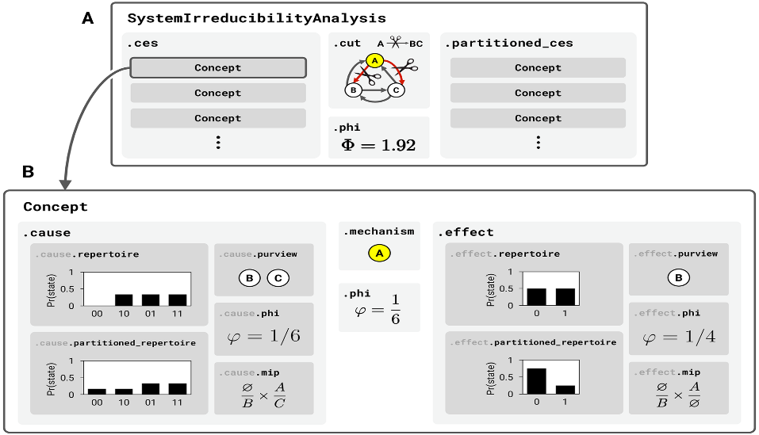

**Nota:**

Para evitar construir TPM y matrices de conectividad a mano, puede utilizar la interfaz gráfica de usuario para PyPhi disponible en línea en http://integratedinformationtheory.org/calculate.html. Usted puede construir las redes que se muestran en las figuras y luego usar el botón Exportar para obtener un archivo JSON que represente la red. Luego puede importar el archivo a Python así:

network = pyphi.network.from_json('path/to/network.json')